|  |  |
| --- | --- |
| **SUBJECT** | US CIS Productivity Bonus Summary Report |
| **DEPARTMENT** | Finance – Payroll |
| **RECORDER (Name Designation)** | Nipuna Madumal: Payroll Executive |
| **APPROVED BY (Name Designation)** |  |
| **LAST UPDATE** | 17/08/2017 |
| **PATH ON NETWORK FOLDER** |  |
| **NO. OF PAGES INCLUDING THIS**  **PAGE** | 02 |

**US CIS Productivity Bonus Summary Report**

Bonus Summary report is prepared once a week (Friday) for the last production week of Friday to Thursday.

Open the weekly productivity worksheets submission report received from the Data Entry Operator – Labor Management via e-mail.

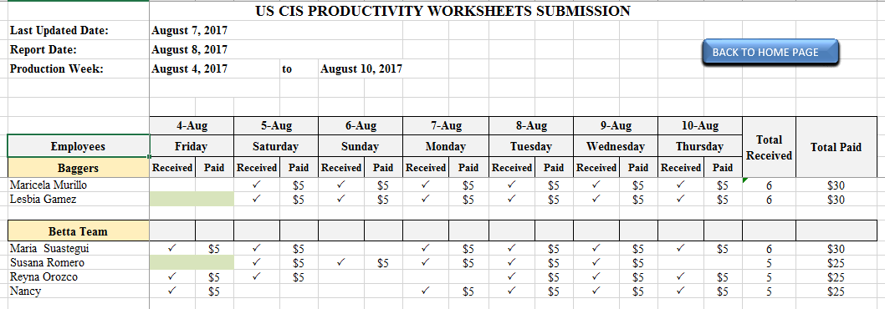This report shows the number of productivity work sheets submitted by each employee and submitted dates.

[Click here for get sample productivity worksheet submission report](https://cisintlcom-my.sharepoint.com/personal/nipunam_cisintl_com/_layouts/15/guestaccess.aspx?docid=0a5ea0898849e4e08b966dfffb96c8e49&authkey=AWgCpC-_Ax6y7X_UoLr8rFY&expiration=2018-02-13T09%3a33%3a28.000Z)

Employees are paid five dollars for each submitted productivity worksheet. Enter five dollars into the column under the submitted date.

Enter total number of productivity worksheets submitted for the relevant week under the column named as PWS SUBMIT.

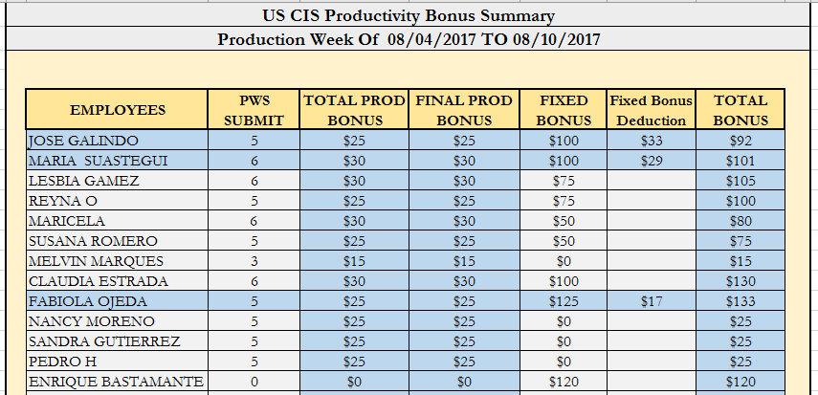

[Click here for productivity bonus summary report](https://cisintlcom-my.sharepoint.com/personal/nipunam_cisintl_com/_layouts/15/guestaccess.aspx?docid=02a66a9ef4c1d40cb9bb46cc769979f09&authkey=AVDskcTR25qTQq7RltjBblE&expiration=2018-02-13T10%3a13%3a18.000Z)

Fixed bonus values should be included to fixed bonus column.

Fixed bonus values are sent by the management. Fixed bonuses should be included after management inform and that values should be remain until changes are informed by the management.

Fix bonus deduction is send by Junior executive – production planning and according to that fixed bonus deduction is done.

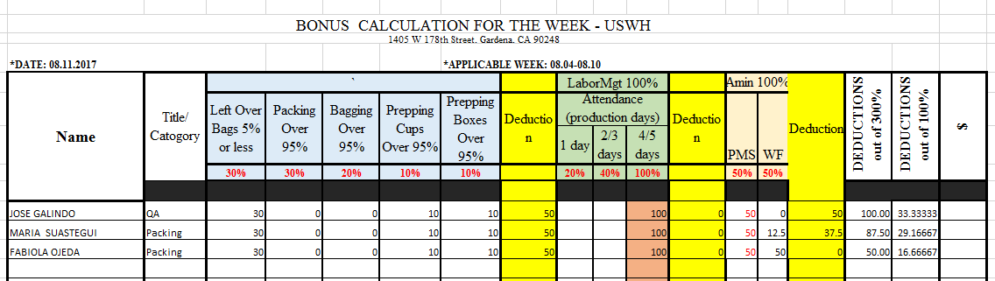

[Click here for fixed bonus calculation report](https://cisintlcom-my.sharepoint.com/personal/nipunam_cisintl_com/_layouts/15/guestaccess.aspx?docid=087258f7f11dc4ee684d08b4913d50afe&authkey=ARdHnlB_wmLzEwitq0MrbSU&expiration=2018-02-13T10%3a18%3a28.000Z)

Total Bonus = Final Production Bonus + Fixed Bonus – Fixed Bonus Deduction