**OPR for Enter Payroll details to ADP**

|  |  |
| --- | --- |
| **SUBJECT** | Enter Payroll Details to ADP |
| **DEPARTMENT** | Finance – US Payroll |
| **RECORDER (Name Designation)** | Nipuna Madumal: Payroll Executive |
| **APPROVED BY (Name Designation)** |  |
| **LAST UPDATE** | 22/08/2017 |
| **PATH ON NETWORK FOLDER** |  |
| **NO. OF PAGES INCLUDING THIS**  **PAGE** | 03 |

* First log in to the ADP by using user ID and password as below.

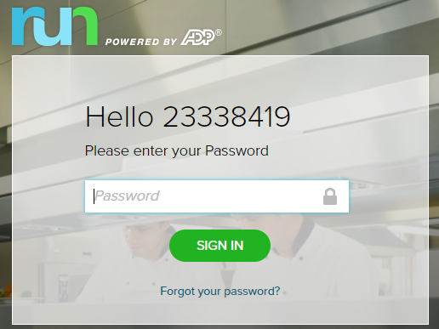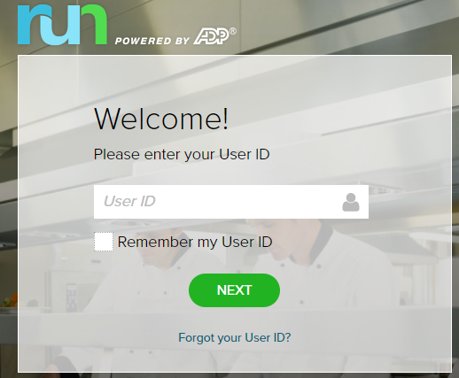

* Then go to Run Payroll in the home tab.

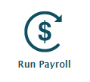

* 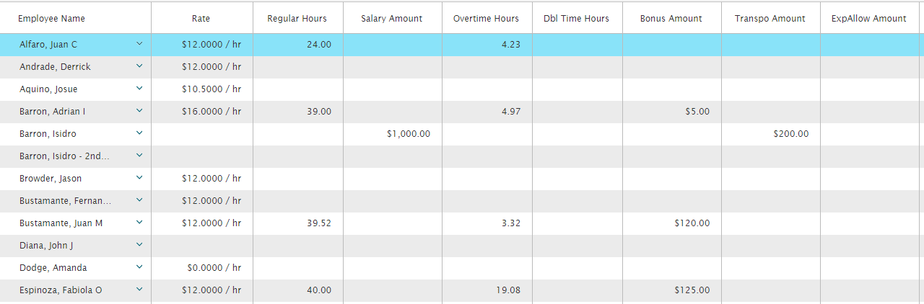Then enter the payroll details to payroll chart according to payroll summary.
* Please remind to click Save button in the bottom after entering each two/three record.



* After entering all the records, you have to click Preview Payroll button in the bottom.



* 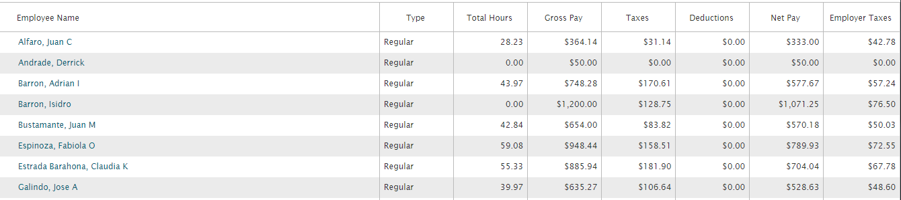Then you can see the summary of the payroll like this.
* After confirming the all the records are accurate, you can click the Approve button.

