|  |  |
| --- | --- |
| **SUBJECT** | Create Effective Rate Per Hour Report |
| **DEPARTMENT** | Finance – Payroll |
| **RECORDER (Name Designation)** | Nipuna Madumal : Payroll Executive |
| **APPROVED BY (Name Designation)** |  |
| **LAST UPDATE** | 24/08/2017 |
| **PATH ON NETWORK FOLDER** |  |
| **NO. OF PAGES INCLUDING THIS**  **PAGE** | 03 |

**Create Effective Rate Per Hour Report**

Introduction

By this report we can found the actual pay rate for an hour for an employee for a week. Find the relationship between the working hours and actual pay amount. We can find that highest pay rate to lowest pay rate for an hour with this report. After processing the weekly payroll this report is create.

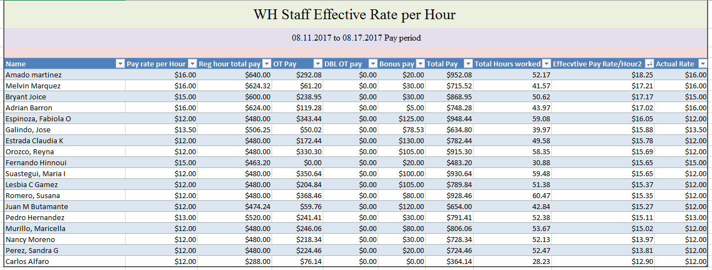Effective Rate Per Hour is created with the help of Payroll Summary of the week.

Above screenshot is shown the report and it contains with above details.

[Click here for get Effective Rate Per Hour Report](https://cisintlcom-my.sharepoint.com/personal/nipunam_cisintl_com/_layouts/15/guestaccess.aspx?docid=00fd6d66ad1274b978eaef55e0a523129&authkey=AX47OoaqRnDJKPBrRgxbOic&expiration=2018-02-20T15%3a17%3a16.000Z)

* 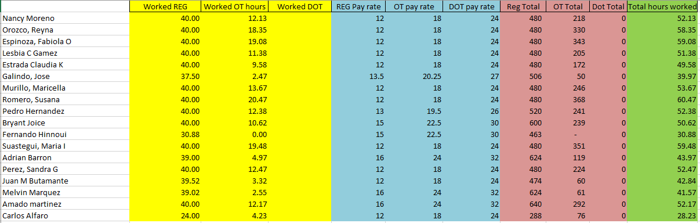First we have to summarize the details and we have use like following format for that.
* Regular hours, OT hours and Double OT hours filled first according to the payroll summary.
* Then we can see Regular pay rate, OT pay rate and Double OT pay rate for each employee.
* Then by multiplying the hours in to rate can get the total of each.
* Also in the last column, total working hours are included.
* Then we fill the main report in the following



* We mention the pay rate per hour each employee.
* Then it shows Total pay of Regular hour, OT hours and Double OT hours.
* Also, we include the Bonus pay of the employees.
* Finally we sum up all the pay and get the total pay of each employee.
* Then we get the total hours worked.
* Finally we divide the Total Pay by Total Working Hours and find the Effective Rate Per Hour.

Effective Rate Per Hour = Total Pay (Regular+OT+Double OT+Bonus)

Total Working Hours