**Sales vs Labor Report - CIS**

|  |  |
| --- | --- |
| **SUBJECT** | Sales vs Labor Report - CIS |
| **DEPARTMENT** | Finance – US Payroll |
| **RECORDER (Name Designation)** | Nipuna Madumal: Payroll Executive |
| **APPROVED BY (Name Designation)** |  |
| **LAST UPDATE** | 15/07/2017 |
| **PATH ON NETWORK FOLDER** |  |
| **NO. OF PAGES INCLUDING THIS**  **PAGE** | 04 |

Objective of the Sales vs Labor Report

The main purpose of this report is to find out the percentage between sales and labor figures in weekly wise. How many labor units are utilized for generate a unit of sale. Presenting a comparison about the weekly sales, labor and production details about the week. In this report make a comparison on five near weeks.

You can get a sample report by clicking the following link.

[Click here for Sales vs Labor report](https://cisintlcom-my.sharepoint.com/personal/nipunam_cisintl_com/_layouts/15/guestaccess.aspx?docid=017dbbd6a8fb246489514701bbac0e519&authkey=AWuLMksmF2v9baELczyAaHU&expiration=2018-01-21T10%3a01%3a08.000Z)

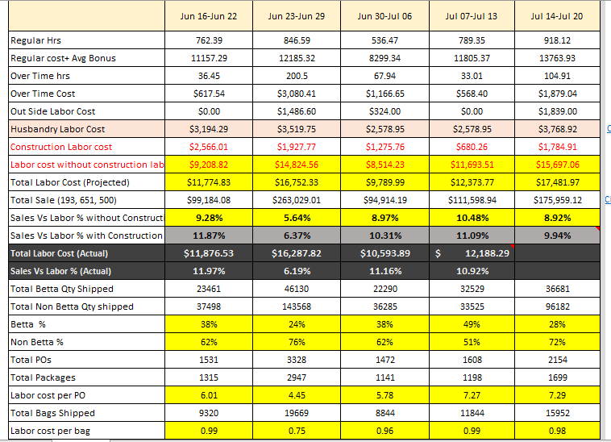

Above screenshot is shown the sample sales vs labor report.

This report is beginning with Regular hours of the week and up to the Sales vs labor (Actual) prepared by the Payroll Executive.

After that Assistant Manager – Production Planning is prepared for ending of the report.

This report is comprising with mainly three sections.

1. Weekly comparison – In here include the labor, sales and production details.
2. Labor cost % of the section.
3. Over time analysis.

Now we will look how to get those figures in to the report.

Regular hours, regular cost + average bonus, over time hours, over time cost – For create this need to get weekly payroll summary details. Log into the uAttend and select the particular week and run the report. Then make necessary adjustments and take those details. When we calculate the average bonus we get the average bonus of the consecutive three weeks.

Outside labor cost – This detail sends by the authorized HR Admin officer in US. She sends the details separately for the week and calculate the sum and put in to the report.

Husbandry labor cost – According to the weekly payroll summary this detail get. Brian, Steve, Claudia, Fernando and Patrik are consist to Husbandry team.

Construction Labor cost – Total salary amount of construction department is take as construction labor. Isidro Barron is only employee work in that department and his total package is consider as the construction labor.

Labor cost without construction labor – Get the total labor cost and minimize the construction labor cost.

Total labor cost – In this figure consist of four main portions. They are regular labor cost, over time cost, average bonus and outside labor cost. These details get by the weekly payroll report.

Total sale – Total sale value is consisting two parts. Normal sales (193, 651 and 292) and whole sale. Normal sale value can get by ETF (invoice summary report) and whole sale value get by Assistant Accountant – TFI.