**Sales vs Labor Report – ASI**

|  |  |
| --- | --- |
| **SUBJECT** | Sales vs Labor Report - ASI |
| **DEPARTMENT** | Finance – US Payroll |
| **RECORDER (Name Designation)** | Nipuna Madumal: Payroll Executive |
| **APPROVED BY (Name Designation)** |  |
| **LAST UPDATE** | 17/08/2017 |
| **PATH ON NETWORK FOLDER** |  |
| **NO. OF PAGES INCLUDING THIS**  **PAGE** | 03 |

**Introduction**

The objective of this report is to compare the labor details and sales details of the week. This report can sort by week or job wise. By the Labor Planning Assistant done this report up to the cost center details. After that Payroll Executive fill the Sales and other cost details.

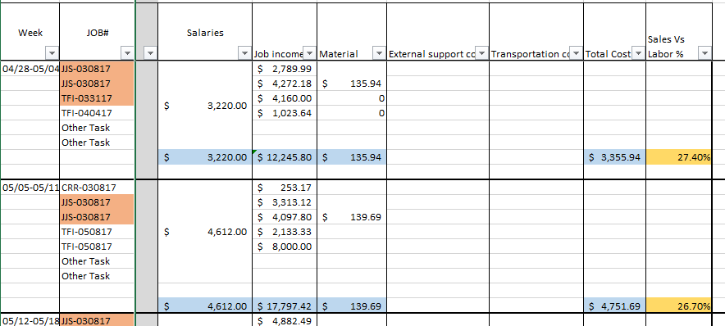You can see the part of a report by following image.

[Click here for Sales vs Labor report – ASI](https://cisintlcom-my.sharepoint.com/personal/nipunam_cisintl_com/_layouts/15/guestaccess.aspx?docid=072798bbf6a794cf1bba983f1de869bf1&authkey=AQkRQM2e9-BtkS8g47AXZRc&expiration=2018-02-18T09%3a09%3a05.000Z)

Up to cost center details are fill by labor management department. After that Salaries, Job income and cost details are fill by Payroll Executive.

Salaries – Salaries are taken from the ADP. In the payroll summary we can get the total salary for ASI company.

Job income – In here job income is calculated in an unique way. In ASI done their job wise. They accept one job at once and before completing that job they accept another job. They done several jobs at once.

First, we have to consider the job estimate of a particular job. If they send the job estimate we consider it as the full income of the job. If not, we have to consider the Sales Invoices. Sales invoices are raised by the Finance department. Normally what they do is total sale amount is break in to section and when the job is ongoing they have pay.

As an example,

Job is – JJS030817

1 st payment – 30% $ 20,924.94 [click here for invoice # 102](https://cisintlcom-my.sharepoint.com/personal/nipunam_cisintl_com/_layouts/15/guestaccess.aspx?docid=0b4eb6c1f0f94458bb054966934eeb8df&authkey=AbSUN-__rofPUHOTBGpOlGs&expiration=2018-02-18T09%3a36%3a10.000Z)

2nd payment – 60% $ 41849.88 [click here for invoice # 103](https://cisintlcom-my.sharepoint.com/personal/nipunam_cisintl_com/_layouts/15/guestaccess.aspx?docid=0b7926e5ba16144678ea36c9f92cef882&authkey=ASiGiZEAzi-1_zzw0JPY9RA&expiration=2018-02-18T09%3a36%3a39.000Z)

3rd payment – 100% $ 6,974.98 [click here for invoice # 105](https://cisintlcom-my.sharepoint.com/personal/nipunam_cisintl_com/_layouts/15/guestaccess.aspx?docid=0428fd67a7bf7479ab3a03e82bd2414b3&authkey=Ae0ANlqRnJVvwfs2U0GJKNE&expiration=2018-02-18T09%3a37%3a05.000Z)

Total Job Income $ 69,749.80

Also we have to consider the Total Labor Hours utilized for a particular job. Then Total Income divided by total labor hours and find income earned per hour. Finally multiplied by hours worked in to income earned per hour.

As an example,

Total income for a particular job is $ 1000. Other details are as follows,

|  |  |  |  |  |
| --- | --- | --- | --- | --- |
| Week | Job No | Employee | Hours Utilized | Job Income |
| 5.12 – 5.18 | XYZ 0225 | Justin | 15 | 150 (15 x 10) |
| 5.12 – 5.18 | XYZ 0225 | John | 24 | 240 (24 x 10) |
| 6.16 – 6.22 | XYZ 0225 | Justin | 32 | 320 (32x 10) |
| 7.12 – 7.27 | XYZ 0225 | Justin | 18 | 180 (18x 10) |
| 8.4 – 8.10 | XYZ 0225 | John | 11 | 110 (11 x 10) |

Here total hours utilized for XYZ 0225 is 100 hrs. (15+24+32+18+11). What we do is total income is divide by total hours utilized.

Income earned per hour is, $ 1000/ 100 hrs = $10

Then multiplied by each hour utilized by each employee.

Material cost, External cost and Transport cost is source from QB.

Finally, Sales vs Labor % calculate by total cost divided by total income.