**CIS INTERNATIONAL HOLDINGS CORP**

**OPR FOR PO CANCELATION**

|  |  |
| --- | --- |
| **SUBJECT** | **PO CANCELATION** |
| **DEPARTMENT** | **COUSTOMER SERVICE** |
| **RECORDER (Name & Designation)** | **VIKUM MARASINGHE (CSE)** |
| **APPROVEDBY (Name & Designation)** | **PURODHA PERERA (HOD CS)** |
| **CREATED DATE** | **06/20/16** |
| **LAST UPDATED (MM/DD/YY)** | **05/4/17** |
| **PATH ON NETWORK FOLDER** | **N/A** |
| **NO. OF PAGES INCLUDING THIS PAGE** | **2** |

***PO Cancelation***

When received a cancelation request from Petco, Refer the below screenshot.

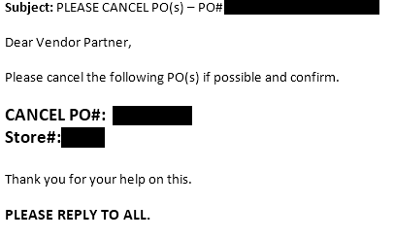

When received a cancelation request from Petco,

* Log into the ETF website and look up the PO # under “PO Summary Totals Report” on EDI Details and check the PO and its line items/ Status very carefully.
* If the PO is already shipped, needs to provide the PO Status to the client stating the PO cannot be canceled as the PO has been already shipped out.
* If the PO status is “Open”, Go to the Change PO Status menu and suspend the PO.

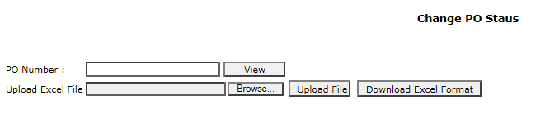

* Once canceled the SID will be 12.
* Double check the PO Status from “PO Summary Totals Report” and confirm to the client that the PO has been canceled.

**Please note:** Do not Cancel or Hold any PO’s on Store Request as it effects the inventory keep between Petco Home Office and the Petco Store’s. Cancel PO’s only received directly from Petco home Office (Demand Analyst’s and Live Companion)