**CIS INTERNATIONAL HOLDINGS CORP**

**OPR for Monitoring & reporting to IT Admin on all Petco.com Orders Subject to Cancellation**

|  |  |
| --- | --- |
| **SUBJECT** | **Monitor & report to IT Admin on all Petco.com Orders Subject to Cancellation** |
| **DEPARTMENT** | **Customer Service Department** |
| **RECORDER (Name & Designation)** | **Purodha Perera** |
| **APPROVEDBY (Name & Designation)** | **Purodha Perera** |
| **CREATED DATE** | **06/29/2016** |
| **LAST UPDATED** | **06/29/2016** |
| **PATH ON NETWORK FOLDER** | **N/A** |
| **NO. OF PAGES INCLUDING THIS PAGE** | **1** |

**Monitor & report to IT Admin on all Petco.com Orders Subject to Cancellation**

1. E-mail notification received from Drop Ship Orders [DropShipOrders@PETCO.com](mailto:DropShipOrders@PETCO.com)
2. E-mail subject line – “CIS INTERNATIONAL HOLDINGS CORP--Petco.com Orders Subject to Cancellation--Open POs Over Age Limit”

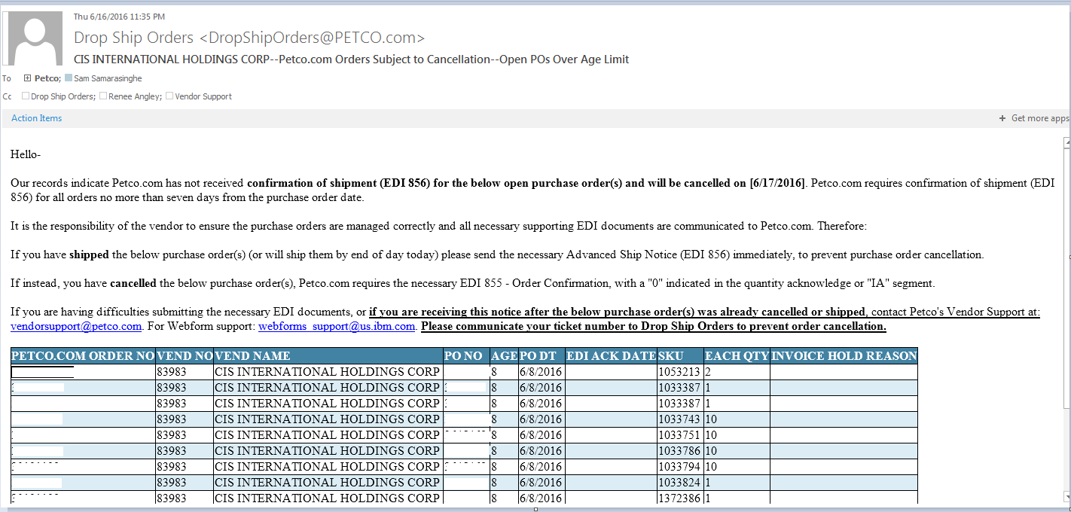

1. Immediately forward to IT Admin & Matt once the above e-mail notification is received from Petco.com