**TEKNOWLEDGE SHARED SERVICES-SRI LANKA**

**OPR PETCO.COM #651 PLANNING**

|  |  |
| --- | --- |
| SUBJECT | OPR PETCO.COM #651 PLANNING |
| DEPARTMENT | PRODUCTION PLANNING |
| RECORDER | SIVANTHA SAMEERA |
| APPROVED BY | Buddika Madurangana |
| CREATED DATE | 06.16.2016 |
| LAST UPDATED | 03.13.2018 |
| PATH ON NETWORK FOLDER |  |
| NO. OF PAGES INCLUDING THIS PAGE | 6 |

**Objective**

To provide Open Petco.com PO list with required item list to the Warehouse from Monday to Friday. This report must be provided before 6.00 am US time.

POs will be considered to the production, which created up to 4pm SL time on current day and any back POs remaining

**Customer 651 Planning Guide line.**

1. 651 POs are with short validity period. POs must be planned on the same day received & regular shipping days will be Monday to Thursday. POs to be planned on Friday if the PO is classified as Saturday delivery.

Note:

Currently there is a delay to receive 651 POs. some POs are delayed up to 1 day.

1. On a regular production day, POs received until 4pm SL time will be included for daily ship list. If the POs should be delivered on coming Saturday will be kept until Friday to ship out.
2. Due to PO receiving delay and Weekend, usually more POs are available to ship out on Monday. If any PO open with Saturday delivery and overdue, need to inform CSD and get customer confirmation to ship on weekday.
3. Available POs must be checked against the stock availability and Weather. If the PO is having several line items and not all the items available, PO can be planned and zero ship the non-stock items. if the total line items are not available, whole PO will be requested to zero ship from IT.
4. Weather must be checked and plan the POs which are eligible to ship. If any PO is open more than one day due to weather, must be informed to CSD and get further advice on same from the customer.
5. All PO records must be maintained daily basis.
6. While the EOD process, manual courier site reconciliation must be done and inform IT to change status as shipped and invoice.
7. IT is responsible to monitor all EDI notification which required for each step on 651 processes.

**Generate MPOs.**

Path: EDI Details – Purchase Orders

1. Customer – 651 – Petco.com
2. Po Status – Unassigned
3. PO date – last production date, To: today date

Petco.com POs are required to be assigned (Generate MPOs) to ETF from Sunday to Wednesday 12.00 mid night US time. (Monday to Thursday 3.00 PM SL time as per the current time difference) Select the all POs and manual update.

<http://www.cisintl.com/PurchaseOrders.aspx>

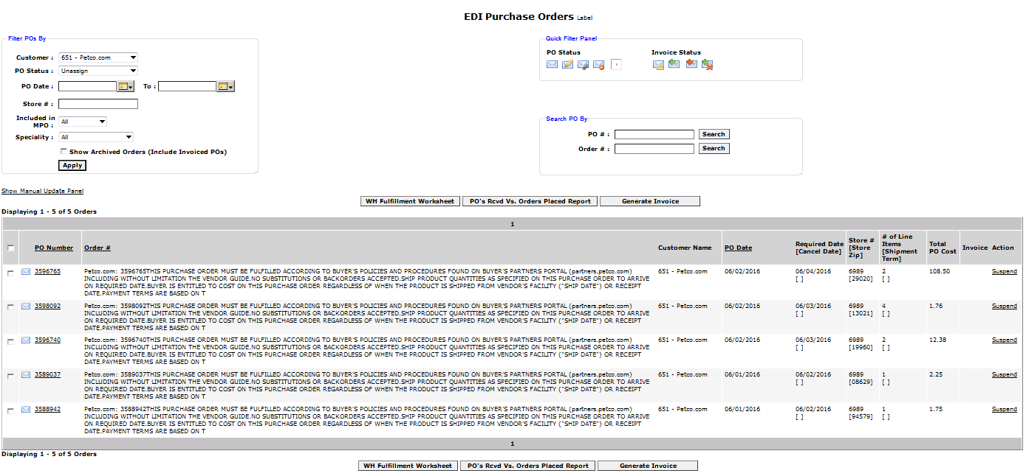 After generating MPOs need to concern following steps to before prepare the plan.

* Check the inventory.
* Check pending orders with Order Entry.
* If items are not in stock but expected within 24 hours, hold to ship.
* If the items are not in stock and not expected to arrive within 24 hours, zero ship and complete invoice.
* If the items are in stock, ask the warehouse for a reason as to why they were not shipped.

**Preparation of the Pick and ship list**

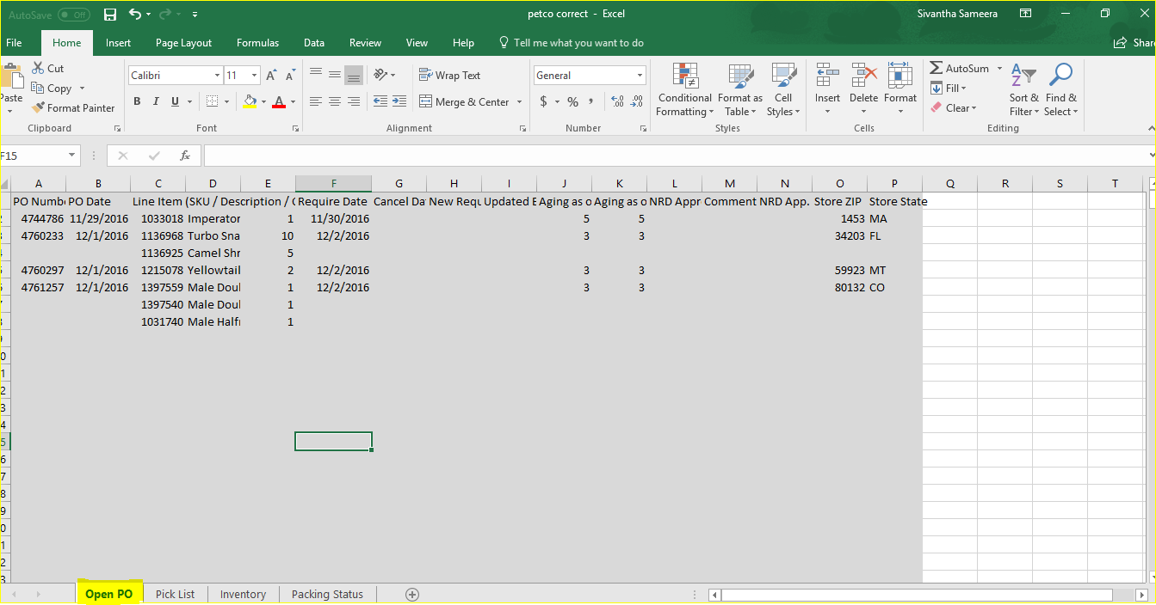PO list to be taken by use the prepared excel sheet. It is containing 4 tabs, Open PO, Pick list, Inventory and packing status.

**Step 1** – Create MPO and takes open PO in “Generate report” Format

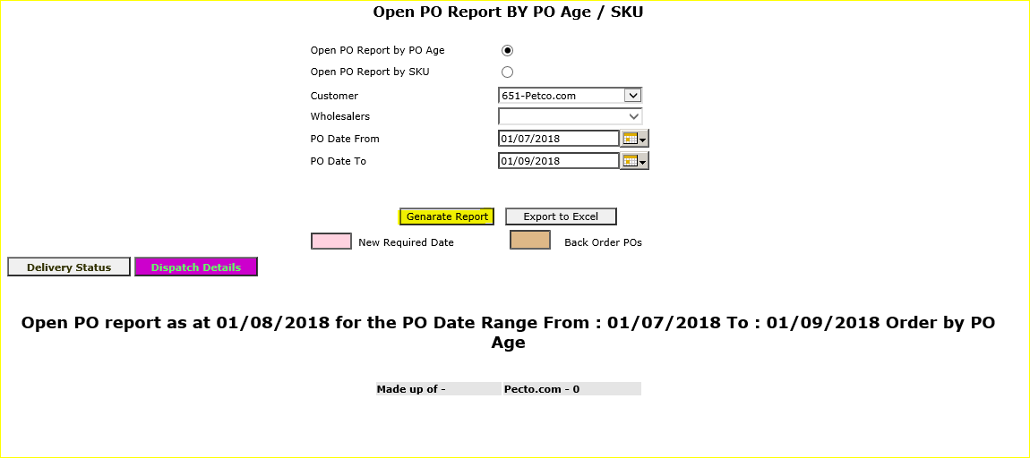

**Step 2** – Copy the all PO detain in open PO generate report and past as a data in working sheet open PO tab.

**Step 3** – Past the updated inventory sheet send by USWH, to the Inventory Tab.

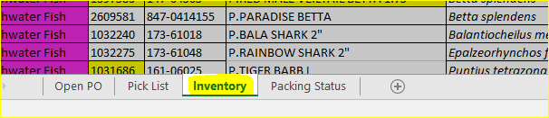

**Step 4** – Assign the POs using production planning new

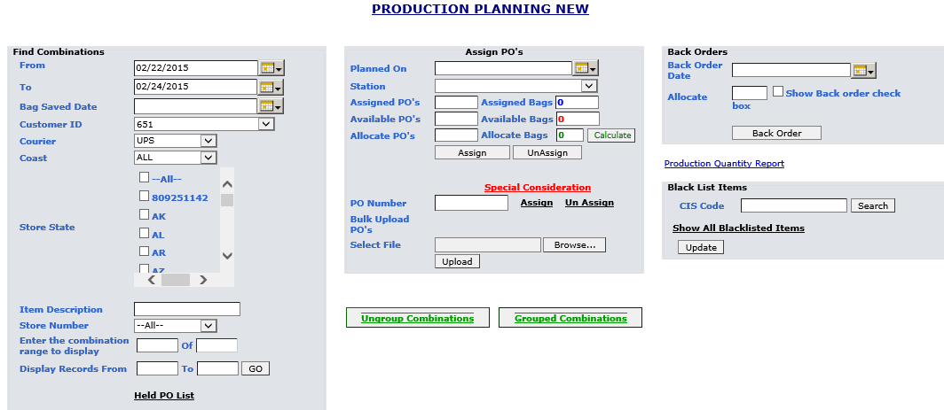

**Step 5** – Once POs Assign, using the packing status update page take packing status excel and past it into working sheet packing status tab and PO numbers convert the “numbers”.

Path - http://cis.eteknowledge.com/ProductionMatrix/packerInfoUpdate.aspx

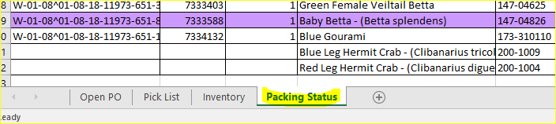

Step 6 – take the Pick list and prepare the final Pick and ship list using the below report format

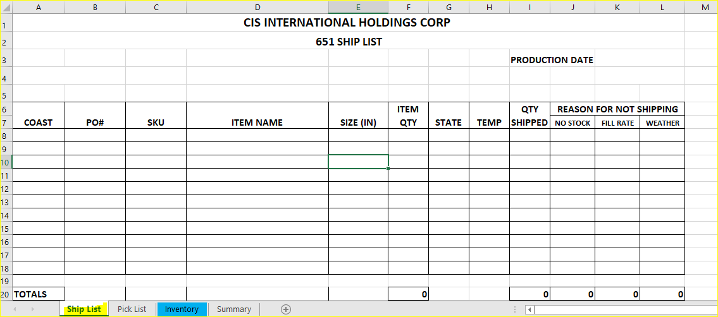**Ship list**

**Pick List.**

* Pick list must be prepared with below information
* Items must be categorized as Betta, FW, SW & Other
* Pick list must be sorted as per items & it’s EOQs
* Fish size must be available.

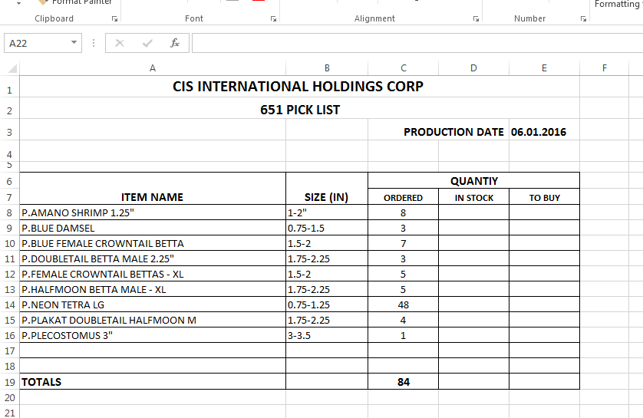

**Summary**

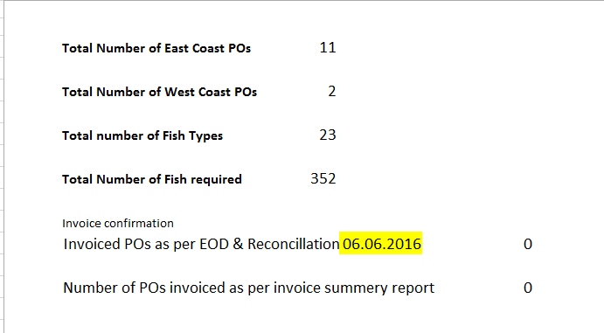

Note: Invoice summery report will provide the Number of invoice POs as per EOD & Reconciliation.

**Recipients**

To : - Brian Kim <briank@etropicalfish.com>; Fabiola Ojeda <FabiolaO@etropicalfish.com>; Reyna Orozco [reynao@etropicalfish.com](mailto:reynao@etropicalfish.com)

Cc: - Andy Hettiarachi - Manager-Administration -US <andyh@etropicalfish.com>; Buddika Maduranga - Labour & Production Planing <buddikam@cisintl.com>; Christopher Tritschler <chris@etropicalfish.com>; Maria Reyes <mariar@etropicalfish.com>; Maria Sauastegui <marias@etropicalfish.com>; Matt Rice <MattR@etropicalfish.com>; Sivantha Sameera - Production Planning <sivanthas@cisintl.com>; Steve Upp <steveu@etropicalfish.com>; Tuan Hossen - Customer Service <tuanh@cisintl.com>; Vikum Marasinghe - Customer Service <vikumm@cisintl.com>

Subject: All | Packers-Petco.com Pick and Ship list

**Note: Report is assigned under Production Planner Access.**

**Process Low Chart**

Invoice

Pack & Ship

Plan the Labor

**Receive POs**

Check Stock

Check Weather

Plan the POs