**TEKNOWLEDGE SHARED SERVICES-SRI LANKA**

**OPR FOR CUSTOMER#292 PRODUCTION PLAN**

|  |  |
| --- | --- |
| SUBJECT | OPR FOR CUSTOMER#292 PRODUCTION PLAN |
| DEPARTMENT | PRODUCTION PLANNING |
| RECORDER | BUDDIKA MADURANGANA |
| APPROVED BY |  |
| CREATED DATE | 11/06/2017 |
| LAST UPDATED | 12/12/2018 |
| PATH ON NETWORK FOLDER |  |
| NO. OF PAGES INCLUDING THIS PAGE | 12 |

**OBJECTIVE**

Plan the customer 292 POs to ship the POs as specified by the customer. All customer requirement to be filled according to the company procedure and production plan to be submitted timely to carry out production.

**PROCESS**

Currently, we are serving to 5 DCs of customer 292. DCs are 08, 23, 39, 40 & 42.

## Current DCs and delivery dates

|  |  |  |  |  |  |  |  |
| --- | --- | --- | --- | --- | --- | --- | --- |
| **DC** | **City** | **State** | **Ship Day** | **Arrival Day** | **Airport** | **Preferred Airline** | **Alternate Airline(s)** |
| 8 | Phoenix | AZ | Sunday | Monday | PHX | WN |  |
| 23 | Bethel | PA | Saturday | Sunday | PHL | AA |  |
| 42 | Reno | NV | Sunday | Monday | RNO | WN |  |
| 39 | Ottawa | IL | Saturday | Sunday | ORD | WN | AA |
| 40 | Newnan | GA | Saturday | Sunday | ATL | DL |  |

**PO receiving**

Customer 292 POs are received to ETF 10 days before ship outs. Usually the POs are received on Wednesday/Thursday to ship from 2nd Saturday onward.

**Provide PO & Box details to Logistics.**

Logistic do the Air line bookings and following details to be provided on every Thursday (once receive the new POs) to logistic.

|  |  |  |  |  |
| --- | --- | --- | --- | --- |
| PO# | Type | Hand over date | DC# | Boxes |
| 612148613 | Betta | 9/15/2018 | DC 40 | 9 |
| 612148609 |
| 612148574 | Betta | 9/15/2018 | DC 39 | 18 |
| 612148575 |
| 612148610 | Betta | 9/16/2018 | DC 42 | 9 |
| 612148611 | Guppy |
| 612148576 | Guppy | 9/16/2018 | DC 08 | 24 |
| 612148578 | Betta |
| 612148577 | Betta |
| 612148612 | Betta | 9/18/2018 | DC 42 | 6 |

**Box Calculation**

Box calculation must be done based on the EOQs and number of bags can be packed in a box.

Once the new POs received,

* Get the PO number for each DC
* Identify the ship out dates
* Check the fish Quantity
* Calculate bags and boxes
* Fill the above table
* Send to Logistic on every Thursday for the ship outs starting from 2nd Saturday.

**Pack Quantities**

* **Betta- 55 Bettas in a bag, 11 Bags in a Box**
* **Guppy- 75 Guppies in a bag, 12 Bags in a Box**

|  |  |  |
| --- | --- | --- |
| item | EOQ | bags per box |
| Guppy | 75 | 12 |
|  |  |  |
| Betta | 55 | 11 |

**Update Airway Bill number on the POs.**

Logistic do the booking as per the above details on Thursday.

Send the Final Mile Tracking to Key Accounts Manager for approval

Approved boking details will be sent to each DC by logistic on Tuesday and cc to Production Management. This document is FINAL MILE TRACKING.

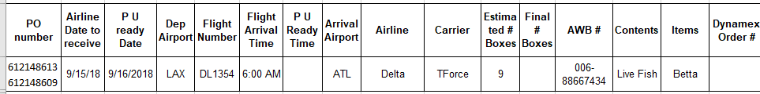

Once received this document on Tuesday, Get the confirmed Airway bill numbers from the documents and update the AWB on the POs.

Go to,

* EDI Details
* Purchase Order
* Select the customer- 292
* Select the relevant PO received date (Last Wednesday/Thursday)
* Select the DC#
* Click on Apply

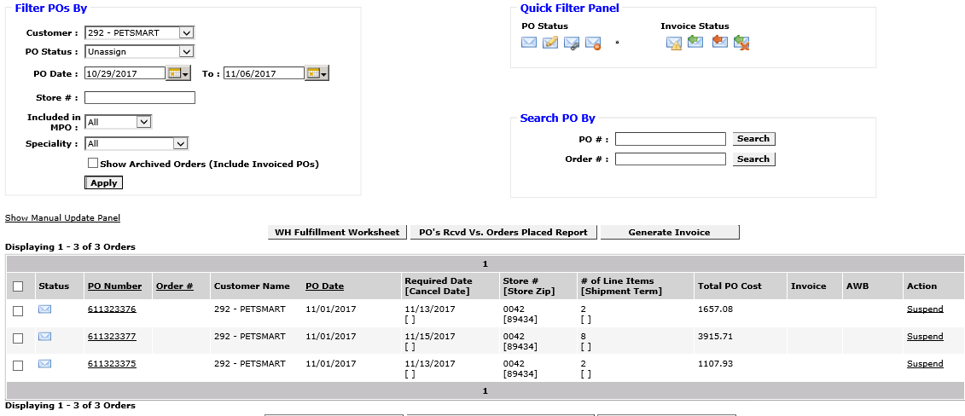

* Once the POs are loaded,
* Click on the PO number
* Provide the AWB number and save.

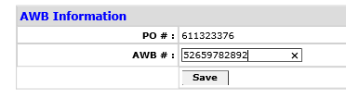

Do the same for all POs

Go to EDI details-Purchase Order, provide same information and search for POs. now the POs are updated with the AWBs.



**Planning Steps.**

1. Station assignments

Packing and bagging stations to be assigned prior to plan POs. Assigned labor to be identified for 292 packing from the weekly labor schedule and Packing and Bagging stations to be assigned as below.

* Logo on to ETF
* Production Planing admin
* Station assignment
* Select the Station Name (Ex. Packing-Station P1)
* Select the employee name (Ex. 292 Regular)
* Select the supervisor (Ex. Andy H)
* Start Time: (06:00)
* End Time: (14:00)
* From, To- you need to select the date or date range.
* Tick on the relevant day and save.
* Create Station as per the DC availability for the day.
* Same to be followed to create bagging station and only difference is Station to be selected bagging station.

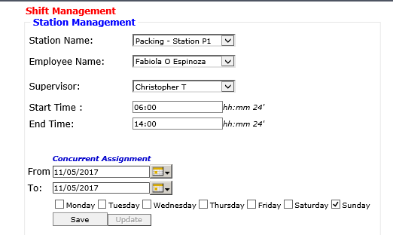

**PO Assignment/MPO Assignment**

Before start to plan production, 292 POs for the relevant production week must be assigned to ETF. (Create MPO)

Go to,

* EDI Details
* Purchase Order
* Select the customer- 292
* Select the relevant POs received date (Last Wednesday/Thursday)
* Select the DC# (or load all POs for the week)
* Click on Apply



* Once the POs are loaded, check AWBs are available for each PO
* Select all (or can be created one by one)
* Click on Show Manual update panel
* Click on update
* Now the MPOs will be assigned to ETF

**Production Plan**.

**Inventory Check**

Inventory of the required items must be checked prior to start 292 production Plan.

**Adjust fish availability**

If the required items are short or not available, Plan must be adjusted accordingly. (Excel Plan, Bag saving etc.)

Same item requested for 2 or more DCs and Quantity is not enough, allocate the available stock proportionally on each PO.

Once the POs are assigned and bag saving/assignment done, need to adjust the shortage items on ETF.

1. Go to Bulk QR label printing page
2. Provide production date, Station etc. and display orders

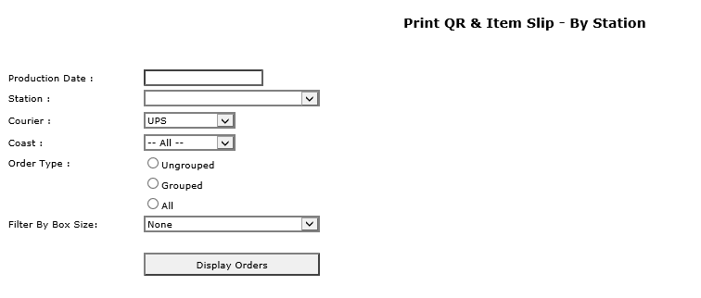

1. Once the POs loaded, click on View and update

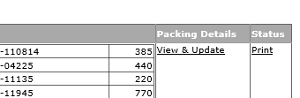

1. Adjust the relevant bag quantity and click on update Quantity
2. Send the bag adjustment details to WHMgt, QAMgt and Team leaders.

**PO assignment**

ETF- Production Planning and Admin- Production Planning new

Select the PO date range (as per ship outs)

Customer ID: 292

Click on Ungroup combination. (Currently customer 292 POs and shipped individually and no group POs are available)

Once the POs are loaded, make sure the correct POs which need to be shipped. (Final Mile tracking sheet can be referred to check)

Select the POs which need to plan. Click on Show POs in the combination. Now the available number of POs are shown in Available POs

Assign DCs separately under Packing Stations and assign as per priority.

Select the Production Date

Select the packing Station

Put the number of POs in Allocate POs

Assign

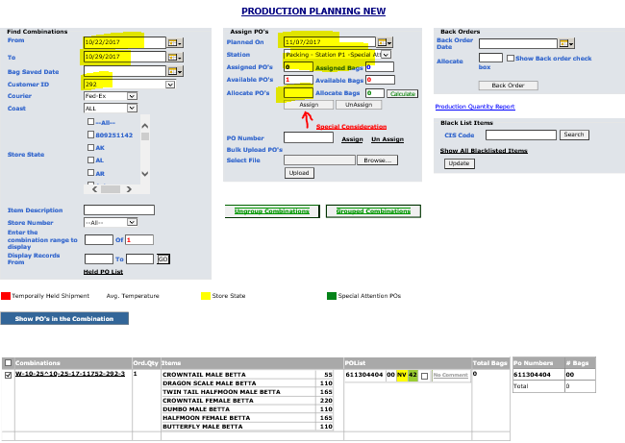

**Bag Saving, Bag assignment**

1. ETF- Fish Breakdown and Bagger Assignment- View fish breakdown details

Select Production Date

Select Packing Station

Customer: 292

Load calculated value (Default)

Click On view

It will show you the all assigned bags for the station. Check the correctness of EOQ and change if required. Then Save.

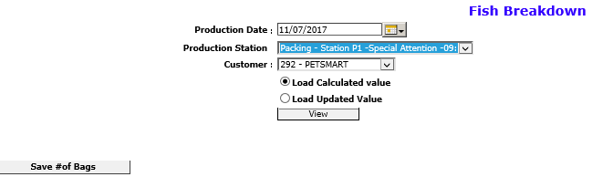

1. ETF- Fish Breakdown and Bagger Assignment- bagger assignment

Select Date

Customer: 292

View

Select the bagger

Tick on the items (all bags must be assigned to one or more bagger depend on the quantity)

Add

Assign Bags

Note: once all bags are assigned, Available to assign should be zero.

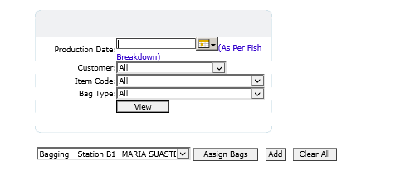



**Note: Click on the Box Calculation once bag assignment done.**

1. ETF- Fish Breakdown and Bagger Assignment- View assigned baggers

By selecting Production date, Customer and Station, you can see the available bags for given production day. This must be checked against the production plan (Fish Breakdown) and confirm the accuracy.

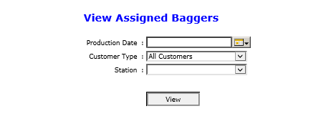

**Production Plan Preparation**

Once the POs are assigned to the station Production plan can be prepared in Excel.

This Excel must contain below tabs.

1. Packer breakdown
2. Fish Breakdown
3. Summary
4. Bagging distribution

**Packer Breakdown.**

ETF- Production Planning Admin- Packing Status Update

Click Start

Select Production Date

Tick on All

Display Orders

Import Ungroup POs to Excel

Copy the downloaded data to Excel

Add the Station Name, Date, Customer

Prepare the summary with Quantity, EOQ and Bags

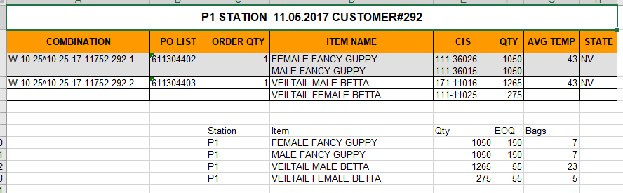

Fish Breakdown

Update the Fish requirement in below Format. Bag details must be updated as DC wise.

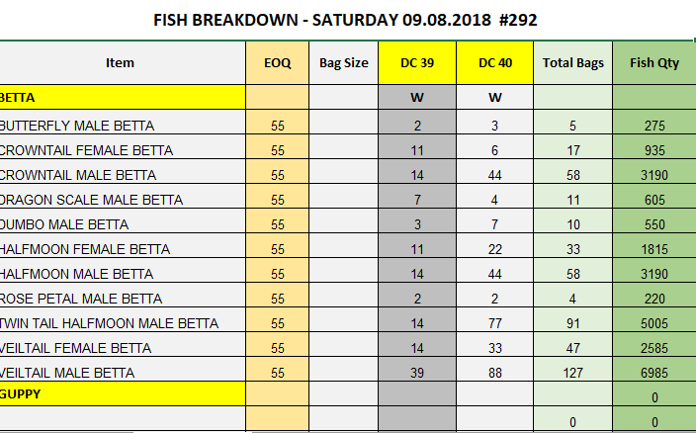

**Summary**

Station, Bags, Number of POs summary to be updated.

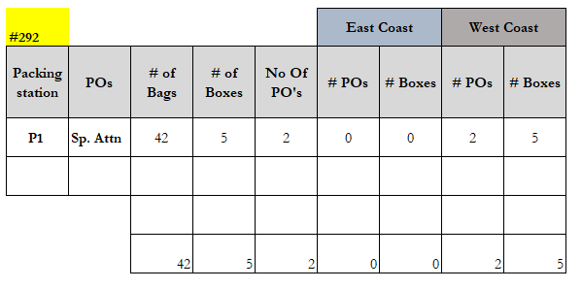

Note: Number of box can be taken from Packing status update page which you download the packer breakdown. Click on the Print label for combination (Each PO) and get the number of boxes allocated by system.



**Bag Distribution**

As per the labor requirement and planned labor, bags to be distributed.

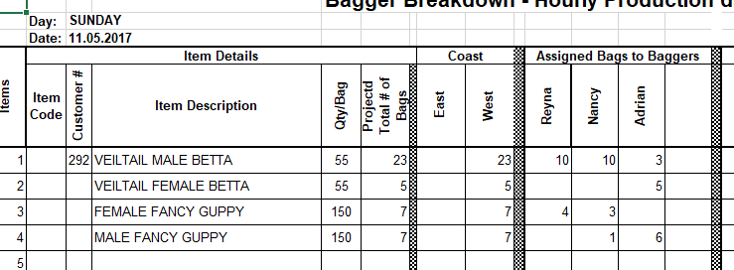

**Other Documents which need to send along with 292 Packer/Fish Breakdown**

1. Betta Mix- (This is no longer required after 12/10/2018)
2. Driver Box loading Log-292

Following format to be sent to Team leads after filling the planned data (yellow colored) on it.

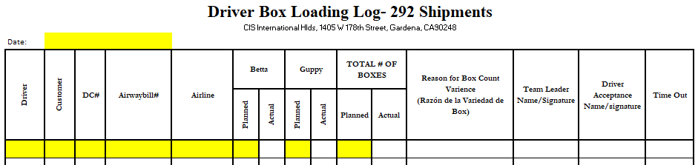

Actual data must be filled by the Team lead and hand over to driver.

Scan copy must be sent to ProdMgt after every 292-production day**.**

1. Check list for Team Leads

This check list must be followed by the team lead and updated scanned copy must be sent to ProdMgt after every 292-production day.

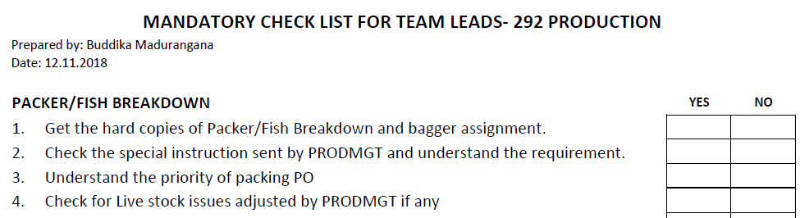

**Inform IT Admin & IT Support**

Once the production planning completed for 292, IT admin and IT support must be informed vis email with following information.

This is to arrange their support crew and invoice the POs once shipped.

|  |  |  |  |
| --- | --- | --- | --- |
| **#292** |  |  |  |
| **Packing station** | **POs** | **No Of Un Grp PO's** | **No of Grp PO's** |
| **P10** | **Regular** | 2 |  |
|  |  |  |  |
|  |  | 2 | 0 |

**Box Reconciliation- 292**

292 Box reconciliation to be done on every Monday to identify any count deficiency and find the reason.

ProdMgt Initiate the reconciliation by filling Projected, Planned and Packing slip box quantity for each DC and Logistic must fill the Driver details and Airline received details.

Variances must be highlighted and look for the reason. Unknown issues must be escalated.

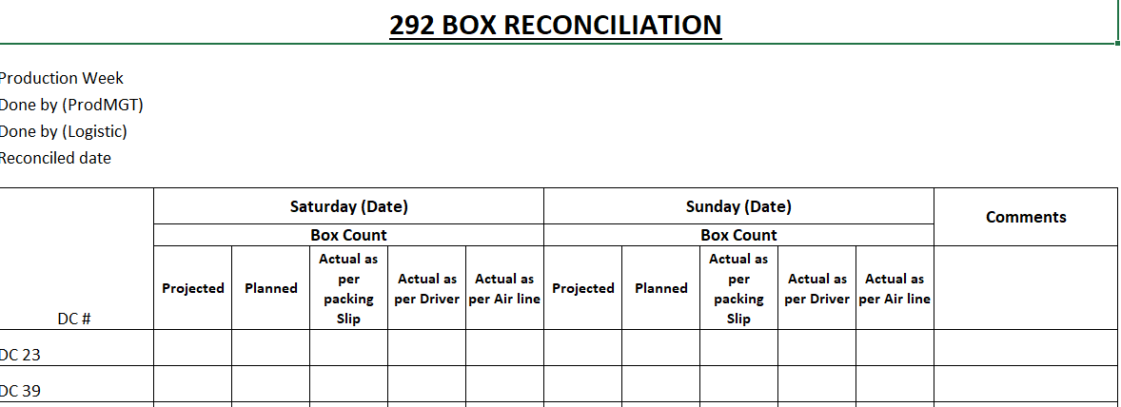

**Labor Allocation**

Following will be considered while allocating labor for 292 Packing.

1. 292 betta shipment is planned to arrive on Fridays. Shipment pick up and initial sorting, storing to be planned accordingly.
2. Betta sorting to be done first and Guppy bagging to be done later. This to be followed to keep guppies minimum time in bags.
3. Saturday and Sunday packing crew to be arranged for 292 packing and someone must schedule for drop offs.
4. Total number of drop offs to be determined as per the priority.
5. Currently, SL Styro coolers are used for 292 packing. These boxes must be adjusted prior to shipping and labor to allocate after every S shipment. (Friday)
6. All above to be planned as per bench marks.

**Process Flow Chart- 292 Production**

