**TEKNOWLEDGE SHARED SERVICES-SRI LANKA**

**OPR -B2B/#500 WHOLE SALE PO PLANNING**

|  |  |
| --- | --- |
| SUBJECT | OPR -B2B/WHOLE SALE PO PLANNING |
| DEPARTMENT | PRODUCTION & LABOR PLANNING |
| RECORDER | BUDDIKA MADURANGANA |
| APPROVED BY |  |
| CREATED DATE | 07/05/2018 |
| LAST UPDATED |  |
| PATH ON NETWORK FOLDER |  |
| NO. OF PAGES INCLUDING THIS PAGE |  |

**Objective**

Provide a comprehensive process to plan B2B/Whole sale order fulfilling the customer requirement and on time delivery.

**PO Receiving**

Customer can register on the B2B (Whole sale) site and place the PO as he needed. The PO will be sent as an email to the customer, Planners & IT by ETF sales email account.

PO contains,

Customer details

Required fish and Quantities and values

Shipping method

Ship out & delivery dates

Box details & Packing charges

Some other instance, customer send his request via email to Marketing & Customer service. They will guide the customer to register on the B2B site or create and account for the customer and place the order as he needed.

**PO Planning**

Production Planner must check the new POs received from ETF Sales daily basis. POs must be planned to meet the requested delivery dates.

Production Plan

B2B/Wholesale Production Plans are made on Excel format which contains 3 tabs.

1. PO details- Same information available on email must be pasted.
2. Production details

PO#, Customer account (B2B/Whole Sale), Date

Item code, Item Name, Package, Number of Packages and required fish quantity to be updated.

Required Box size to be provided as mentioned in the email

Additional column will be kept to update location

1. Fish Breakdown

This is the fish requirement summary which need to be picked.

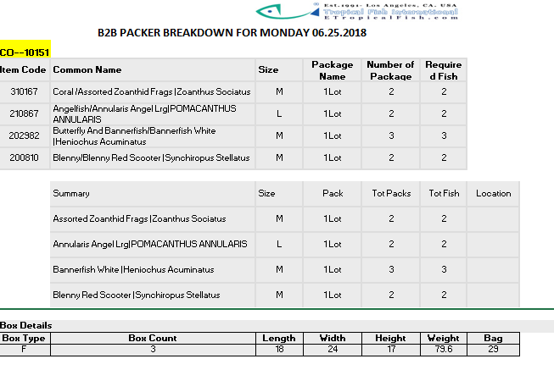

Special Instruction

If customer has specified any on the PO, must be highlighted to WH

Hawaii POs must deliver with import Permit

Labor Allocation

Labor allocation will be done as per the bench mark. As per the current process, QA team will pick the fish and bag them as per the PO. packing will be done by regular packing crew.

Production Plan submit to WH

Prepared plan must be submitted to WH and recipients will be,

1. WHMgt
2. QAMgt
3. Logistics
4. Customer Service
5. IT Admin
6. Cc-Prod & LaborMgt