**OPR for Daily Sales vs Labor Report**

Objective

|  |  |
| --- | --- |
| SUBJECT | OPR for Daily Sales vs Labor Report |
| DEPARTMENT | Finance - Payroll |
| RECORDER | Nipuna Madumal |
| APPROVED BY | Buddika Maduranga |
| CREATED DATE | 09/20/2017 |
| LAST UPDATED | 02/21/2019 |
| PATH ON NETWORK FOLDER |  |
| NO. OF PAGES INCLUDING THIS PAGE | 09 |

The main objective of this report is to measure the daily actual labor utilization against the Sales. This information is required to fine tune the process to reach company goals.

Main content of the report.

1. Labor Details – Project regular hours & OT hours, Actual regular hours & OT hours, Project external labor hours & actual external labor hours. Also amount related to those hours.
2. Sales details – Daily Actual sales details and percentages
3. Dispatch details – Daily dispatched POs.

**How to update the Report**

Employee List which need to consider for Sales Vs Labor

|  |  |  |  |
| --- | --- | --- | --- |
| Employee | Consider for the report | Consider regular hrs/cost only | Not consider for the report |
| Regular Employees |  |  |  |
| Melvin Marquez | **** |  |  |
| Martin Armenta | **** |  |  |
| Espinoza, Fabiola O | **** |  |  |
| Estrada Claudia K | **** |  |  |
| Galindo, Jose | **** |  |  |
| Suastegui, Maria I | **** |  |  |
| Juan M Butamante | **** |  |  |
| Romero, Susana | **** |  |  |
| Orozco, Reyna | **** |  |  |
| Christian Nolasco | **** |  |  |
| Murillo, Maricella | **** |  |  |
| Carlos Martinez | **** |  |  |
| Chris Barron | **** |  |  |
| Angelina Nunez | **** |  |  |
| Amado Martinez | **** |  |  |
| Jonathan Ramirez | **** |  |  |
| Sebastian Burgueno | **** |  |  |
| Jaime Mendoza | **** |  |  |
| Melina Torres | **** |  |  |
| Veronica Ruiz | **** |  |  |
| Silvestre Ramos | **** |  |  |
| Luis Agleria | **** |  |  |
| Hugo Soto | **** |  |  |
| Maria Torres | **** |  |  |
| Tania Bernal | **** |  |  |
| Rocio Pineda | **** |  |  |
| Jose Otero | **** |  |  |
| Ana Ruiz | **** |  |  |
| Silvia Ramirez | **** |  |  |
|  |  |  |  |
| Office Staff |  |  |  |
| Brian Kim |  | **** |  |
| Steve Upp |  | **** |  |
| Isidro Barron |  | 50% only |  |
| Maria Reyes |  |  | **** |

Above chart shows the applicable and non-applicable employees for this report. All the regular employees are considering for the report. Brian, Steve, Isidro and Patrick are the other members which need to include for this report. only regular hours and cost are considered for aforesaid members since they are salaried employees. Maria and Christopher are do not consider for this report.

Note: Above list is the most recent list of the employee who is consider for labor report.

Contents of the report in sequence

1. Daily Projected Production hours

This values are taken from weekly labor schedule prepared by Labour Management on every Thursday for coming production week. In that report, 1st shift, second shift and External labor schedules details to be copy and paste.

Need to remove Isidro B details since he is already counted under Fixed staff.

Fixed Salary crew hours are accommodated as per their working schedule. But need to review and update once the schedule changed.

1. Projected OT hours

This values are taken from weekly labor schedule prepared by Labour Management on every Thursday for coming production week. In that report, 1st shift, second shift and External labor schedules details to be copy and paste.

1. Projected Total hours

Sum of Projected regular hours and Overtime hours.

1. Actual regular hours, Actual OT hours and Actual total hours

Actual regular hours and Actual OT hours are taken from uAttend with making adjustments. Actual total hours are consisting with Actual regular hours and Actual OT hours.

As the first step, we have to log in to the Uattend. Also need to get Sign in/out sheet from labor management team. Then cross check the Uattend punches and sign in/out sheet. If it is any mismatch regularize the Uattend accordingly.

In the “Timecard” tab you can find the employees and their time punches.



After that go to the “Report” tab in uAttend.



In report section you can get a summary of the particular day.

In the date range select the date. In the summary section, we can get total hours utilized for the day. In the Gross pay section, we can get the total cost of each employees.

Also, there are particular employees consider for this report. The name list is you can see below table. According to that we should untick the non-relevant employees and click the “Search”.

After that we can get summary of the day. In different excel sheet copy the both summary and gross pay report and make relevant adjustments and get the details for the final report.

1. Construction and Maintenance hours

Isidro`s is the only employee who is working for construction and maintenance department at the movement. Also, if there is any employee working addition to Isidro for Construction or Maintenance tasks, need to check with Labor Management on daily basis and include their hours separately.

1. External Labor

Every Thursday Labour Management is preparing an external labor tracker. According to that report, take external labor details will be updated. That is a forecast for the coming week.

After the end of the week every Thursday, HR Admin – US is sending an actual external labor utilized for the week. If there is any variance edit the actual external labor hrs accordingly.

Also, external labor rate is $12 per hour. Total external labor cost is calculated total hours multiplied by labor rate.

1. Daily Sales
2. Total projected labor dollars by day (Reg. hrs.)

This amount is taken from daily projected production hours multiplied by average pay rate. Average pay rate is taken analyzing the several week regular production staff labor cost divided by worked hours.

1. Total actual labor dollars by day (Reg. hrs.) and Daily actual OT

This is taken from Uattend after making relevant adjustment.

Note: need to take total $ amount of the employees whose considered for labor calculation. Also the Fixed salary employee cost to be taken even if they are on paid leave.

1. Projected OT cost

According to the weekly labor schedule we can get the projected OT hours and that will be multiplied by average OT rate.

1. Projected bonus of production staff

Average Weekly bonus for production staff is considered as $1400 and that will be divided by the number of production staff planned, then multiply that figure with number of production staff daily planned.

Note: Bonus of production staff consist Fixed bonuses and Productivity sheet filling bonus ($5 per daily PW sheet)

1. Actual Bonus of Production Staff

Total fixed bonus of Production staff (Currently $900) is divided by 7 days to get per day value. If any of the production staff member whose entitled for fixed bonus and did not show up completed week, that amount must be excluded.

1. Bonuses & Allowances for Fixed Salary Emp- Projected

Bonuses and allowances of the Fixes salary staff are considered under this. Total amount of each fix salary staff is divided by 5 working days and aligned as per their work schedule.

1. Bonuses & Allowances for Fixed Salary Emp- Actual

Calculation to be made as above and these amounts must be added even if they are on paid leave.

1. Total Projected Labor Dollars

Sum of Projected regular cost, Projected OT, Projected bonus and allowances

1. Total Actual Labor Dollars

This information is taken from Uattend.

1. Construction and maintenance cost

In here only Isidro`s cost is considering as the construction and maintenance cost. If there is any one work additionally that one also considered under this.

1. Outside labor cost

If any labor utilized from outside to be updated under this.

1. Projected Sales

This information to be taken from the Production Tracker which prepared by Production Management.

1. Daily Actual Sale

Log to ETF,

EDI Details- Invoice summary report

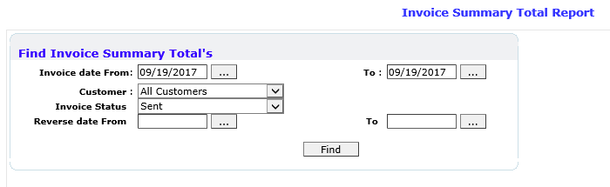

Select the particular date in “from” and “to” both. Select all customers in customer field. Invoice status Send. Finally click find.

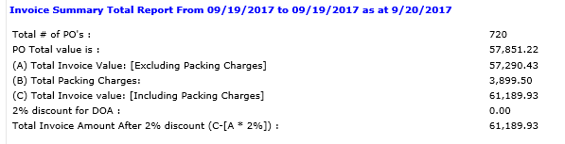

“Total Invoice Amount After 2% discount” is the relevant sale value for the day.

1. Accumulated Total Labor Dollars as of the current day.
2. Accumulated Weekly Overtime as of the day.
3. Number of packages Shipped

Log to ETF,

Shipping & Dispatching- Dispatch Report

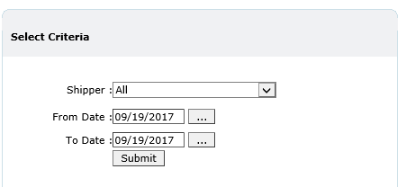After that you can reach Dispatch Report module.

Select Shipper as All. Then select relevant date also. Finally click submit.

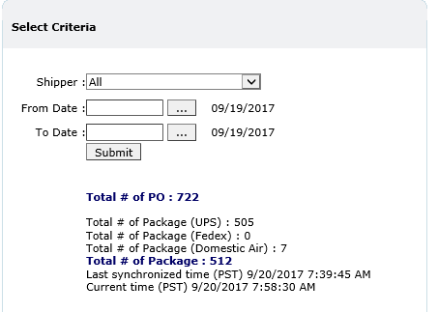

“Total # of Package” is the dispatch amount for the day.

1. Percentage of Overtime as of Total Labor Dollars for the Week.

Daily overtime cost against the accumulated labor cost as of the day.

1. Labor % Goal - Company expectations

Desired labor % as per the Sales vs Labor Matrix. Projected sales figure must be m with Matrix and update the relevant labor %.

1. Projected Sales Vs Labor for Whole Week

Percentage of accumulated projected labor against the accumulated projected sales as of the day.

1. Actual Sales Vs Labor as of Today

Percentage of accumulated Actual labor against the accumulated Actual sales as of the day.