**TEKNOWLEDGE SHARED SERVICES-SRI LANKA**

**OPR FOR ETF, COURIER SITE RECONCILIATION**

|  |  |
| --- | --- |
| SUBJECT | OPR FOR ETF, COURIER SITE RECONCILIATION |
| DEPARTMENT | PRODUCTION PLANNING |
| RECORDER | BUDDIKA MADURANGANA |
| APPROVED BY |  |
| CREATED DATE | 03/01/2016 |
| LAST UPDATED | 01/08/2018 |
| PATH ON NETWORK FOLDER |  |
| NO. OF PAGES INCLUDING THIS PAGE | 4 |

**OBJECTIVE**

To find out the Un-scanned POs while dispatching and manually update PO status as shipped.

Once the packing completed, box will be labeled, closed and scanned at dispatching station. Once the package is properly scanned ETF will recognize the relevant POs as shipped and change the Status as shipped. If the package is not properly scanned, ETF keep the PO as open and these POs can be planned again for the next days and make duplicate shipments. To avoid this, ETF Courier Site reconciliation must be done on every shipping day.

**PROCESS**

US shipping starts on Monday and continue up to Thursday. According to the time zone difference, ETF Courier Site reconciliation must be done on Tuesday to Friday morning SL time.

EOD process

1. IT starts the EOD process from Tuesday to Saturday at 10.15 SL time.
2. First they Void the POs and un-shipped POs will be voided.
3. Once the POs voided, IT will notify Prodmgt.
4. Now Production Management has to start ETF Courier Site reconciliation and find out the POs which were not scanned but shipped. List of the POs to be submitted to IT for manual update.
5. IT update the POs as shipped manually and start invoicing process.

ETF Courier Site reconciliation

1. Once the POs are voided, go to open PO report and get the all Open POs up to last Sunday.

EDI Details – Open PO report

<http://www.cisintl.com/ProductionMatrix/_OpenPOReport.aspx>

Select Open PO Report by PO Age

Customer 193-Petco Animal supplies

Select the date range (PO date to-last Sunday and PO date from-1 month back from last Sunday)

Select Export to Excel

Excel file will be generated,

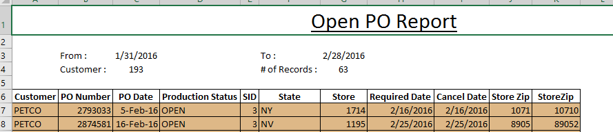

1. Remove the other columns and keep only the PO# column and save it on the desktop. Save the file as Excel 5.0/95 workbook.

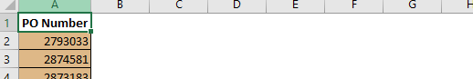

1. Log in to UPS account

<https://www.ups.com/one-to-one/login?returnto=https%3a//www.ups.com/myWorkspace/home%3floc%3den_US%26WT.svl%3dPriNav&reasonCode=-1>

Credentials

User Name: ssamarasinghe

Password: tropical

1. Go to Tracking. Select Quantum View Manage
2. Once the page loaded, click on Download as csv.
3. Open the file,

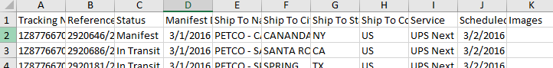

1. Cut & paste reference number column as a first column.
2. Select the column and Press Ctrl+H, and replace “|” with “/”
3. Add 7 more columns in between first and second column.
4. Select all Copy and paste in next sheet. Delete the first column & Select all, copy & past on next sheet.
5. Do this until you get 8 sheets
6. Save the file as Excel 5.0/95 workbook.
7. Open Open PO file and UPS file at once in same window.
8. Use VLOOKUP function on open PO file and fill the 8 columns with UPS details.

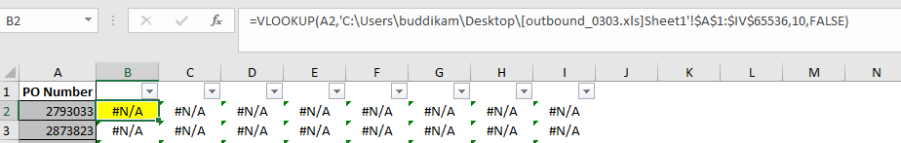

1. Once all the 8 column are updated, filter and find the In-Transit or Delivered POs
2. Copy and Paste all these In-Transit/Delivered POs to second sheet of Open PO list & remove duplicates.
3. Now you have the PO list which shipped but did not get scanned.
4. Use VLOOKUP again and get the tracking number and ship dates for UPS file.

Voided POs

Shipping & Dispatching- Void PO report

<http://www.cisintl.com/ProductionMatrix/VoidedPOReport.aspx>

Date range Yesterday date for both & get the list

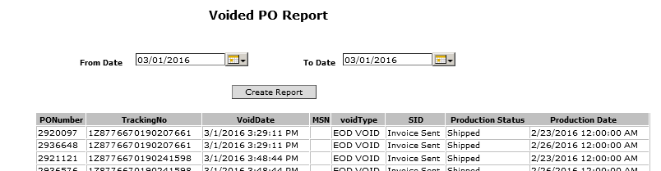

Get the PO list that un-scanned but shipped, get the PO list of voided from above and remove duplicate POs.

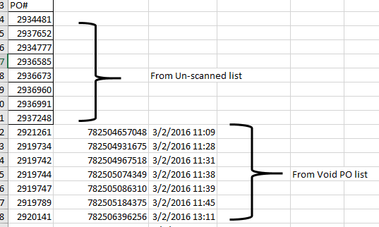

The remaining POs of Void report are already with tracking numbers and check these tracking numbers in UPS & FedEx tracking to check whether shipped or not. If the PO is shipped, include that PO to un-scanned but shipped list and submit IT to change the status.

UPS

<https://www.ups.com/WebTracking/track?loc=en_US&WT.svl=PNRO_L1>

FedEx

<https://www.fedex.com/apps/fedextrack/?action=track&cntry_code=us>

Email should be sent to IT Admin in below format.

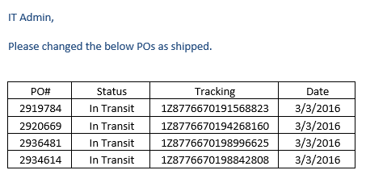

Process Flow Chart

Get Open PO report

Ship POs

Inform IT to change Status

Invoicing

Get UPS report

Reconciliation

Run EOD process &Void POs

Get Void PO report