**TEKNOWLEDGE SHARED SERVICES-SRI LANKA**

**OPR: CIS Pallet Forecast for UPS**

|  |  |
| --- | --- |
| SUBJECT | CIS Pallet Forecast for UPS |
| DEPARTMENT | PRODUCTION PLANNING |
| RECORDER | BUDDIKA MADURANGANA |
| APPROVED BY |  |
| CREATED DATE | 03/04/2016 |
| LAST UPDATED | 01/08/2018 |
| PATH ON NETWORK FOLDER |  |
| NO. OF PAGES INCLUDING THIS PAGE | 3 |

Objective

Need to submit the projected number of pallets required for the day to UPS on each shipping day.

Base on our requirement, UPS prepare their own plan.

Calculation

1. Once the production plan completed, take the summery of box requirement for the day Coast wise.

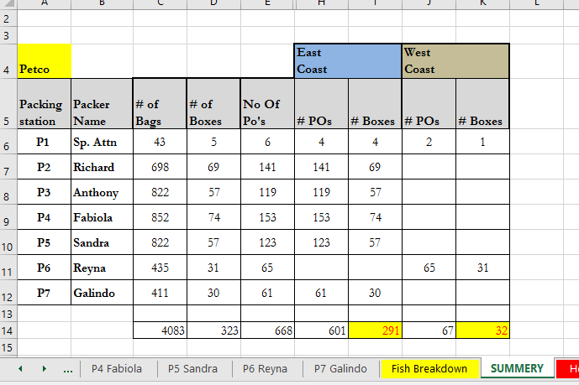

1. Base on the Grouped/Ungrouped POs planned for each coast, Box size projection to be done. While projecting, size of the POs to be considered. If the promos are available, Promo box type/number of Boxes are known and calculation to be made accordingly.
2. Approximate number of boxes can be stacked in one pallet,

A: 60

B: 45-50

C: 36

F: 24

Number of Pallets required = Number of boxes / No of boxes can be stacked

1. Once the projection is made,
2. Following format to be filled in email,

Subject: CIS VOLUME FORECAST (DAY) (Date)

UPS,

Here is the quantity of pallets shipping out today.

00        East coast pallet

00       West coast pallet

1. Ground pallet
2. Email recipients,

Laura Orozco <lorozco@ups.com>; Lorraine Liebsack <lliebsack@ups.com>; Leroy Ale <lale@ups.com>; jpinelo@ups.com; Jesus De Avila <jdeavila@ups.com>; jwilson2@ups.com; Johnny Scott <johnnyscott@ups.com>; erigby@ups.com; elazconiniguez@ups.com; Ama Gyima <agyima@ups.com>; alroldan@ups.com; pashcraftiii@ups.com; sxeubanks@ups.com; bryangarcia@ups.com; ajstevens@ups.com; [imorillo@ups.com](mailto:imorillo@ups.com)

Cc: Andy & Chris

**Process Flow Chart- Pallet Forecast**

Calculate Pallets

Daily Production Plan Completion

Inform UPS team

Number of Ground Pallets

Number of East Coast Pallets

Number of West Coast Pallets

Number of box as per Coast