**TEKNOWLEDGE SHARED SERVICES-SRI LANKA**

**OPR: HOLD POs of STORES and STATES**

|  |  |
| --- | --- |
| SUBJECT | HOLD POs of STORES and STATES |
| DEPARTMENT | PRODUCTION PLANNING |
| RECORDER | BUDDIKA MADURANGANA |
| APPROVED BY |  |
| CREATED DATE | 02/01/2015 |
| LAST UPDATED | 03/04/2016 |
| PATH ON NETWORK FOLDER |  |
| NO. OF PAGES INCLUDING THIS PAGE | 3 |

**Objective**

POs are required to be planned on particular production dates as per the customer request to reach these POs to the stores on desired dates of the customer. To hold a POs, following steps to be followed.

**Hold a store.**

Go to Production Planning & Packing – Hold Store from production

Link: <http://www.cisintl.com/HoldStores.aspx>

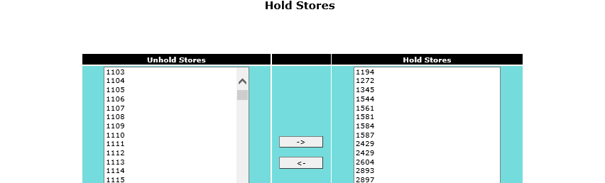

Required POs to be kept under Hold store category until the required production day. On the required Production date, the PO should be moved to un-hold PO category.

Once the PO is un-hold, it can be assigned to a nominated packer, who will handle special attention POs using production planner screen.

Go to: Production Planning Admin – Production planning new

Link: <http://www.cisintl.com/ProductionMatrix/ProductionPlanning_NEW.aspx>

Provide the store number and retrive Group/Ungroup POs seperatly and assined to the packer.

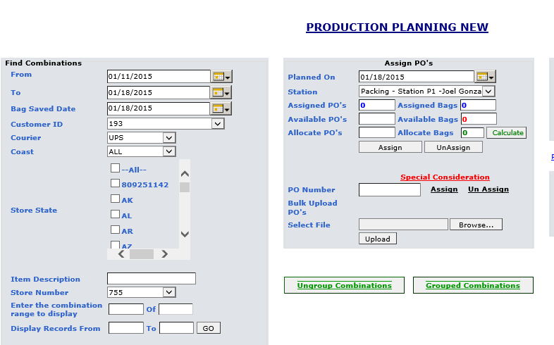

**Hold States**

If the POs of a perticular state to be shipped on a given day, the POs to be assigned under reserve packer daily until the required production day. On the required production day, the POs to be assigned to nominated packer who will handle special attention POs and highlight in the breakdown.

Tick State code and retrive Group/Ungroup POs seperatly and assined to the packer.

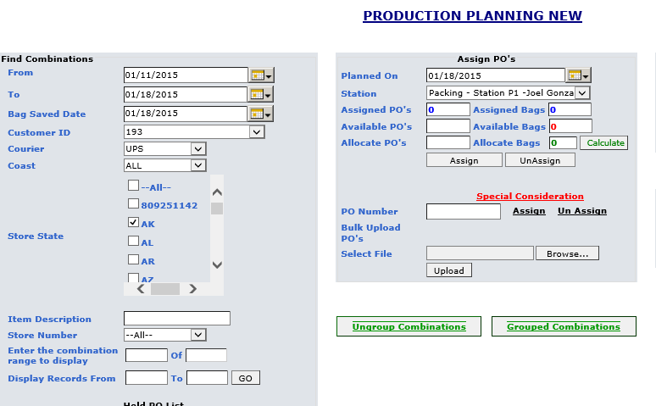

**Back Orders**

If any special attention POs is not shipped on the requested production day, The PO to be planned on the following day under special attention until it will be shipped. If any special attention PO is not shipped during the assigned production week, the POs will become back orders and need to plan all special attention back POs on Monday and notify warehouse management to ship them all.