**TEKNOWLEDGE SHARED SERVICES-SRI LANKA**

**OPR: CHECK PROMO LABLE PRINTING POSSIBILITIES**

|  |  |
| --- | --- |
| SUBJECT | CHECK PROMO LABLE PRINTING POSSIBILITIES |
| DEPARTMENT | PRODUCTION PLANNING |
| RECORDER | BUDDIKA MADURANGANA |
| APPROVED BY |  |
| CREATED DATE | 03/04/2016 |
| LAST UPDATED | 01/08/2018 |
| PATH ON NETWORK FOLDER |  |
| NO. OF PAGES INCLUDING THIS PAGE | 2 |

**Objective**

Need to make sure the Labels of Promotional POs can be printed without any discrepancy. This will avoid production interruptions once the Promo POs are planned ship.

**Process**

1. Need to check the promo calendar on ETF & get the planned promo details for coming week on Thursday.

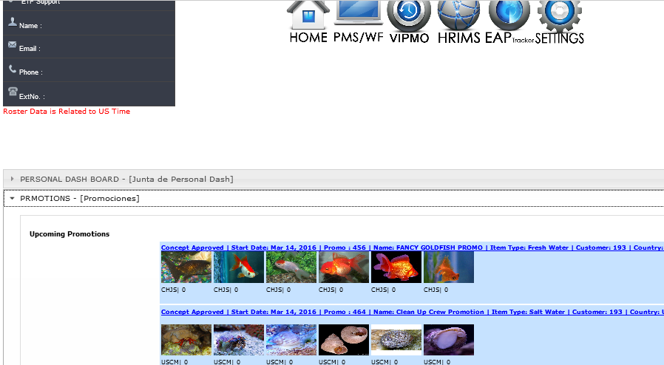

1. Check POs are received for the Promo on Thursday.
2. Create MPO for one PO from each promo

EDI Details-

Put the PO number on search PO

Select the PO once it loaded

Go to manual update panel and create MPO

1. Assign the PO under reserve packing station (Please refer Production Planning OPR if required)
2. Save bags
3. Inform IT with below details to check the label printing possibilities.
4. PO#
5. Assigned station
6. Items and quantities

Process Flow Chart

Inform IT to check the item availability and Label printing possibility

Receive the Promo POs

Assign to test packer

Bag saving & assignment