**TEKNOWLEDGE SHARED SERVICES-SRI LANKA**

**OPR FOR CUSTOMER#292 PRODUCTION MONITORING**

|  |  |
| --- | --- |
| SUBJECT | OPR FOR CUSTOMER#292 PRODUCTION PLAN |
| DEPARTMENT | PRODUCTION PLANNING |
| RECORDER | BUDDIKA MADURANGANA |
| APPROVED BY |  |
| CREATED DATE | 06/17/2019 |
| LAST UPDATED |  |
| PATH ON NETWORK FOLDER |  |
| NO. OF PAGES INCLUDING THIS PAGE | 4 |

**OBJECTIVE**

To complete 292 production as scheduled and drop the packages to the assigned Airline before the cutoff time.

**PROCESS OVERVIEW**

1. Production Planning
2. Production plans are prepared for 292 based on the customer requirements. Customer#292 has specified the delivery dates for each DC.
3. Re-bagging

All items for DC39, Veiltail male for all DCs, Platinum for all DCs are currently re-bag prior to ship

Relevant re-bagging is schedule one day prior to shipping day.

Production planning provide the quantity details to Team Leads via email. This include cut off times and production sequence.

1. Prepared production plan is sent to the Team Lead, QA & WHMgt on shipping day.
2. Packing alignment will be done based on the shipment Cut off times and advise team leads.
3. Driver Box loading sheet and Team Lead check list will be sent along with the plan.

|  |  |  |  |  |  |
| --- | --- | --- | --- | --- | --- |
| DC# | Packing Day | Shipping day | Cut Off | Delivery Day | Comments |
| DC 23 | Friday | Saturday | 9AM | Sunday |  |
| DC 39 | Saturday | Saturday | 1PM | Sunday | Non-Veiltail Schedule |
| DC 40 | Saturday | Saturday | 5PM | Sunday |  |
| DC 08 | Sunday | Sunday | 3PM | Monday |  |
| DC 42 | Sunday | Sunday | 3PM | Monday |  |
| DC 39 | Monday | Monday | 3PM | Tuesday | Veiltail Schedule |

Note: Cut off time can be varied from time to time. Need to check weekly Cut off time sheet from Logistic

1. Labor Planning
2. Labor for 292 activities are included to weekly schedule according to the PO quantities
3. Time and task are planned to meet production plan and the customer requirement.
4. Skilled labor will be used for each task
5. All the tasks are included in individual maps.
6. Logistic
7. Air line bookings are done based on box quantity for each DC
8. Get the approval from Business Manager for above
9. Send the Aire line details to Customer, Production and WH.
10. Send the actual tracking details once shipped
11. Follow up and mediate on delays and advise the concern parties.

**292 PRODUCTION MONITORING**

1. Refer the weekly labor schedule/Production Tracker to understand the 292 activities for the week.
2. Refer the 292 SHIPPING CUT OFF TIMES BY DC which is prepared by Logistic to get the cut off time for each DC
3. Aware of options if there any delay- for all DCs, All Airlines

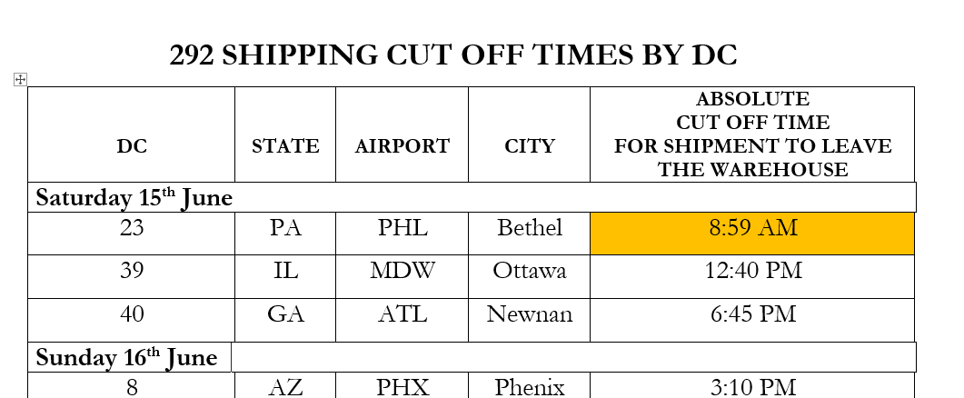

1. Review the 292 Production plan and Production instruction prepared by Production Planner. If anything is not clear, need to contact the Planner and clarify
2. Check the daily labor allocation and compare with the actual attendance
3. Communicate with the team leads regarding absent labor,
4. Evaluate the impact of absent labor
5. Possibility of getting support from labors which allocated for another task.
6. Communicate with unplanned labor and bring them in.
7. Communicate the issues with Production & Labor planners and get further advice.
8. Update WHMgt, ProdMgt, LaborMgt regarding changes made.
9. Closely Monitor production over CCTV and communicate with Team leads regarding production
10. Get and hourly update,
11. Currently this update to be taken from team leads, once bag scanning is started this info can be taken from system
12. As per the given sequence and cut off times, bags must be ready
13. Evaluate remaining time and production remainder
14. Determine the possible delay and confirm with Team leads
15. Look for the available option to avoid delay
16. Use additional Labor if available (Labor assigned for other tasks or unplanned labor bring in depend on the time availability)

Maintain contact details of labor who can be brought in emergency.

1. Get the labor whose assigned for the other DCs which needed to be dropped later
2. Possibility of using different stock
3. Review the quality concerns and get advice from QA team
4. If the delay can be avoided with one of above, advise team leads, provide update via email.
5. If the delay cannot be avoided,
6. Find out the exact reason that delays the production
7. Estimate the possible delay (time)
8. Check with logistic regarding the impact
9. Request Logistic to make new booking or change booking if necessary
10. Update HOD and Planner
11. Update WHMgt
12. All info to be provided such as Estimated delay, Reason to delay, Corrective action, New booking details
13. Team leaders, Drivers and Labor must be notified regarding the change and follow up for the completion
14. Document the incident in below format.

|  |  |  |  |  |  |  |
| --- | --- | --- | --- | --- | --- | --- |
| **INCIDENT REPORT-292 PRODUCTION** | | | | | | |
|  |  |  |  |  |  |  |
|  | Production date: |  |  |  |  |  |
|  |  |  |  |  |  |  |
|  | Prepared By: |  |  |  |  |  |
|  |  |  |  |  |  |  |
| **SR#** | **Affected DC# & PO#** | **Incident in details** | **Affected duration/Delay** | **Corrective Action** | **Information Provided to** | **Comments** |
|  |  |  |  |  |  |  |
|  |  |  |  |  |  |  |
|  |  |  |  |  |  |  |
|  |  |  |  |  |  |  |
|  |  |  |  |  |  |  |

1. Incident report must be sent to Warehouse Management, Production & Labor Management, Accounts Manager, Admin Manager and Logistic on same day.
2. Incident to be discussed by above parties and preventive action to be taken to avoid same in future.

