**TEKNOWLEDGE SHARED SERVICES-SRI LANKA**

**OPR: ONTIME SHIPPING & ORDER FILL RATE #193**

|  |  |
| --- | --- |
| SUBJECT | ONTIME SHIPPING & ORDER FILL RATE #193 |
| DEPARTMENT | PRODUCTION PLANNING |
| RECORDER | BUDDIKA MADURANGANA |
| APPROVED BY |  |
| CREATED DATE | 12/11/2018 |
| LAST UPDATED | 01/04/2019 |
| PATH ON NETWORK FOLDER |  |
| NO. OF PAGES INCLUDING THIS PAGE | 6 |

**OBJECTIVE**

To have an accurate Ontime Shipping & Fill rate details for each individual item shipped during a single production week.

**REPORT FORMAT**

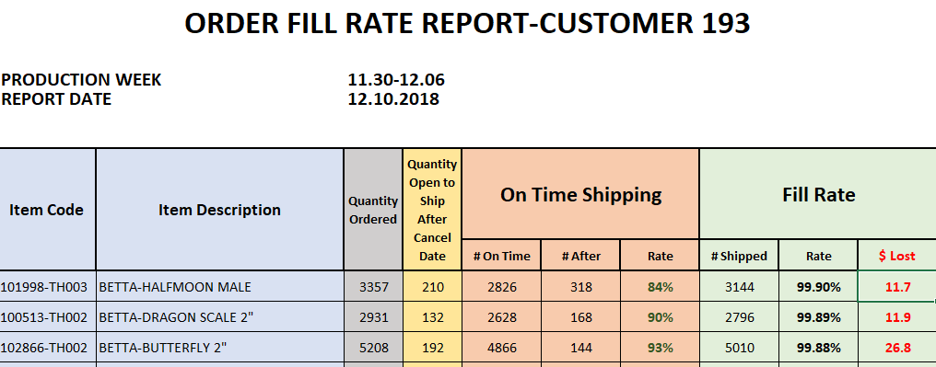

**DEFINITIONS**

**ONTIME SHIPPING**

If the PO is shipped before it’s canceled date, the shipped items of that PO are categorized as on time shipped items.

**ORDER FILL RATE**

Percentage of Actual shipped items quantity against the original PO item quantity that shipped during the production week. Fill rate is calculated item wise.

**SHIPPING WEEK**

Shipping week is from Friday to Thursday.

**DEFINITION OF REPORT CONTENTS**

1. Quantity Ordered

This is the quantity available to ship for the production week and below detail are required to gather on every **Friday morning SL time after EOD process** (US time Thursday after EOD). This is to prepare Ontime/Fill rate report for the week ending Thursday (yesterday).

To get the quantity Ordered,

1. Open Orders (Qty)-

Open PO report to be run up to Last Saturday and start date must be selected 3 weeks backward from last Saturday. Generate Report option to be used and copy the data to Excel once loaded on ETF. Need to take open POs with Cancel date up to next Monday. Next Tuesday or beyond to be excluded since still we have a chance to ship these POs.

1. Shipped POs (PO Qty)-Original PO item Quantity of Shipped POs

There are two ways to get this info,

1. ETF shipped Quantity report-

ETF-EDI Details-Shipped Quantity report

Date range last Friday to Thursday (yesterday)

Need to get the Total PO quantity

1. ETF dispatch detail report must be run from Last Friday to Thursday (Yesterday) and it will provide PO/Item details which shipped during the week. This include back POs, Current week POs and New week POs which shipped during the week.

Note: Need to take Original PO quantity of the shipped POs (Not the shipped quantity)

Quantity ordered is a cumulative quantity of above two reports.

**Quantity Ordered = QTY of Open Orders (Cancel date up to next Monday) + PO QTY of Shipped Orders during week**

1. Quantity Open to Ship After Cancel Date

This details must be taken same way as above mentioned to get Open order details, but after weekly PO cancelation (if any). Key Accounts Manager review Open Order after every production week and inform Customer to cancel the POs based on aging.

Weekly PO cancelation information are received on Friday night SL time and it is required to get this information once IT cancelled the POs as advised in the list.

1. Ontime Shipping

Items of the POs which shipped during the shipping week and before it’s Cancel date to be considered as Ontime shipped PO.

1. After Shipping

Items of the POs which shipped during the week and after it’s Cancel date to be considered as After shipped PO.

1. Rate

Percentage of Ontime shipped POs against the Quantity Ordered (As defined by above)

1. Fill Rate

Fill Rate= Total quantity shipped/ (Qty ordered - Qty Open to ship after cancel date)

1. Lost

Lost is the deficit of the item qtys in $. These are the items cancelled.

**(Quantity Ordered - Quantity open to ship after Cancel date - Total shipped) X item Value= Lost $**

REPORT DATA

1. Quantity Ordered
2. Open Orders

Open PO report to be run up to Last Saturday and start date must be selected 3 weeks backward from last Saturday. Generate Report option to be used and copy the data to Excel once loaded on ETF. Need to take open POs with Cancel date up to next Monday. Tuesday or beyond to be excluded since still we have a chance to ship these POs.

ETF- EDI Details-Open PO report

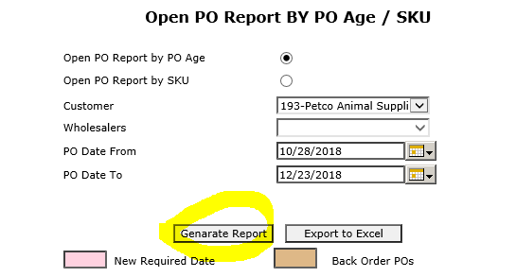

1. Way to get Shipped PO details (two options)
2. ETF shipped Quantity report-

ETF-EDI Details-Shipped Quantity report

Date range last Friday to Thursday (yesterday)

Need to get the Total PO quantity

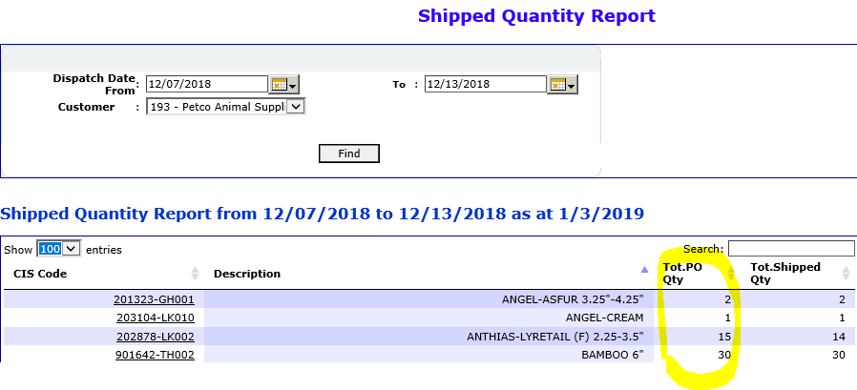

1. ETF- EDI Details-Open PO report-Dispatch details

Provide the shipping week start date and end date on the pop up. & Export to Excel.

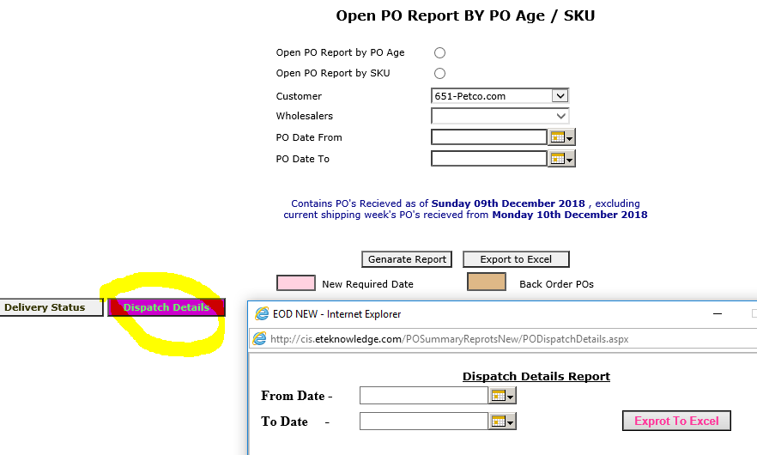

Open the Excel and remove the duplicate of PO# & Item Description at once.

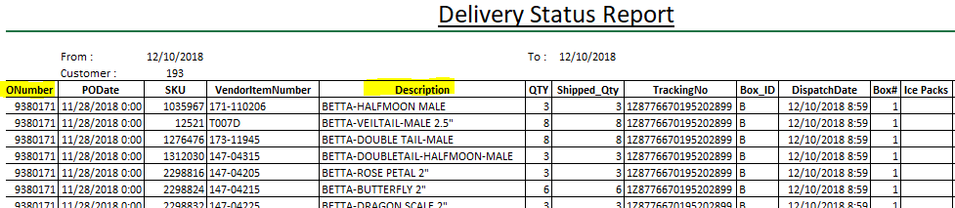

Add new column to the excel and add the cancel date for each PO. VLOOKUP has to be used and cancel dates can be taken from OPEN PO reports which taken at the beginning of the week.

To get the total shipped item quantities, use PIVOT table and get the summary on Description and Shipped quantity.

1. Combine above Summary and Back order report to get QUANTITY ORDERED. PIVOT table can be used.
2. Quantity Open to Ship After Cancel Date

Details to be taken on **Sunday** and Before getting this report,

Check any PO Cancel request was sent to IT and cancelation done.

If the cancelation was not done, it must be done prior to get the details

ETF- EDI Details-Open PO report

Select Open PO Report by Age

Customer#193

Date Range- PO date to (Last Saturday), PO Date From (3 weeks backward from last Saturday)

Generate Report

Copy Data to Excel

Select only the POs with Cancel date passed.

Apply PIVOT table for Item & Quantity

This is the Item Quantities Open After Cancel Dates

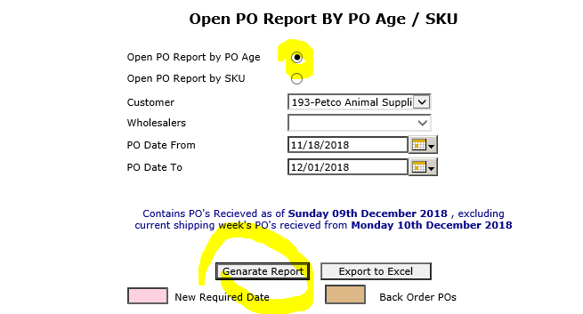

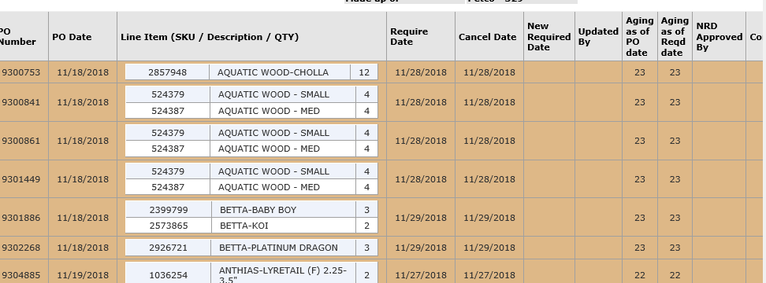

1. Ontime Shipping & Rate

Get the Excel file which made for #1, after applying the Cancel dates, Filter for POs shipped before the Cancel date, apply PIVOT and get the summary of Ontime shipped quantities

Rate= Ontime shipped quantity/Quantity Ordered X 100

1. After Shipping

Get the Excel file which made for #1, after applying the Cancel dates, Filter for POs shipped After the Cancel date, apply PIVOT and get the summary of Ontime shipped quantities

1. Fill Rate

#Shipped- Total quantity shipped (Ontime + After)

Rate: Total Shipped Quantity/(Quantity Ordered-Qty Open after Cancel) X 100

1. Lost $

**(Quantity Ordered - Quantity open to ship after Cancel date - Total shipped) X item Value= Lost $**

Item Value- To be taken from PO Summary Report by dividing Values from Quantities.

ETF-EDI Details-PO Summary Report