|  |  |
| --- | --- |
| **SUBJECT** | OPR for Creating Purchase Orders in ETF |
| **DEPARTMENT** | Marketing – Order Entry |
| **RECORDER (Name Designation)** | Ravihari Punchihewa : Executive - Order Entry |
| **APPROVED BY (Name Designation)** |  |
| **LAST UPDATE** | 07/07/2016 |
| **PATH ON NETWORK FOLDER** |  |
| **NO. OF PAGES INCLUDING THIS PAGE** | 5 |

**Step 1**:

Go to Sales and customer Management and Select “View enter sales order”

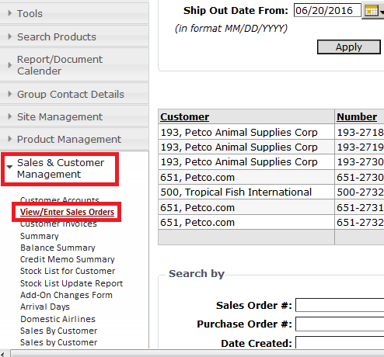

**Step 2:**

Click on to “Enter new Sales Order” icon to enter new sales order

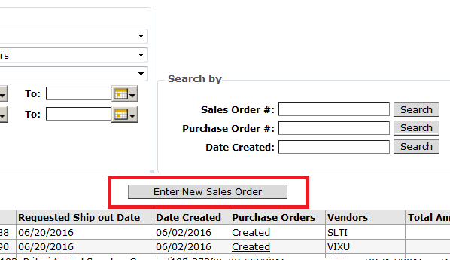

**Step 3:**

Fill below with relevant details

1. Customer: Select customer from drop down list
2. Requested ship out date to customer: select the date from calendar
3. CIS Item Code: Put CIS code and click “Look Up” icon and select item code
4. Total Qty: Put total qty in text box
5. Click “Add Item” icon

IMPORTANT:

* 1. Double check the basic criteria when placing the orders - Scientific Name
  2. Double check the basic criteria when placing the orders - Fulfilment history of the Livestock item
  3. Double check the basic criteria when placing the orders - Price paid on previous occasions
  4. Double check the basic criteria when placing the orders - .For a given item, grade the existing vendor list (of aprox of 100-125 vendors) in to ‘Primary’, ‘Secondary A’ and ‘Secondary B’ categories.

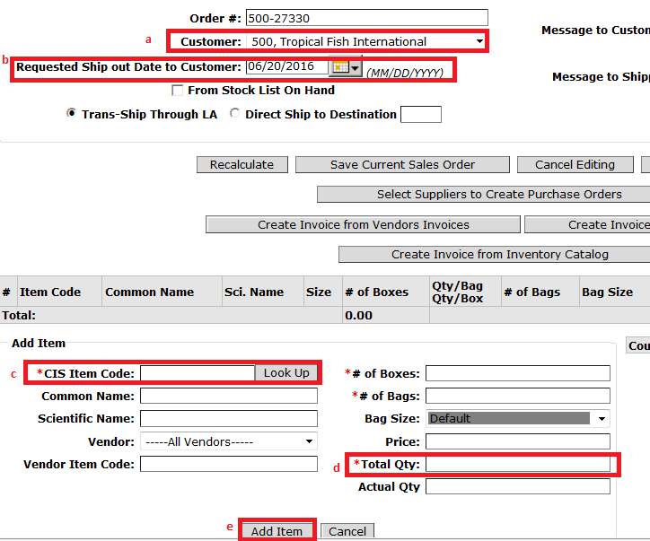

**Step 4**:

Once you add the item, screen will appeared as below

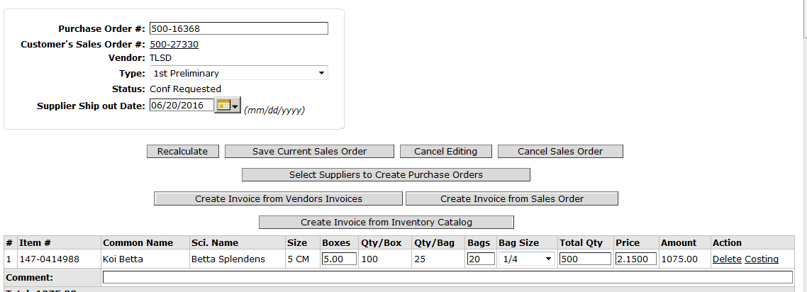

**Step 5:**

After entering all items, click “Select supplier to create purchase order”

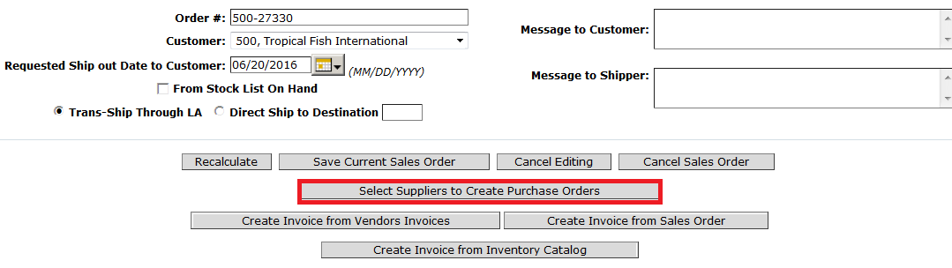

**Step 6:**

Once you get below screen, select the ship out date from calendar and Select create first preliminary order

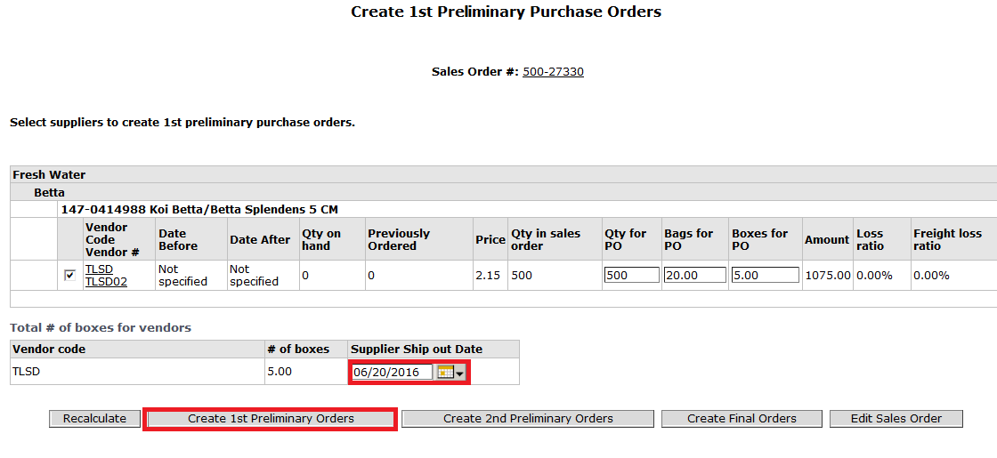

**Step 7:**

If you want to add new items to the PO or edit PO details , select “created” icon

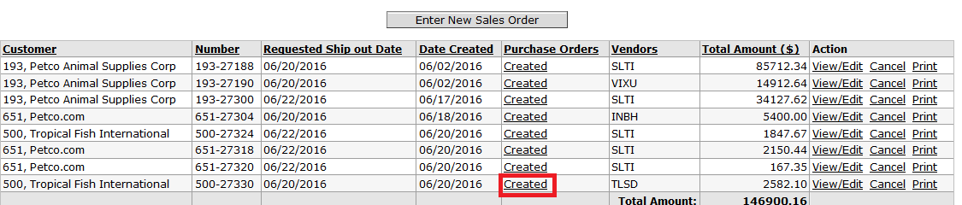

**Step 8:**

Follow the same steps and click “Save Order” after editing.