**OPR for Update Shipment Planner in ETF.**

|  |  |
| --- | --- |
| **SUBJECT** | OPR for Update Shipment Planner in ETF. |
| **DEPARTMENT** | Marketing – Order Entry |
| **RECORDER (Name Designation)** | Pasindu Ranathunga – Marketing-Assistant |
| **APPROVED BY (Name Designation)** |  |
| **LAST UPDATE** | 07/07/2016 |
| **PATH ON NETWORK FOLDER** |  |
| **NO. OF PAGES INCLUDING THIS**  **PAGE** | 08 |

**Process Record for Updating Monthly Shipment Planner**

1. Login to ETF
2. Go to Purchasing and Supplier Management -> Monthly Shipment Planner
3. Select:
   1. Week: All weeks for the whole month
   2. Month
   3. Year

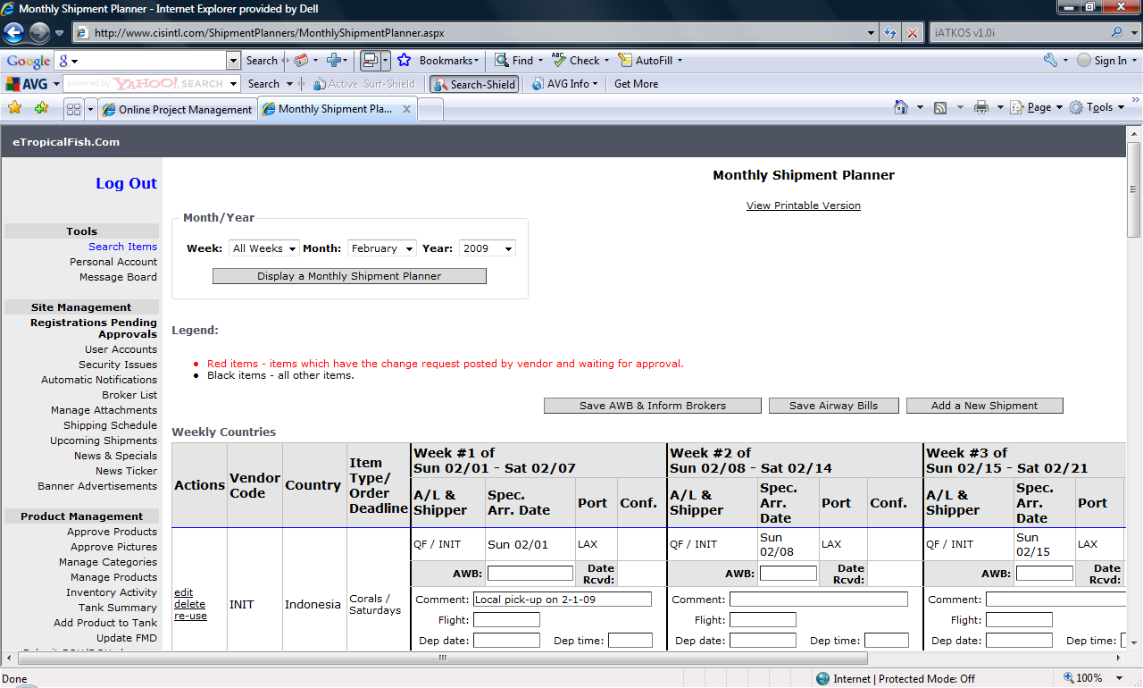

1. Check if the Vendor is included on the Shipment Planner
2. Select the week for which the shipment is arriving on. Check whether the Specified Arrival Date is on the planner. For weekly shipments that are arriving on the same date every week, this might be setup.
3. Enter:
   1. AWB
   2. Date Received
   3. Comment
   4. Flight
   5. Dep. Date
   6. Dep. Time
   7. Arrival Time
   8. Boxes Booked

You can get this info from the AWB mailed by the vendor.

1. Select Save AWB and Inform Brokers or Save AWB.

Adding a new Shipment

1. Select Add a New Shipment

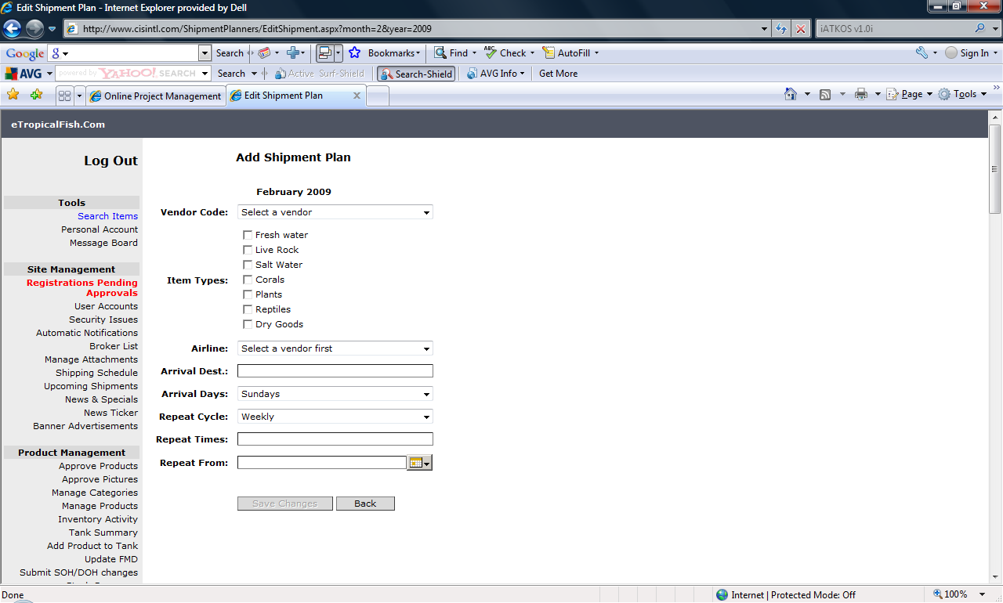

1. Enter the following Info:
   1. Select Vendor Code
   2. Select Item Types
   3. Select Airline
   4. Select Arrival Destination
   5. Select Arrival Days
   6. Select Repeat Cycle. Based on the selection made here the vendor will appear either once, bi-weekly or just on the date specified on the Monthly Planner.
   7. Enter Repeat Times
   8. Select the date the cycle should start
   9. Select Save Changes
2. The newly added shipment should appear on the Monthly Shipment Planner, from the specified start date.