**TEKNOWLEDGE SHARED SERVICES-SRI LANKA**

**OPR PROMO FILL RATE REPORT**

|  |  |
| --- | --- |
| SUBJECT | OPR for Promo Fill Rate Report |
| DEPARTMENT | Marketing |
| RECORDER | Manjula Dissanayaka |
| APPROVED BY |  |
| CREATED DATE | 07/07/2019 |
| LAST UPDATED | 07/07/2019 |
| PATH ON NETWORK FOLDER |  |
| NO. OF PAGES INCLUDING THIS PAGE | 2 |

Objective

Customer expected Fill rate is 100% and need to have a detailed report which provide individual item fill rate on every Promotion.

While preparing the Prom Fill rate, we have to consider

1. PO week- Sunday to Saturday
2. Shipping week- Friday to Thursday

**Preparation of Promo Fill Rate Report**

1. Get the promo Items from Prom Status Report for the particular time



1. Get the shipped quantity details



1. Get remaining item details by referring bellow format

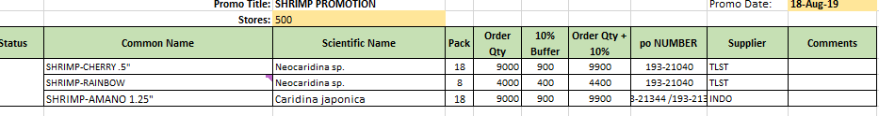

1. Fill the bellow Promo Fill rate report by using promo status report for the particular week.

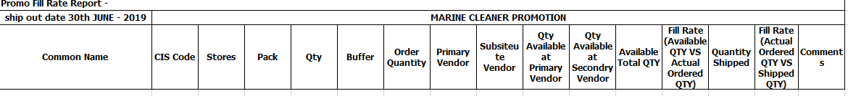

1. Update each items with,
2. Received quantity & total value and Individual value
3. Shipped quantity for each item
4. Remaining quantity for each item
5. This information to be filled in above format and send the report on every Friday .