|  |  |
| --- | --- |
| SUBJECT | OPR for Checking Shipment Planer & Packing Lays Update |
| DEPARTMENT | Sales, Marketing & sourcing |
| RECORDER (Name & Designation) | Manjula Dissanayakae-Assistant Manager Sales & Procurement |
| APPROVEDBY (Name & Designation) |  |
| CREATED DATE | 01/06/2019 |
| LAST UPDATED | 01/06/2019 |
| PATH ON NETWORK FOLDER |  |
| NO. OF PAGES INCLUDING THIS PAGE | 1 |

1. Introduction.

This OPR has been prepared providing guidelines Checking Shipment Planer & Packing Lays Update . This will provide the necessary guidance for staff for the same

1. Shipment Planer Format -Every day 2 times auto created email will received as bellow

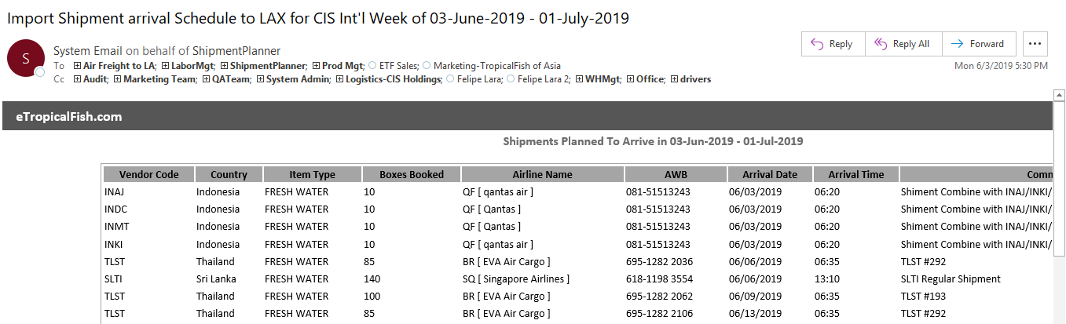

1. Step

Check All the shipment has updated according to pre planed with all the shipment (AWB, No of Boxes, Arrival Time, Arrival Date)

1. Step

Find & update if any found which are not in Shipment Planer

1. Log to ETF
2. Purchasing & Supplier Management
3. Shipment Feedback new
4. Select Vendor as required
5. Enter the date range you required
6. Search
7. Result will be showing as “VIEW SHIPMENT FEED BACK “
8. It Means Packing Layers created in ETF for Specific Shipment
9. 