|  |  |
| --- | --- |
| SUBJECT | OPR for Per Shipment Audit Review Report |
| DEPARTMENT | Sales, Marketing & sourcing |
| RECORDER (Name & Designation) | Manjula Dissanayake– Assistant Manager Sales & Procurement |
| APPROVEDBY (Name & Designation) |  |
| CREATED DATE | 03/06/2019 |
| LAST UPDATED | 03/06/2019 |
| PATH ON NETWORK FOLDER |  |
| NO. OF PAGES INCLUDING THIS PAGE | 1 |

1. Introduction.

This OPR has been prepared providing guidelines Per Shipment Audit Review Report. This will provide the necessary guidance for staff Per Shipment Audit Review Report

1. Per Shipment Audit Review Report Format (Which will be Filling & sending By TLST -Sophie each & every shipment wise )

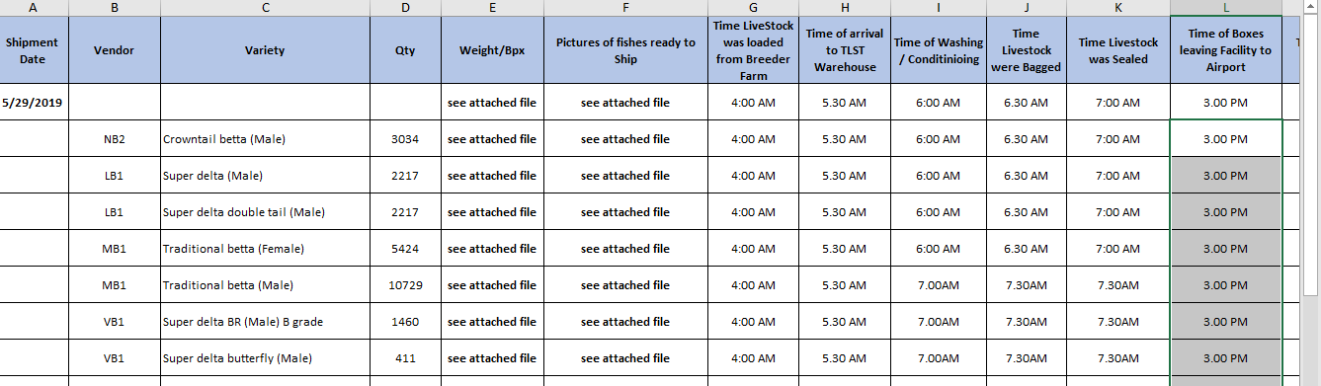

2.1. Above & below both report will be sending By Sophie to Marketing & Marketing to review & Send to Logistics for ETF Uploading 