|  |  |
| --- | --- |
| SUBJECT | OPR for Forecasted Fill Rate Report |
| DEPARTMENT | Sales, Marketing & sourcing |
| RECORDER (Name & Designation) | Manjula Dissanayaka |
| APPROVEDBY (Name & Designation) |  |
| CREATED DATE | 07/07/2019 |
| LAST UPDATED | 07/07/2019 |
| PATH ON NETWORK FOLDER |  |
| NO. OF PAGES INCLUDING THIS PAGE | 2 |

1. Introduction.

This OPR has been prepared providing guidelines for Forecasted Fill Rate Report. This will provide the necessary guidance for staff Forecasted Fill Rate Report

1. Forecasted Fill Rate Report format as bellow

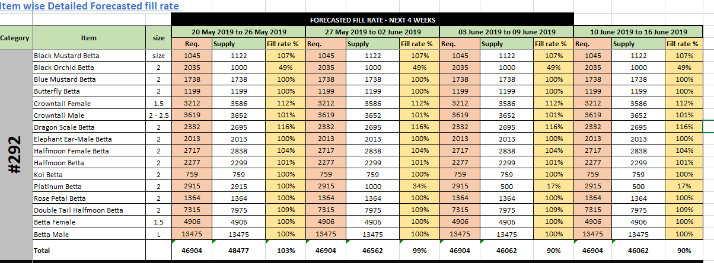

03. Send Bellow format to TLST for Forecasted Availability on every Friday for 4 Weeks Time & average Requirement to be get from ETF (PO Summary report for last for week time & average it -TOTAL Qty for last four Week/Divided by no of weeks 04)

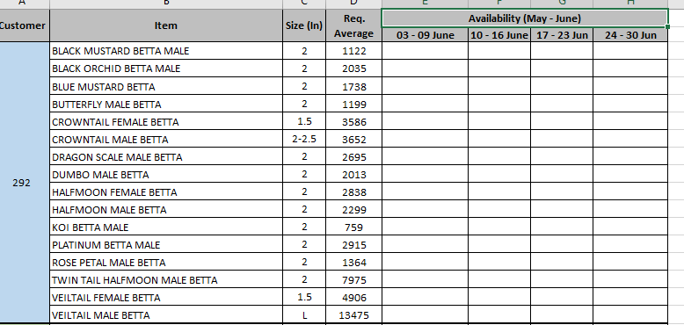

04.Fill out the figures received by TLST to Frist Format which was given on the top of the OPR

05.Updating the Report to ETF on every Monday & bellow Steps to be followed in order to get the work don

06.Log ETF -Report Document/Calder -Select the date s Monday-Attached the Report

-click on send mail button.