|  |  |
| --- | --- |
| SUBJECT | OPR for Update meeting minutes |
| DEPARTMENT | Sales, Marketing & sourcing |
| RECORDER (Name & Designation) | Buddhima Kaveesha – Data Analyst Sales |
| APPROVEDBY (Name & Designation) |  |
| CREATED DATE | 02/10/2016 |
| LAST UPDATED | 02/10/2016 |
| PATH ON NETWORK FOLDER |  |
| NO. OF PAGES INCLUDING THIS PAGE | 1 |

1. Introduction.

This OPR has been prepared providing guidelines Meeting Minutes. This will provide the necessary guidance for staff Update Meeting Minutes

1. Meeting Minutes format

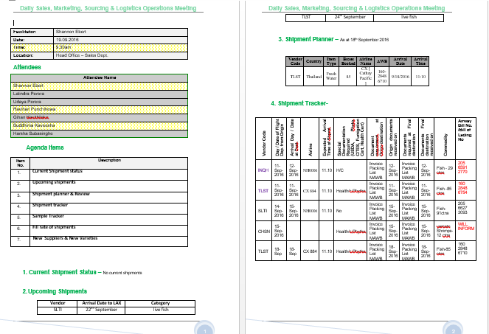

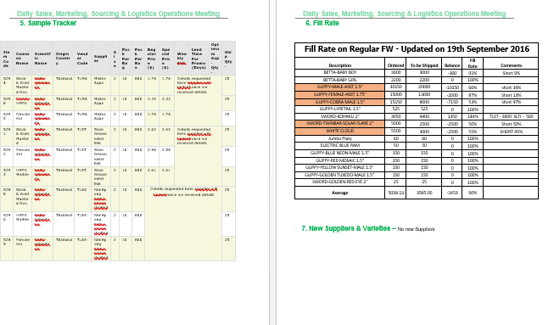

1. Step

Meeting Minutes must include these Agenda Points,

|  |  |
| --- | --- |
| **Item No.** | **Description** |
|  | **Current Shipment status** |
|  | **Upcoming shipments** |
|  | **Shipment planner & Review** |
|  | **Shipment tracker** |
|  | **Sample Tracker** |
|  | **Fill rate of shipments** |
|  | **N New Suppliers & New Varieties** |

Every details get from Morning meeting,

Current Shipment status & Upcoming shipment details: from Logistic Department

Shipment planner & Review: From Monthly Shipment Planner

Shipment tracker: From Logistic Shipment Clearance Tracker

Sample Tracker: Manage Sample Items in ETF

Fill rate of shipments: Details get from SL Farm

New Suppliers & New Varieties: Get from Sourcing Manager