|  |  |
| --- | --- |
| **SUBJECT** | OPR for Sending 4 weeks forcasted report of #193 FW items to SL Farm |
| **DEPARTMENT** | Marketing – Order Entry |
| **RECORDER (Name Designation)** | Ravihari Punchihewa : Executive - Order Entry |
| **APPROVED BY (Name Designation)** |  |
| **LAST UPDATE** | 07/07/2016 |
| **PATH ON NETWORK FOLDER** |  |
| **NO. OF PAGES INCLUDING THIS PAGE** | 2 |

**Purpose**: forecast order quantities for one month. Thereby Farms can meet 100% fill rate for each regular item.

**Report day**: Sri Lanka- Fresh Water- Monday

**Step 1:**Go to EDI details and take PO summary for 5 weeks back

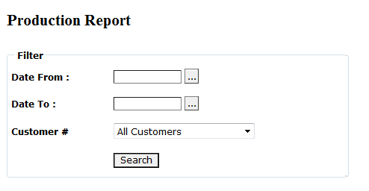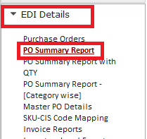

**Step 2:** Calculate average for five weeks

|  |  |  |  |  |  |  |  |
| --- | --- | --- | --- | --- | --- | --- | --- |
| **CIS Code** | **Common Name** | **Total Order from PO summary** | | | | | **Average** |
| **Week 5** | **Week 4** | **Week 3** | **Week 2** | **Week 1** |
| **May16-22** | **MAy23-29** | May 30-June 5 | May6-12 | May 13-19 |
| 811-041458 | BETTA-BABY BOY | 3792 | 1428 | 3084 | 1962 | 2100 | 2473.2 |

**Step 3:** Add buffer % and calculate final round up quantities

|  |  |  |  |
| --- | --- | --- | --- |
| **Buffer %** | **Buffer** | **Total Qty** | **Final Qty** |
|
|
| 8% | 2671.06 | 2671.06 | 2672.00 |

**Step 4:** Include the calculated values in excel format

**Step 5:** multiply the final qty by 2 except betta & then send it to farm

|  |  |  |  |  |  |  |  |
| --- | --- | --- | --- | --- | --- | --- | --- |
| **Monthly Forecast of Order Quantities for Regular 193 Fresh Water Items - SL Farm- July** | | | | | | | |
| **Order #** | **CIS code** | **Common Name** | **Scientific Name** | **Order Quantity** | | | |
| **6th July** | **13th July** | **20th July** | **27th July** |
| 193 | 111-041471 | BETTA-BABY BOY | Betta splendens | 2000 | 2000 | 2000 | 2000 |
| 193 | 111-041481 | BETTA-BABY GIRL | Betta splendens | 1500 | 1500 | 1500 | 1500 |