|  |  |
| --- | --- |
| **SUBJECT** | OPR for Sending Final order of #193 for current week - TLST |
| **DEPARTMENT** | Marketing – Order Entry |
| **RECORDER (Name Designation)** | Ravihari Punchihewa : Executive - Order Entry |
| **APPROVED BY (Name Designation)** |  |
| **LAST UPDATE** | 11/02/2019 |
| **PATH ON NETWORK FOLDER** |  |
| **NO. OF PAGES INCLUDING THIS PAGE** |  |

**Report day**: Thailand Preliminary order – Tuesday or Wednesday

Steps:

1. Get the current shippable quantity from Betta inventory (Maria or Fabiola’s) & paste it on “Shippable QTY on WED” column

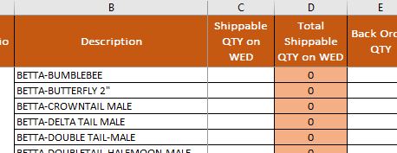

1. Get the Back order from ETF
   1. Go to ETF > Back order report under EDI details > select the date range & search

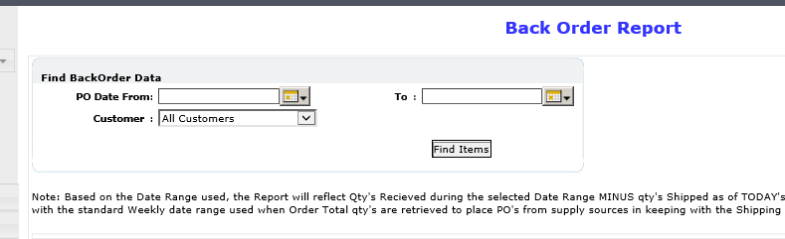

1. Then paste it on “Back Order QTY” column

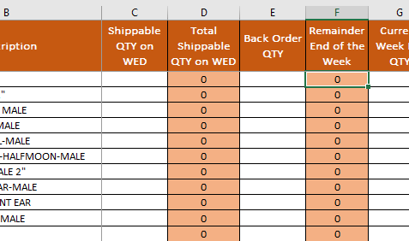

1. Get the current week requirement from ETF & paste it on “Current Week PO QTY” column

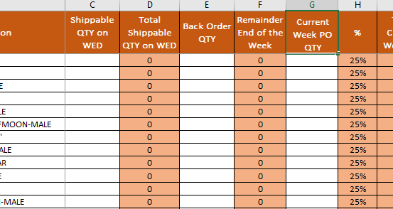

1. Then send the final quantity to Thailand farm