|  |  |
| --- | --- |
| **SUBJECT** | OPR for Creating preliminary order of #193 FW for SLTI |
| **DEPARTMENT** | Marketing – Order Entry |
| **RECORDER (Name Designation)** | Ravihari Punchihewa : Executive - Sourcing |
| **APPROVED BY (Name Designation)** |  |
| **LAST UPDATE** | 11/02/2019 |
| **PATH ON NETWORK FOLDER** |  |
| **NO. OF PAGES INCLUDING THIS PAGE** |  |

**Purpose**: To collect the fishes well in advance for coming week order.

**Report day**: Sri Lanka primary order- Monday

Sri Lanka final order- Friday

**Step 1: Get the shippable qty from Inventory & paste it on “Inventory on Monday” Column**

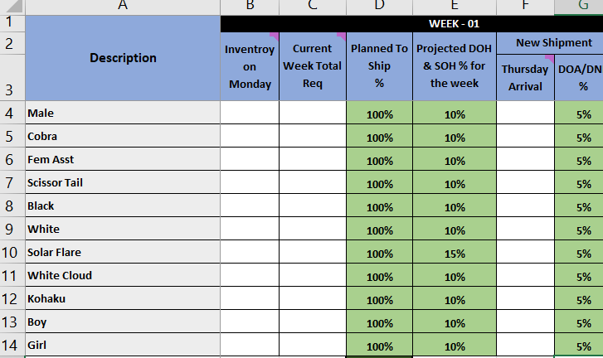

**2. Get the projected requirement from Thursday tracker (production department) & paste it on “NXT Week Total Req” column**

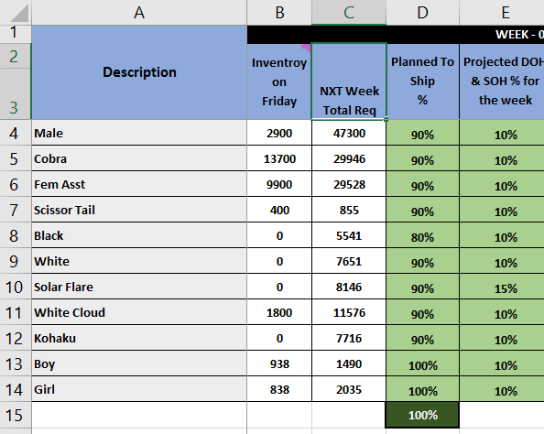

**3. paste the next Wednesday shipment quantity on “Thursday Arrival” column**

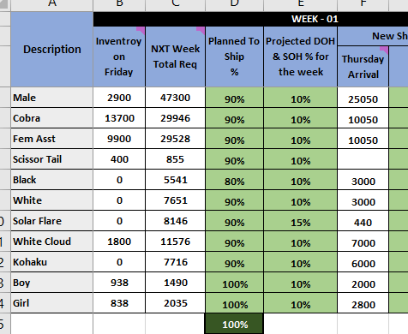

**4. send the preliminary order quantity to Farm**

