OPR for Creating Packing List in ETF

|  |  |
| --- | --- |
| **SUBJECT** | OPR for Creating Packing Lsit in ETF |
| **DEPARTMENT** | Marketing – Order Entry |
| **RECORDER (Name Designation)** | Pasindu Ranathunga – Marketing-Assistant |
| **APPROVED BY (Name Designation)** |  |
| **LAST UPDATE** | 07/07/2016 |
| **PATH ON NETWORK FOLDER** |  |
| **NO. OF PAGES INCLUDING THIS**  **PAGE** | 14 |

1. Add Box/Layer Details-Bulk process

***a.*** Add Box/layer Details –Bulk

**Box Layer Details -> Add Box/Layer Details-Bulk**

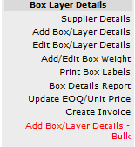

❖ In Box Layer details you click Add Box/Layer Details-Bulk.

❖ When you click the link you will redirect to the Add Box/Layer

Details.

OPR for Creating Packing List in ETF

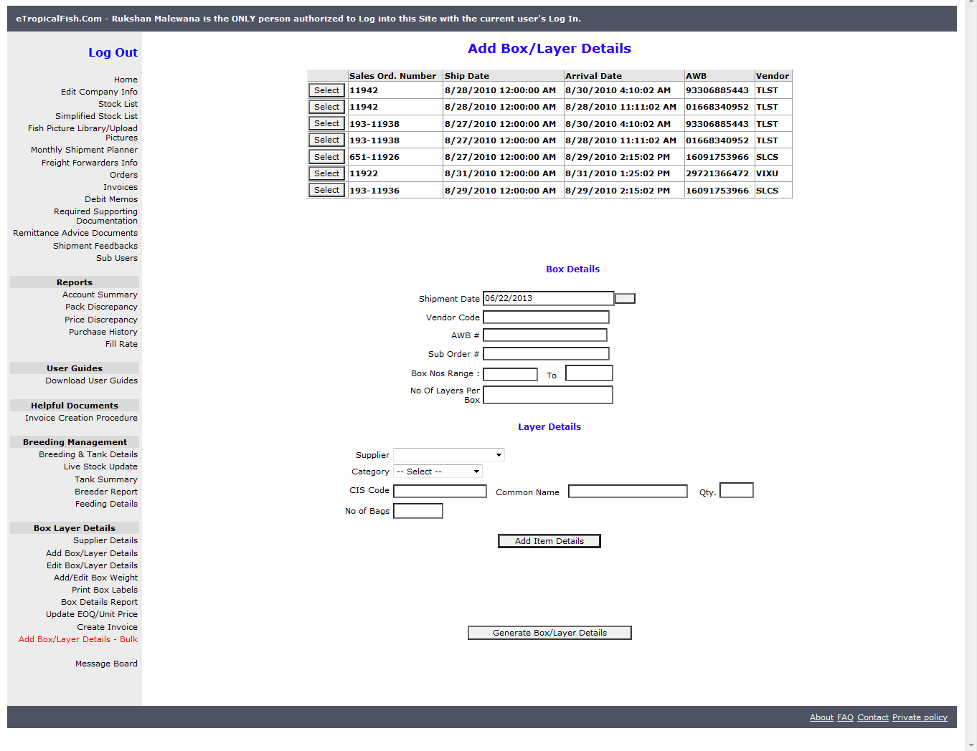

❖ In here, when you click the Selectbutton in the first grid, the shipmentdate, AWB, Vendor code in Box Details will get filled by the details in the grid.

OPR for Creating Packing List in ETF

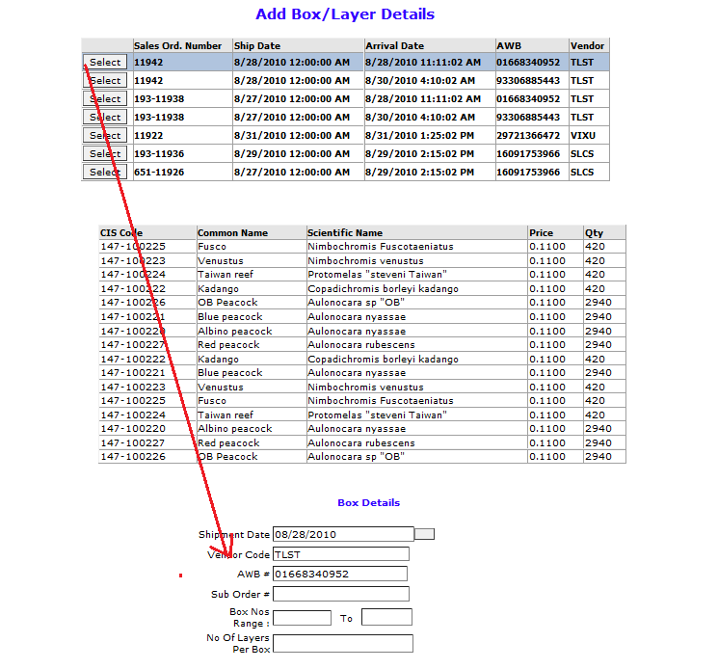

❖ Next you have to fill the other fields in the Box details and in Layer Details as well.

❖ But the CIS code should be taken from the CIS Code details grid (2nd

grid), and press Enter,then common name and the quantity will be taken automatically.

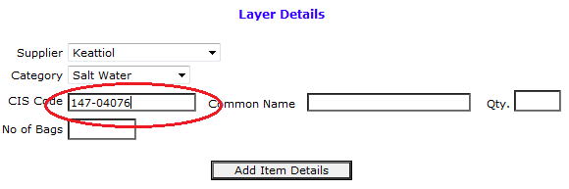

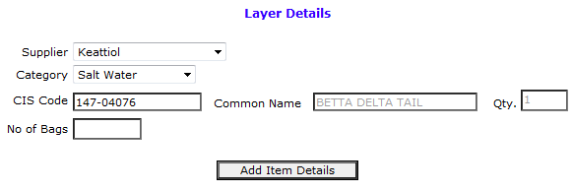

OPR for Creating Packing List in ETF

❖ When click Add Layer Details the relevant details will be shown in a Item

Details grid as below.

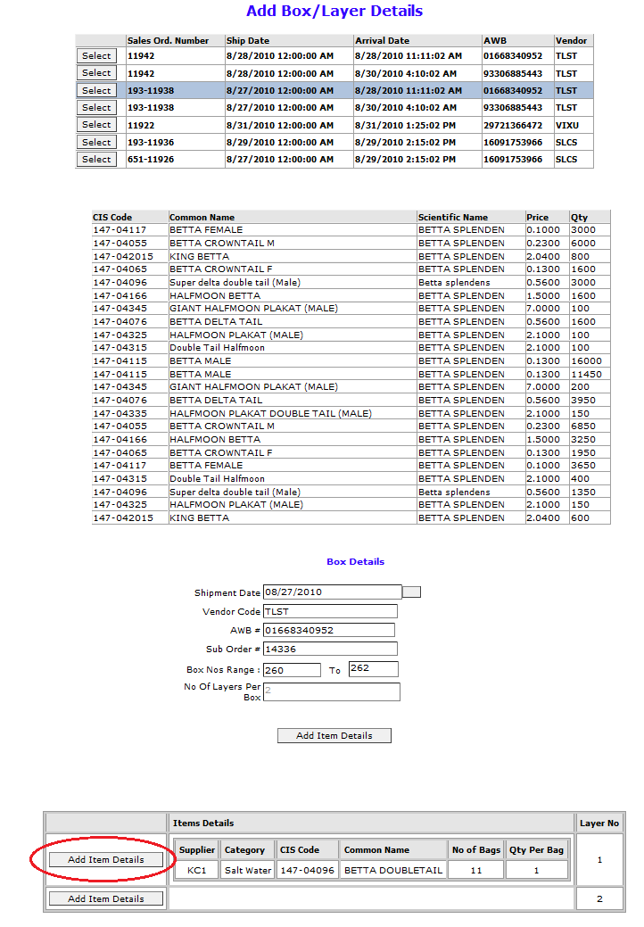

❖ In here by clicking the Add Item Details button marked in the picture you can add multiple items to a particular layer.

OPR for Creating Packing List in ETF

❖ When click the Add Item Detailsbutton in the grid the Layer Details grid will appear and you can add relevant details to the other layer also.

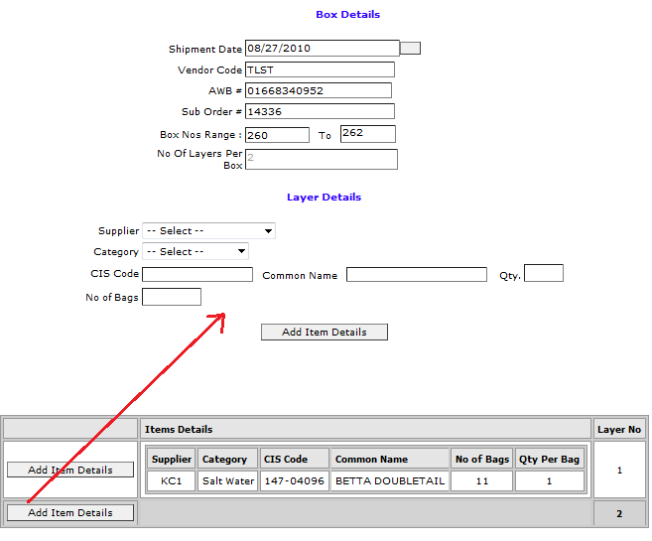

❖ When all the layers are filled you can click the Generate Box/Layer

Detailsbutton relevant details will be shown as below.

OPR for Creating Packing List in ETF

