|  |  |
| --- | --- |
| **SUBJECT** | OPR for Placing #292 orders for TLST |
| **DEPARTMENT** | Marketing – Order Entry |
| **RECORDER (Name Designation)** | Ravihari Punchihewa : Executive - Sourcing |
| **APPROVED BY (Name Designation)** |  |
| **LAST UPDATE** | 11/02/2019 |
| **PATH ON NETWORK FOLDER** |  |
| **NO. OF PAGES INCLUDING THIS PAGE** |  |

**Step 1: Go to ETF & get the PO summary quantity**

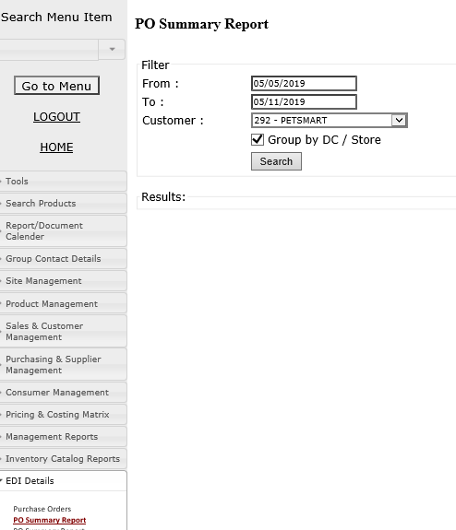

2. Then paste those details relevant DC on “PO” column

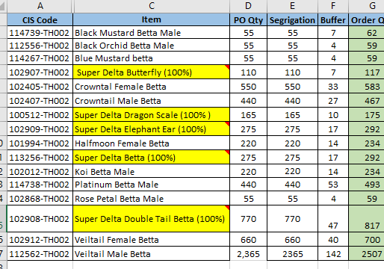

3. then send the final total quantity to Farm

