|  |  |
| --- | --- |
| **SUBJECT** | Stock in Date Update |
| **DEPARTMENT** | Marketing – Order Entry |
| **RECORDER (Name Designation)** | Harsha Subasinghe : Executive - Order Entry |
| **APPROVED BY (Name Designation)** |  |
| **LAST UPDATE** | 30/09/2016 |
| **PATH ON NETWORK FOLDER** |  |
| **NO. OF PAGES INCLUDING THIS PAGE** | 3 |

Order entry maintaining master sheet for 651 which includes sourcing countries.

Master sheet have to update daily orders for 651.

**Step 1**:

Check latest Live Inventory report of Petco.com sent by Claudia.

**Step 2**:

Copy and paste current stock in Current Inventory column of Stocking date for 0 items sheet (current inventory column).

**Step 3**:

Filter value rows in current inventory column and remove dates in stock in date column

**Step 4:**

Filter 0 items in current inventory column and put the relevant expected shipmen date in stock in date.

**Step 5:**

Login to ETF for update the Inventory level Excel Uplad sheet.

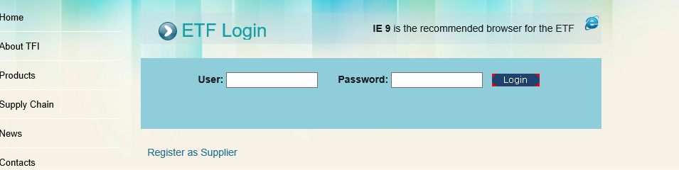

**Step 6:**

Go to EDI details

And Select customer : #651

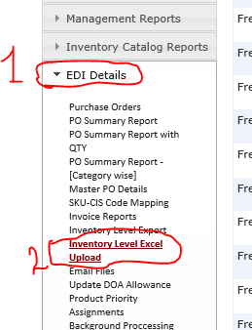

**Step 7:** Click the “Download Inventory Excel” (Download the excel file from ETF for uploading to stock in date)

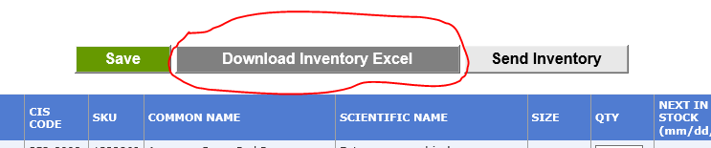

**Step 8**: remove old data from quantity, Next stock in date and SKU column.

**Step 9:** Paste the relevant new data to those columns. (From our stock in date updated excel sheet)

**Step 10:** check and remove duplicated SKU code and update with correct code.

**Step 11:** Upload to ETF

Browse the file and then click the upload button

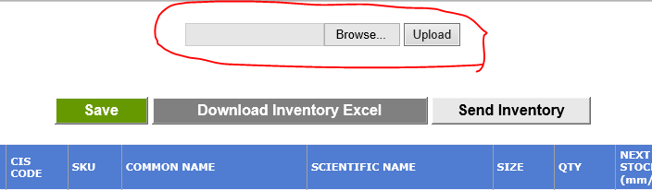

**Step 12:** Click the “Send Inventory”

