**Teknowledge Shared Services Pvt. Ltd**

OPR for How to Connect TV via HDMI Cable

|  |  |
| --- | --- |
| **SUBJECT** | **OPR for How to Connect TV via HDMI Cable** |
| **DEPARTMENT** | IT Support |
| **RECORDER (Name & Designation)** | Fowzan Rahumathullah |
| **APPROVEDBY (Name & Designation)** |  |
| **CREATED DATE** | 25 - Jan - 2019 |
| **LAST UPDATED** | 27 - Jan - 2019 |
| **PATH ON NETWORK FOLDER** | <https://cisintlcom.sharepoint.com/:w:/g/itsupport/ERbHuGXE9JZErRHS7_q3xxEBwUIhTQkUV6_WzKdfVEiwIA?e=NSeFii> |
| **NO. OF PAGES INCLUDING THIS PAGE** | 3 Pages |

1. Make sure that your PC has an HDMI port. HDMI ports resemble thin, wide slots which taper down to a bottom which is more narrow than the top. Most modern PCs have at least one free HDMI port.

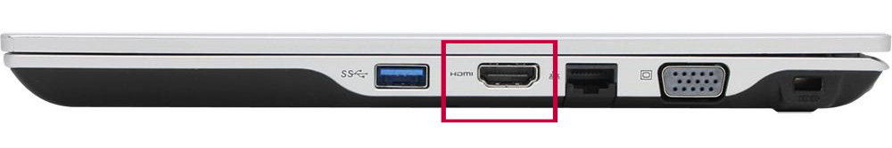

1. Attach one end of the HDMI cable to your TV. The HDMI cable should plug into one of the "HDMI" inputs at the back (or on the side) of the TV.

If your LG TV has more than one HDMI port, the port will have a number on it. This number pertains to the HDMI channel to which you'll need to switch later.

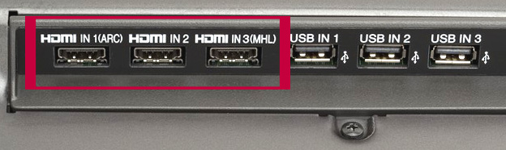

1. Attach the other end of the HDMI cable to your PC. Plug the HDMI cable into the port on your computer.

If you're using an adapter for your PC's video output, plug the adapter into the PC, then plug the HDMI cable into the HDMI port on the outside of the adapter.



1. 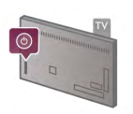Turn on your LG TV. Press the Power button on your LG TV remote to do so.

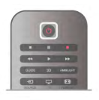

1. Switch to the HDMI input. Use the TV's "Input" button to switch to the HDMI number which pertains to the TV input that you used to plug in your HDMI cable. You should see your PC's screen appear on the TV.

