**Teknowledge Shared Services Pvt. Ltd**

OPR for How to Check O365 licenses and Users

|  |  |
| --- | --- |
| **SUBJECT** | **OPR for How to Check O365 licenses and remove**  **license assigned to resign employees** |
| **DEPARTMENT** | IT Support |
| **RECORDER (Name & Designation)** | Fowzan Rahumathullah |
| **APPROVEDBY (Name & Designation)** |  |
| **CREATED DATE** | 25 - July – 2019 |
| **LAST UPDATED** | 25 - July – 2019 |
| **PATH ON NETWORK FOLDER** | [Click Here](https://cisintlcom.sharepoint.com/:w:/g/itsupport/EZE0MZYL3PZHnDliTfcD22oBBwn91OEfbQ89pvyaMLJnCg?e=C7xnzA) |
| **NO. OF PAGES INCLUDING THIS PAGE** | 3 Pages |

1. Open Browser **(Firefox or Chrome)**
2. Then Log in as Admin user

For Expl: Username : [fowzanr@eteknowledge.com](mailto:fowzanr@eteknowledge.com)

Password : xxxxxxxxxxxxxxx

1. After log in there is a Button **“Admin”** – select
2. Then in left side of the window we can see Option
3. Then select **“User”**

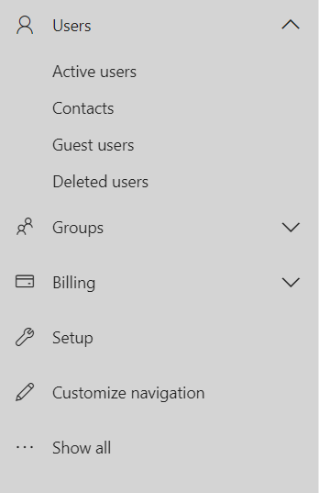

1. Then we can select one of the options to monitor **“users and remove create”**
2. For a Example if you select **“Active User”** Option you can see all user which is in active
3. And there option to create a new User **“Add User”** button left side of the **“Active User”** penal



1. Then create a user as follow our company policy and the Access Request

