**Teknowledge Shared Services Pvt. Ltd**

OPR for Check usability of Guard patrol system

|  |  |
| --- | --- |
| **SUBJECT** | Check usability of Guard patrol system |
| **DEPARTMENT** | IT Support |
| **RECORDER (Name & Designation)** | Tharindu Chinthaka |
| **APPROVEDBY (Name & Designation)** |  |
| **CREATED DATE** | 24 - July – 2019 |
| **LAST UPDATED** | 24 - July – 2019 |
| **PATH ON NETWORK FOLDER** | [Click Here](https://cisintlcom.sharepoint.com/:w:/g/itsupport/EV9LM9WrF3FEs0s_A9H-b8UBGKI7Q10uCdviTDempYOayw?e=L7ZlPO) |
| **NO. OF PAGES INCLUDING THIS PAGE** | 02 Pages |

1. Log in to <https://followmystaff.com/>
   1. Username = itsupport
   2. Password = check OneNote

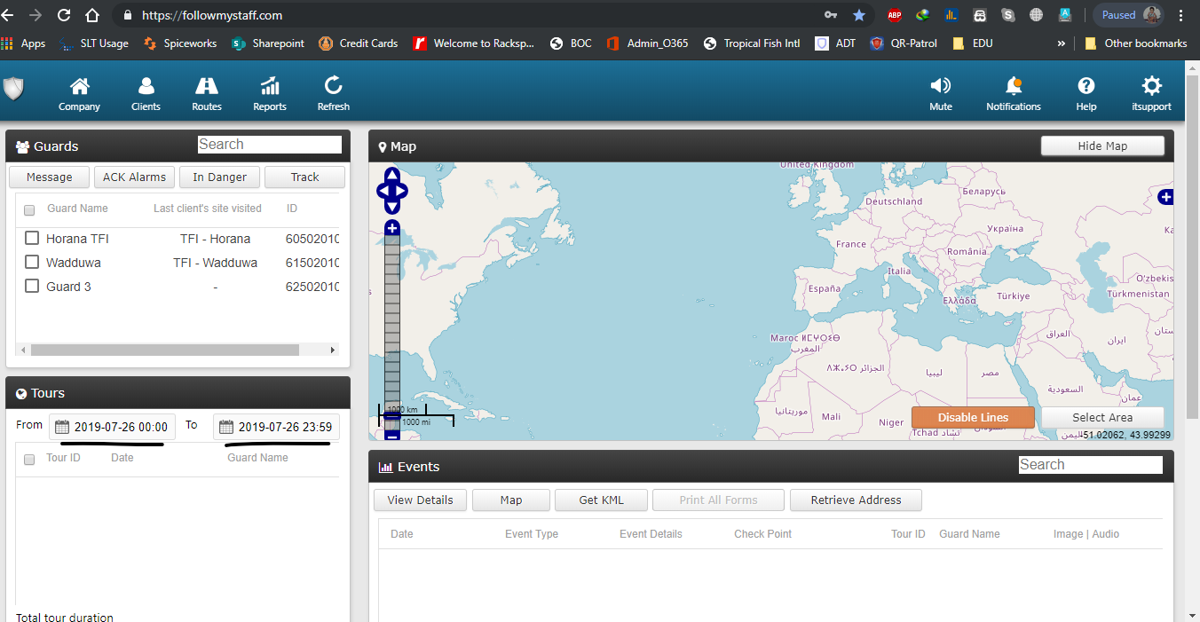

02.chekc the events

03. if any unusual activity informs to Supervisor