**TEKNOWLEDGE SHARED SERVICES-SRI LANKA**

**OPR LABOR SCHEDULING-US WAREHOUSE**

|  |  |
| --- | --- |
| SUBJECT | OPR LABOR SCHEDULING-US WAREHOUSE |
| DEPARTMENT | PRODUCTION & LABOR PLANNING |
| RECORDER | BUDDIKA MADURANGANA |
| APPROVED BY |  |
| CREATED DATE | 03/10/2017 |
| LAST UPDATED | 07/02/2019 |
| PATH ON NETWORK FOLDER |  |
| NO. OF PAGES INCLUDING THIS PAGE | 8 |

**Objective**

Prepare a comprehensive labor schedule for US warehouse considering all labor required aspects and accommodate the requirements timely and effectively.

Once the weekly schedule is finalized, daily labor schedules and individual maps to be prepared.

**Documents/Information to be considered,**

1. Weekly production Tracker- from production Management
2. Dry good tracker
3. Betta inventory
4. Frag production Forecast
5. Weekly Maintenance schedule
6. Availability schedule
7. Skill chart
8. Shipment Planner
9. Meeting/Training Calendar
10. Any other requests
11. US holidays

**Schedule Preparation**

1. **Shifts and Teams**

Two shifts are in operation and first shift consist regular production labor and external labor which operates in the mornings.

Second shift labor are external and operate in the nighttime from 5pm.

Team leads are allocated as per the tasks and one team lead must work along with second shift.

1. **Tasks**

First shift is mainly used for regular production tasks and second shift is mainly used for prepping tasks.

1. **Availability of Labor**

Labor availability must be checked for the week which the labor schedule to be prepared. The availability report must be filled and submitted for each employee from US warehouse on every Wednesday.

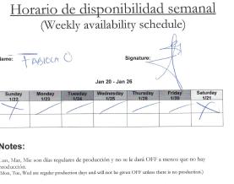

1. **Skill Chart**

Updated skill chart to be referred to assign labor. This will optimize the production and will help to select the most suitable person for the given task.

1. **Weekly production Tracker**

This report will be prepared by Production Planning on every Thursday and it include all the production related information such as number of bags, POs, items, Promotions as a projection.

This is the main document to get the labor requirement for production. Once the report prepared, coordinate and discuss with the planning regarding the requirement and production requirement to be finalized.

Production Labor

Bagging, Clipping, Packing, Closing Dispatching

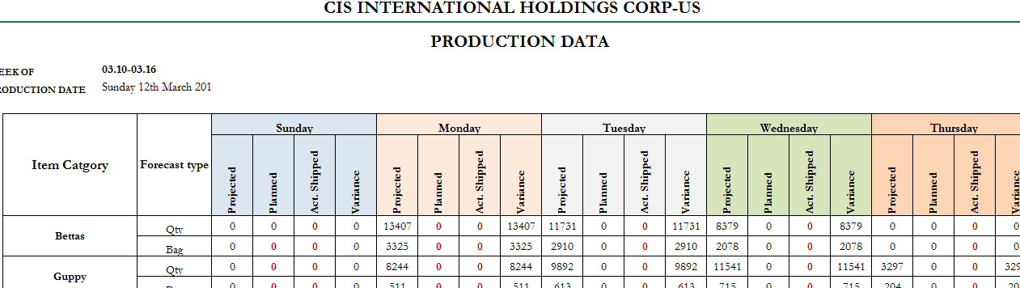

1. **Dry good Tracker**

This report is prepared by production planning on every Thursday and projected dry good requirement are available on this. Base on the quantities, the report will provide the labor requirement to get the job done.

Prepping dates to be finalized with Production planning considering the stock availability and other tasks.

Prepping Tasks- Betta Cups, Box, Plant Cups, Plants

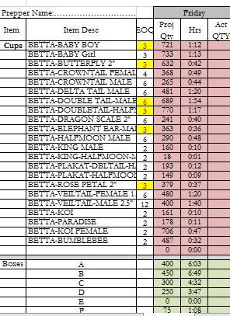

1. **Betta inventory**

All the remaining betta must be re-opened, wash, feed, re-bag and sealed at the end of the week. Betta inventory is the important document to get this information and Labor to be planned accordingly.

1. **Shipment Planner**

Available shipments, arrival date and times, type of the shipments, number of box to be taken from shipment planner. Using the provided Shipment Matrix, labor to be calculated and assigned as that.



1. **Meeting/Training Calendar**

Need to accommodate Labor for the planned meeting and Trainings. This information are provided by System Admin as outlook Calendar/Email/ETF planned meetings.

1. **Any other requests**

Labor may be required to plan non-routing activities. These requests come from US warehouse as email request and need to allocate people and reply to the originator.

1. **US Holiday**

US holidays to be consider for weekly labor schedule.

**Labor Scheduling Timing and Days**

1. **Packing**

Packing is done on Sunday to Thursday depend on the requirement. But on rare occasions Packing can be planned on Fridays and Saturdays.

Regular timing

Sunday-2.30PM onward

Other days-9.00AM onwards

Note: depend on the requirement the start time can be vary. Packers can be planned maximum 12 hrs per day.

1. **292 Processing**-
2. 292 shipment and sorting
3. 292 re-bagging
4. 292 betta sorting
5. 292 packing and shipping
6. 292 Drop off

Note: currently 292 betta shipment is planned to arrive on Thursdays and ship outs are on Saturday, Sunday and Mondays. Re-bagging will be done for all DC39 items, All Veiltail Male items and All Platinum betta. Re-bagging to be planned on previous day of shipping and current shipping plan is, DC23, 39 (Non Veiltail), 40 on Saturday, DC8, 42 on Sunday and DC39 Veiltail items on Monday.

1. **Bagging**

Bagging is done on Sunday to Thursday depend on the requirement.

Sunday- Betta, Inverts (Start Timing can be varying from 9.00AM to 1.00PM)

Monday to Thursday- Betta, Regular Fish, Promo (Start Timing can be varying from 4.00AM to 6.00AM)

Bagging support and Bagging Floater to use as required

1. **Clipping**

Clippers to be plan along with the baggers. Clipping work load to be taken from tracker and labor to be allocated as per bench mark.

For the promotions (FW/SW) need to use more than one clipper.

1. **Betta Processing**

Betta team must provide betta for daily production as per production requirement. (Betta counting/sorting)

Friday- Open all remining betta, wash, Feed and put in cups (from 6.00AM)

Saturday- Re bag & Sealing/EOQ bagging all open betta (from 6.00AM)

Sunday- Betta counting sorting for the production, Betta shipment acclimation (from 1.00PM)

Monday to Thursday- Betta counting sorting, opening (dirty), re bagging (as required), Inventory

Thursday-open all betta in stock (from 4.00AM or 6.00AM)

1. **Shipments**

Labor to be properly allocated for shipments.

Shipment Pick up- plan to leave WH 1.30 hrs after arrival

Shipment acclimation- plan people after 3 hrs of arrival

Note: Shipment Matrix to be used to calculate the Labor requirement and need to allocate people accordingly.

1. **Prepping**

Currently most of the prepping tasks are done using second shift. Production requirement, stock availability to be reviewed while planning.

Labor to be allocated as per the benchmark and the team leader must fill out the prepping tracker/second shift tracker and send back to Labor management.

Plant prepping can be planned on weekend. If the stocks are available, need to prep the requirement at the end of the week.

Plant dry good- Plant related dry good item must prep along with the plants.

1. **Fragging**

Labor to be allocated for Frag related activities as per the Frag production forecast. Bench marks to be considered for each task.

Fragging

Frag bagging

Pull out

Dipping

1. **Plant Care**

Plant care activities are listed as below

1. Shipment clearance- Plants coming from the outside the USA, will be inspected by USDA. mostly the appointment will be received on next day of arrival
2. All the plants must be un-boxed at the arrival
3. Plant should be put in black trays as bottom potion of the box to be on the top of the tray.
4. If the plants arrive after holding several days at USDA, all boxes to be open and plant to be washed and put in trays with little water. This is to remove chemicals.
5. Once all the boxes are open and put into black trays, Marginal, Tropical and Bamboo to be put in sand trays with recommended spacing
6. Desert plants will be kept in trays as received until prepped
7. Moss can be kept in the same boxes little watering to be done
8. DOH to be removed daily and update on the white board of each tray
9. Watering to be done as per the moisture level
10. Daily plant maintenance check list will be sent with pictures
11. Labor management need to review and allocate labor for necessary tasks
12. Prepping to be planned as per Production requirement. All the relevant prepping tasks, sequence to follow and labor to be planned as per benchmarks
13. **Any other task**

WH will inform the non-regular tasks and need to allocate people per the requirement.

1. **House keeping**

Labor need to allocate properly for housekeeping task. This is routing activity and all the areas must be specified and mentioned on Tracker/maps to get the cleaning done.

Team lead check list to be checked and allocate labor as required.

1. **QA and Husbandry**

Regular task and nominated people to be used.

Need to check the skill chart and allocate labor for husbandry activities.

Critical husbandry tasks

1. DOH pulling
2. Feeding
3. Inventory taking
4. Report updating
5. Acclimation monitoring
6. **Construction & Maintenance**

Weekly maintenance schedule to be referred and skilled labor to be planned as requested.

QA walk through and Production feed back also to be considered to allocate maintenance tasks.

1. **Wholesale**

Depend on the availability of wholesale work orders, Production planning prepare the plan. Labor must be allocated and skills to be considered.

1. **Meetings and Trainings**

Regular trainings and meetings are planned on Fridays**.**

**General Work Allocation Table**

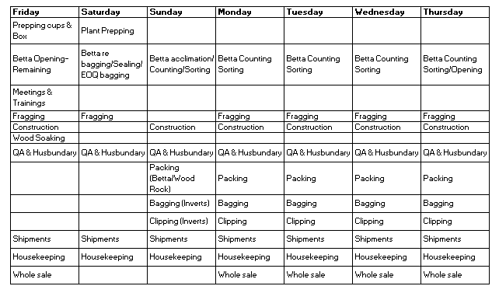

**Weekly Labor Schedule**

**Considering all above-mentioned activities, following format to be filled with the labor requirement.**

**Note:**

1. **Bench marks to be considered and labor to be allocated accordingly.**
2. **Plan single person maximum for 8 hrs per day and 5 days per week. (after 8 hrs OT must be paid and 6th day will be fully overtime). Additional hours, Days can be planned with justified reason.**
3. **Separate schedules to be sent for regular production staff, External staff and Second shift staff**
4. **Prepared labor scheduled to be discussed with WHMGT at Weekly Planning Meeting on every Thursday and finalize.**
5. **Finalized Labor Schedule must be submitted to USWH, on Thursday before 12.00Noon. this Labor Schedule will be displayed on the Notice Board.**
6. **For the WH Staff, Separate schedule will be sent on same day.**

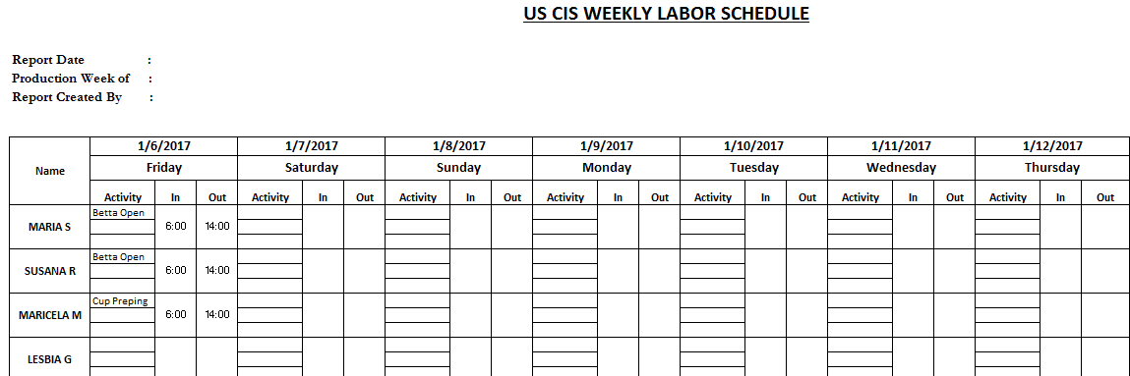

**Out of Schedule Report.**

**Once the Weekly Labor schedule is finalized at the Weekly Planning meeting, it will be sent to USWH to notify the employees.**

**Actual attendance to be recorded against the schedule during the week and un-planned attendance to be recorded daily.**

**This will help to monitor labor hour utilization and it must be considered while a requirement to plan additional labor for the same week.**

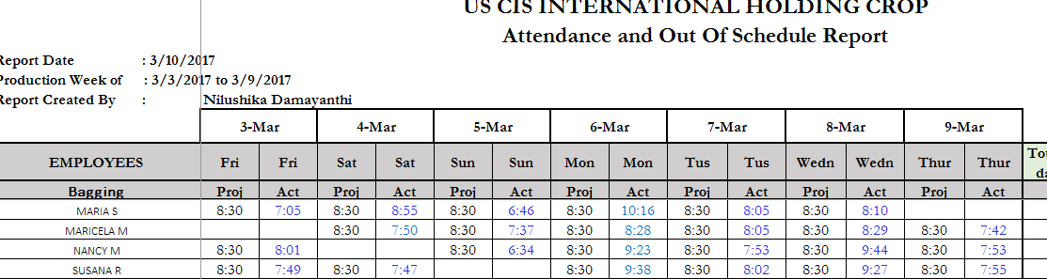

**Daily Labor scheduling**

1. Daily labor scheduling will be done based on weekly schedule and use the Labor planning module to schedule the tasks
2. All the daily activities are accommodated in the module and labor to be allocated as per the requirement.
3. Based on the benchmarks, labor allocation will be calculated on same and Maps will be generated
4. After checking all, daily labor schedule to be sent to USWH and Maps to be printed prior to start shifts.
5. Additional labor related information to be provided via emails
6. Second shift task must be updated on second shift tracker and send thru report calendar

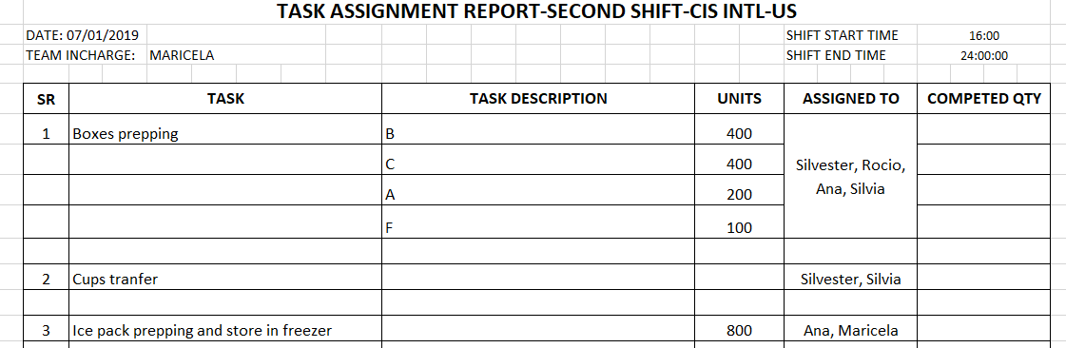

1. **Please refer LABOR PLANNING MODULE OPR**

**PROCESS FLOW CHART**

