**OPR-LABOR PLANNING & POST ANALYSIS FOR INCOMING SHIPMENTS**

|  |  |
| --- | --- |
| SUBJECT | OPR-LABOR PLANNING & POST ANALYSIS FOR INCOMING SHIPMENTS |
| DEPARTMENT | LABOR PLANNING |
| RECORDER | BUDDIKA MADURANGANA |
| APPROVED BY |  |
| CREATED DATE | 06/20/2018 |
| LAST UPDATED | 12/31/2018 |
| PATH ON NETWORK FOLDER |  |
| NO. OF PAGES INCLUDING THIS PAGE | 09 |

**Objective**

Incoming shipments are very important part of the process and Labor must be planned effectively to pick the shipment and acclimate as per the approved criteria. Actual labor utilization must be measured and analyzed as a post shipment analysis.

**Shipment information**

Upcoming shipment information are available on shipment Planner email. This is an autogenerated email and provide updated shipment details. This information are updated by Order Entry and verified by Logistics.



Available information are on the shipment planners as below,

1. Vendor code
2. Country
3. Item type
4. Number of boxes
5. Airline and Airway bill
6. Arrival date and time

**Important to consider**

1. Arrival time & pick up

Arrival time is very critical for Livestock shipment. Clearance will be done thru 9am to 11pm daily and average 2.5-3 Hr will be taken to release from the arrival (Fish and wildlife inspection). If any shipment is planned to arrive between 11pm to 9am will be released after 9am.

½ Hrs must be allocated driver to reach Airport. Considering this, Driver must leave the WH after 1.30Hrs of shipment arrival. ½ Hrs are allocated to release & load the shipment and another ½ Hrs to reach to the WH.

Note:

1. Driver must have all documents prior to leave WH. He must take enough pallets to load the shipment.
2. Once the documents are submitted for the cargo clearance, 15 to 30 minutes are taken, and Cargo will be brought to cargo loading area.
3. Driver needs to palatize all the boxes to our own pallets, wrap them and load to the lorry.

For the local shipments, Driver must be arranged as per the supplier confirmation to the Airport of required location.

1. Documents and shipment arrival information

Driver & Clearing agent must have all the documents on time. This part will be handled by Order Entry by updating shipment planner and Logistic is providing documents.

1. Number of boxes and livestock type

Labor allocation must be done according to the number of box available. If the box quantity is more than 150, helper must be allocated to pick the shipment. Driver must have accurate number of boxes to arrive and he must collect all boxes accordingly. Driver will decide the size of the vehicle based on the box quantity. Labor allocation for the acclimation also based on number of boxes.

Livestock type also make changes to the clearance process. certain type of livestock items need permits or special inspection. For example, Koi & Goldfish shipment must have USDA permit to release. Plant shipments must be submitted to USDA once cleared from the airport and CIS can pick the shipment once inspected. Appointment will be done by the clearing agent and inform CIS.

**LABOR ALLOCATION**

1. Refer the shipment planner while allocating weekly labor requirement.

Weekly labor schedule must be prepared on every Thursday for the week starting Friday. All the shipments available for the week must be considered and labor must be allocated.

Note: some shipments may not be confirmed while preparing the weekly schedule. need to check with Order Entry and if any possibility to arrive the shipment as mentioned in the shipment planner, keep allocating labor. But the shipment planner must be checked daily and necessary adjustment to be done to the daily labor schedule. for the urgent changes, Labors must be notified by the Labor Management.

1. Skill chart & Availability

Skilled & Available labor must be allocated for the shipment pick up, Acclimation.

Source document – Skill chart

1. Shipment pick up

As mentioned above, shipments will be released thru 9am to 11pm. Any shipment arrives after 11pm will be released after next day 9am. Minimum 3 hrs will be taken to clear the shipment after arrival. ½ hrs allocated to reach Airport from the WH. Therefore, Driver must leave the WH after 1.30 hrs of arriving the shipment. ½ hrs are allocated to handover the documents, release the shipment and load the shipment and another ½ hrs to arrive to WH.

If the number of boxes are more than 150, 1 helper must be allocated for shipment pick up.

**Note: Driver must update the incoming shipment master and scan and send back to Labor management with all relevant details.**

1. Shipment acclimation

As mentioned above, shipment must reach WH after 4 Hrs of actual shipment arrival to airport. Acclimation crew must be ready at the WH by this time.

**Guideline**

1. Fresh water shipment acclimation must be completed within 3 hrs period
2. Saltwater shipment acclimation must be completed within 2 hrs period
3. Coral shipment acclimation must be completed within 3 hrs period.
4. QA Labor:

QA must be assigned to observe and Record Quality Observations and ENSURE Protocol Compliance. QA CANNOT be counted on to perform Bag opening and clipping. QA time must be allocated accordingly.

1. Once the shipment arrived to WH, box must be categorized and aligned in sequence. All to be weighted and record.
2. Number of boxes and bags availability to be considered and hours must be allocated for both openings.
3. Additional time must be given to open every new box.
4. Certain Live Stock types need MORE time and care in Opening - such as Shrimp, Anemones, etc. - approx. 10% more time than an average fish
5. Certain Live Stock types need to be first Re-Oxygenated after a Small % of new Water has been added and then Acclimated as a SECONDARY step. This means this process requires additional time for adding water and Re-Oxygenation. E.g. of items are Shrimps and Carpets
6. Certain Fish need to be INDIVIDUALLY SEGREGATED (using Bin Dividers or Special Plastic cages) to be kept separate from each other.
7. If the item need specialized care while acclimating are categorized and “Specialized care” and additional 10% time will be allocated than standard allocation. Those items which are not in “Specialized care category” will fallen in to “Generic care category” and standard bench marks will be used.
8. Betta shipment are not required to acclimate. Need to open the boxes but not required to open all the bags unless bettas found dirty or dead. All the received bettas must be sorted, open as required on the same day once arrived.
9. Live Rock container- Live Rock must be in the system within 24 hours of arrival. This will maintain the quality of the live rocks

Steps

Order Entry/Logistic- Plan the container and update the shipment planner with arrival details

Logistic- Coordinate with the forwarder and arrange the shipment to WH. Arrival confirmation will be provided to Labor Mgt.

Labor Mgt- Allocate labor as per the bench mark.

Steps and Bench Marks

1. Unloading the boxes- 20 Boxes 5 Min
2. Box Open and unpack- 30 sec per opening single box, 8 Sec to un wrap the live rock- 1pc
3. Rinse the rocks (in two bins) 6 sec per time
4. Put in the system- 30 Pcs in 5 min
5. Update the inventory sheet- 15min

**SHIPMENT PICK UP & ACCLIMATION MATRIX**

Considering the above guidelines, Shipment pick up and acclimation Matrix is made on Excel. Bench marks are applied for all relevant tasks and correct inputs must be provided to calculate actual labor requirement.

Steps

1. Update shipment details

Refer the shipment planner and update with country code, number of boxes, arrival time. If the shipment arrives between 11pm-9am, arrival time must be updated as 9am.

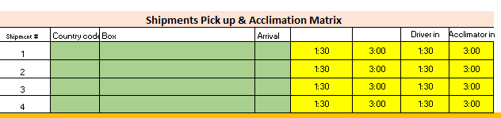

1. Update the Shipment acclimation Matrix table

Usually one shipment contains different types like Fresh Water, Salt Water etc. shipment number must be as per first table. Then the fish type to be selected from drop down. Number of boxes and bags for that item type must be provided.

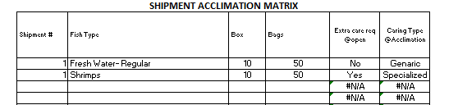

1. Matrix will calculate the required labor as per the given details.
2. Information can be updated up to 4 shipments using this matrix. Shipment wise labor requirement will be given in separate tables.
3. As per the required time, labor to be allocated. Number of labor to be allocated to meet the **Guideline a, b, c. (Acclimation to be completed in given time frame)**
4. This will provide shipment pick up time, acclimation start, Acclimation duration and End.

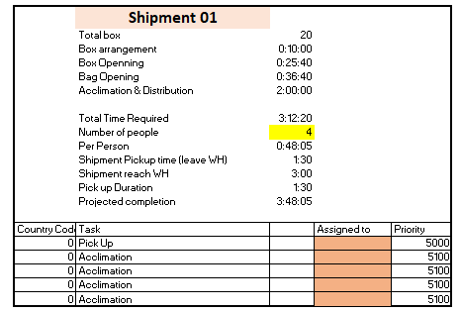

1. Labor must be planned according to above and notify them for unplanned situation.

**POST SHIPMENT LABOR ANALYSIS REPORT-CIS US**

This is a daily report must be prepared by Labor Management and thru the report calendar. Planned vs Actual to be analyzed and variance to be questioned via question log.

Source documents

1. Shipment pick up and acclimation Matrix (2nd Tab)
2. Incoming shipment Master- Send by Driver
3. Productivity worksheets of relevant people

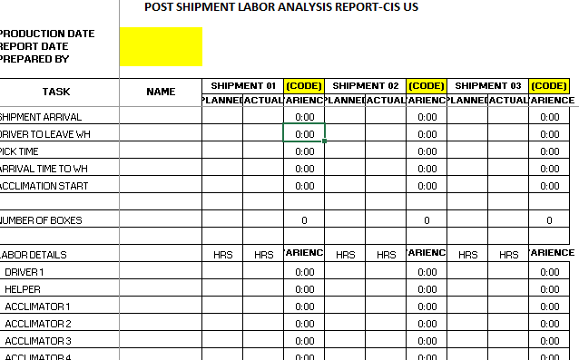

**PROCESS FLOW CHART**

Allocate

Review the Process with historical data

Questioned as required

Post shipment Labor Analysis

PWS

Attendance

Acclimation

PWS

Incoming shipment Master

Shipment Pick Up

Labor Schedule

Labor Availability

Skill Chart

Shipment Planner

Daily Checkup and Update