**TEKNOWLEDGE SHARED SERVICES-SRI LANKA**

**OPR LABOR ANALYSIS & REPORTING-US WAREHOUSE**

|  |  |
| --- | --- |
| SUBJECT | OPR LABOR ANALYSIS & REPORTING-US WAREHOUSE |
| DEPARTMENT | LABOR MANAGEMENT |
| RECORDER | BUDDIKA MADURANGANA |
| APPROVED BY |  |
| CREATED DATE | 01/10/2019 |
| LAST UPDATED | 07/02/2019 |
| PATH ON NETWORK FOLDER |  |
| NO. OF PAGES INCLUDING THIS PAGE | 5 |

Objective

Analyze the labor utilization and maintain the labor cost according to the company goals. Process changes and improvements to be done and measured continuously to improve the productivity.

Labor Analyzing

Mainly labor to be analyzed daily basis and weekly basis. Also, the labor utilization to be measured as,

1. Employee wise
2. Station wise
3. Task wise
4. Shift wise

Daily Labor Analysis

1. Daily Labor Allocation

Daily labor allocation will be based on weekly labor allocation

All the task that needed to be performed on the day will be allocated in daily schedule

Labor module is used to plan daily tasks according to benchmarks

1. Maps

Each employee gets the work allocation map prior to the production

Map consist with all the assigned tasks, location, time, quantity and sequence

Employee follows the map and perform the task

1. Productivity Work sheets

Every employee must fill the Productivity Work sheet according to actual work

Task, quantity, start & end time must be updated

All the Productivity sheets to be scanned to Labor management at the end of the day.

1. Data Entry

Check the number of productivity work sheets received

Check the actual number of people worked

Employees that the Productivity work sheets were not sent. Include their names to the question log

Enter the actual data into Labor Module-Data Entry tab

Data to be entered as per actual worked sequence

If the PWS was not sent, assume the planned tasks were done and update as per actual hours

1. Verify the regular/overtime hours with Uattend records

Uattend records are taken to excel sheet by Payroll and send to Labor Management

Actual worked hours are divided as regular and overtime based on Uattend details

Task are categorized as per regular & overtime

1. Station wise utilization details

Once the data entry is done, Analysis get updated with utilization.

Categorized as Station and assign the names of relevant employees

Excel calculate the varieties of Hours, Cost and Quantity

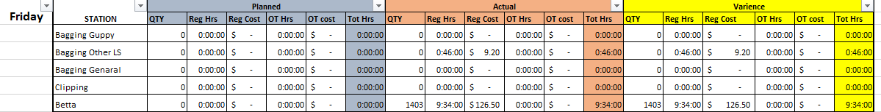

1. Send the summary through ETF report calendar
2. Discuss the highlighted issues in daily planning meeting
3. All the issues to be highlighted in Question log with control number

Daily Sales vs Labor Analysis

Separate OPR is available

Weekly Sales vs Labor Report , Weekly Summary Labor Report, Weekly Labor Variance report

Note: to get the data for all above reports, daily labor utilization records are used but for complete week

1. Above daily labor utilization summary is used
2. Get the total labor planned and actual detail for the whole week
3. Daily actual labor is compared with Uattend details (Employee wise, Normal/OT wise)

Following summaries will be generated once comparison done.

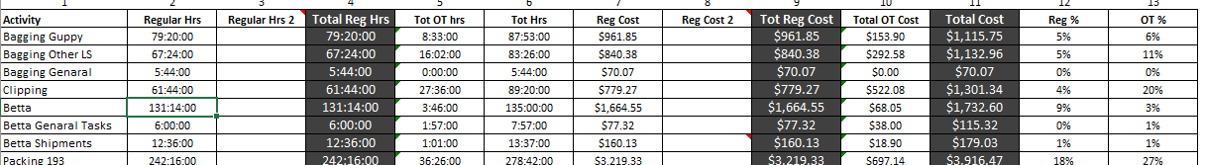

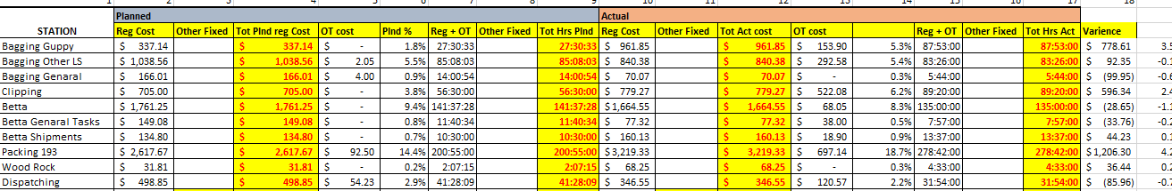

Based on the summary records

1. Labor variance report data updated
2. Sort as per the highest variance

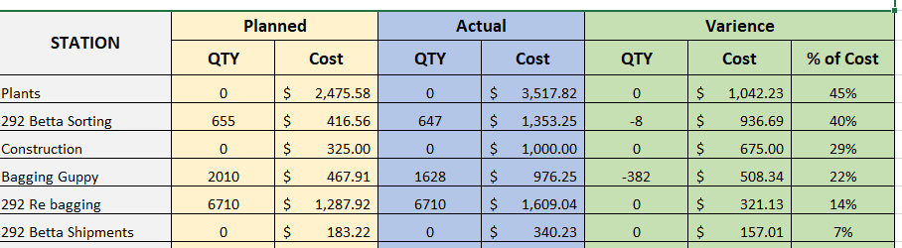

1. Weekly Summary Labor report

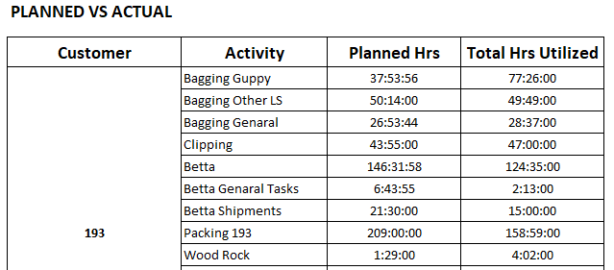

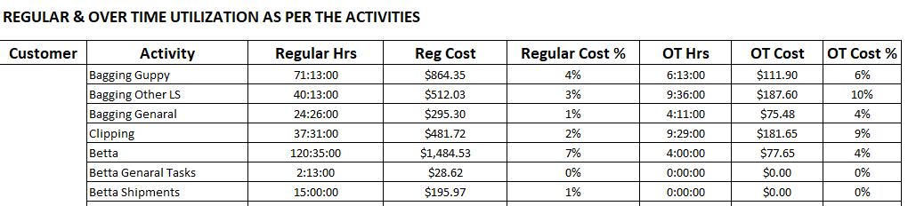

1. Weekly Sales vs Labor report

Following information to be taken from summary

1. QA cost
2. Sales vs Labor % according to Matrix- based on the Sales value, get the recommended Labor % from Matrix

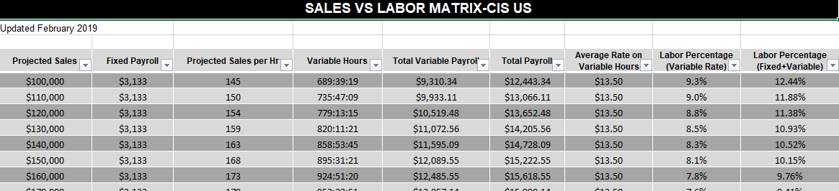

1. Fill rate and Ontime details- From Weekly Fill rate reports
2. Total hours spent for betta
3. Total cost spent for betta
4. Number of betta fish & non betta item shipped in the week
5. 292 Sales details
6. 292 direct Labor
7. 292 indirect labor- QA cost as a % of Sales
8. Station wise Regular hour usage %
9. Station wise OT hour usage %

Note:

All other details on the report are provided by Payroll department.

