**TEKNOWLEDGE SHARED SERVICES-SRI LANKA**

**OPR WEEKLY SALES VS LABOR REPORT-US WAREHOUSE**

|  |  |
| --- | --- |
| SUBJECT | OPR WEEKLY SALES VS LABOR REPORT -US WAREHOUSE |
| DEPARTMENT | PAYROLL/PRODUCTION & LABOR PLANNING |
| RECORDER | BUDDIKA MADURANGANA |
| APPROVED BY |  |
| CREATED DATE | 03/10/2017 |
| LAST UPDATED |  |
| PATH ON NETWORK FOLDER |  |
| NO. OF PAGES INCLUDING THIS PAGE |  |

**Objective**

Analyze the actual labor utilization and identify the labor consumptions section wise. Based on these records, process changes to be applied to minimize the labor cost and maintain at the bench mark of 6% per week.

This report is a collaboration of Payroll and Production/Labor departments. Payroll & attendance details are provided by payroll and Production & Labor provide analytical data to the report.

The weekly report is discussed on every Friday 9.30PM (US Time) with WHMGT, PAYROLL and PRODUCTION & LABOR departments.

Preparation of the report

1. Payroll provide actual in/out times from U-attend on daily basis to Labor planning. This is only for the employees which are entitled to calculate for Labor.

All Employees except,

1.Sam

2.Varuni

3.Matt

4.Andy

5.Maria

6.Andreas

7.Chris

1. Labor planning check the PWS of each individual and distribute their hours as per the activity



1. Completed report is submitted on Friday morning SL time to Payroll.

The summery available on Excel is updated for complete week.

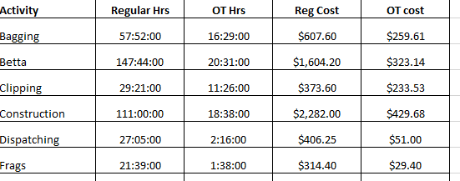

1. Payroll check the total labor utilization and fil the below parts of weekly Sales vs Labor report.
2. Regular Hrs
3. Over time hrs
4. Over time cost
5. Out side labor cost
6. Construction Labor cost
7. Total Labor cost

Sheet will calculate the Labor % with construction cost and without construction cost.

1. Once Payroll fill above info, report is submitted to Production Planning and following info wil be added.
2. Betta quantity shipped
3. Non betta quantity shipped
4. Total POs shipped
5. Total packages shipped