**TEKNOWLEDGE SHARED SERVICES-SRI LANKA**

**OPR FOR FARM LABOR PLANNING**

|  |  |
| --- | --- |
| SUBJECT | OPR FOR FARM LABOR PLANNING |
| DEPARTMENT | LABOR PLANNING |
| RECORDER | Buddika Madurangana |
| APPROVED BY |  |
| CREATED DATE | 08/01/2019 |
| LAST UPDATED |  |
| PATH ON NETWORK FOLDER |  |
| NO. OF PAGES INCLUDING THIS PAGE | 10 |

# Objectives

Utilize the Labor resources efficiently to reach Production goals of SL Farms. Tasks must be clearly identified, Prioritized and assign under required labor category/skill.

Available Farms

Following Farms are currently in operation in Sri Lanka

1. Horana Farm
2. Ingirya Farm
3. Lanka Lumbini-Ingiriya
4. Ingiriya 3
5. Madala
6. Seeduwa
7. Kaduwela

Production Categories in SL Farms

Mainly different Fish varieties are grown in Farms. Apart from Fishes, Tropical plants and some Agro products like coconuts, Green leaves are grown in Farms.

Identify the operational tasks

Based on the product, Farm operational tasks are varied

Need to identify the

1. Product
2. Product related tasks
3. Frequency
4. Number of units related to tasks
5. Specific time whenever applicable
6. Benchmarks of each tasks and relevant video proofs
7. Best way to submit the daily plan details to lower level
8. Way of getting actual details timely manner
9. Process to carry out the Corrective/preventive action

General Task List and benchmarks

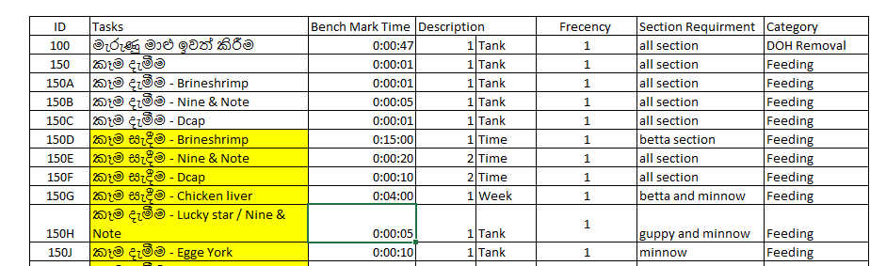

Process analysis and streamlining

This must be done as initial stage and as a routine task based on the analytical data

Initially need to identified underperforming tasks and must be corrected, necessary guideline to be provided to get optimal output.

Proper work study to be done to correct the process and before and after results must be compared

Continuous monitoring and training to be done to improve the process

Farm Management involvement is very important while changing the process and implementing

Weekly Labor Plan preparation- SL Farms

* Below to be consider,

1. Farm regular activities
2. Based on the operational tasks daily regular activities must be finalized
3. Labor skills and Levels to utilize as per the task station wise
4. All above to be measured as per benchmarks and each station must have enough labor to complete daily tasks
5. Overtime are allowed only with justified reason. If the overtime hours are consumed regular basis, need to analyses the tasks and do the necessary action to avoid overtime
6. Outgoing and incoming shipments
7. Must have schedule of all incoming and outgoing shipments relevant to each Farm
8. All shipment related tasks are required to be listed as per the sequence and relevant benchmarks
9. Labor must be allocated as per the required skill and category for shipments
10. Shipment day activities and Pre-shipment activities must be properly planned
11. Labor availability
12. Labor availability is a key concern while planning
13. Planned leave and known shortages must be taken to consideration
14. Need to discuss with Farm Management to resolve pending issues before finalizing the weekly schedule
15. Special requirements/Non routine requirements
16. Need to consider the request received for special/non-routine tasks
17. Identify the required labor and allocate in the weekly schedule
18. OT requirement based on the schedule time
19. Overtime are allowed only with justified reason. If the overtime hours are consumed regular basis, need to analyses the tasks and do the necessary action to avoid overtime
20. Overtime hours must be maintained as per the company goal

* Weekly Labor plan must be submitted to the relevant Farm Managers on every Friday
* Any conflict must be sorted before finalizing the weekly schedule

Daily Labor Schedule

1. Daily labor allocation must be done based on weekly Labor allocation
2. Unplanned tasks must be considered while preparing the daily Labor schedule
3. All the tasks must be planned, and individual Maps must be provided to each employee
4. Map should have following
5. individual tasks in sequence
6. allocated time
7. starting and ending time
8. Section and Station

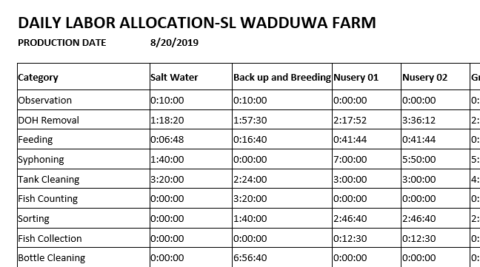

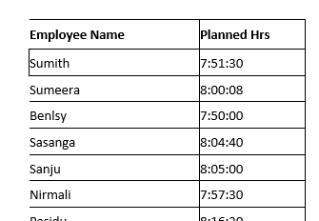

Map

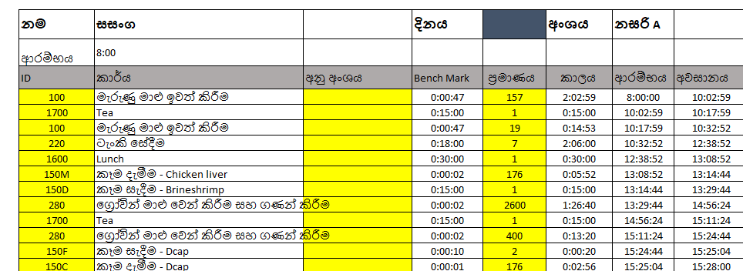

Work execution

1. Farm Manager gets weekly/daily schedules, daily work allocation maps
2. Need to review the daily schedule on previous day
3. Any conflicts must be addressed with Labor Management and resolve previous day
4. Work allocation maps to distribute among the employees
5. Each employee needs to follow the map and performed the assigned task as per assigned sequence
6. Any conflict must be escalated to resolve (Breeder, Farm Manager)
7. Need to update the Productivity work sheet as per the actual task completion
8. Tasks, Start & End times, Units must be clearly mentioned on the Productivity work sheet (PWS)
9. At the end of the day, Farm Manger must have all the updated PWS
10. Need to scan these PWS to Labor Management on the very next day morning

Labor Analysis

1. Labor Management needs to review the number of PWS received for the previous day
2. Maintain a record of PWS receiving
3. The employees who sent the PWS will be entitled for the PWS allowance
4. The employees who has not sent the PWS will be listed and questioned via question log
5. If the employee is continuously failed to submit the PWS will be escalated to HR for disciplinary action.
6. Data will be entered to the excel and PWS updating deficiencies also noted by Labor Management
7. Deficiencies will be included to question log that needed to be attended by Farm Managers and resolve the pending issues
8. Once the data entered, comparison to be done with actual and planned data
9. Variances will be made available on the Labor analysis summary which Farm managers can easily refer
10. Also, the variance to be included in question log
11. Month to date and year to date figures must be maintained to identify the ongoing issues

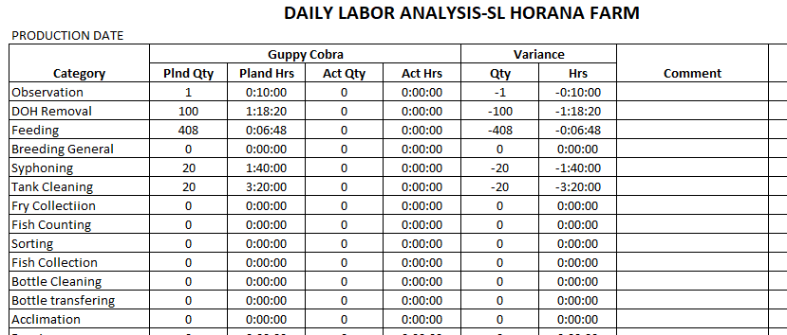

Reports

1. Daily Labor analysis report
2. This is the main report prepare for labor analysis
3. Labor projection was made considering all the routing/non-routine activities
4. Also, the quantity, frequency also projected in the plan
5. Work plan consist with above details and tasks are distributed among labor as per their skill
6. Labor needs to follow the work plan and update the actual task performance on the Productivity work sheet
7. These PWS to be entered as actual details and analyze the areas which varied from the plan
8. Summary of the planned and actual must be provided and questioned the variances
9. Individual employee performance also to be measured and issues to be highlighted
10. Issues must be escalated and resolve with the support of the Farm Management
11. Question Log
12. This report is used to question the identified issues from Farm Management
13. Each question should contain with control number and answers must be recorded
14. Necessary process changes must be done to avoid such kind of issues
15. Tickets, PMS to be assigned to complete the tasks
16. Need to measure the performance once the issue is fixed
17. This is continues improvement process
18. PWS (Productivity work sheet) receive summary
19. PWS must be filled and provided by each employee daily
20. This is the way to get actual work information for analyzing
21. PWS must be clearly updated and any issues to be escalated vis question log
22. Allowance will be paid to encourage for filling PWSs
23. Employee wise PWS receiving record to be maintained and weekly report to be prepared
24. For the salary preparation, monthly Bonus report to be submitted for HR

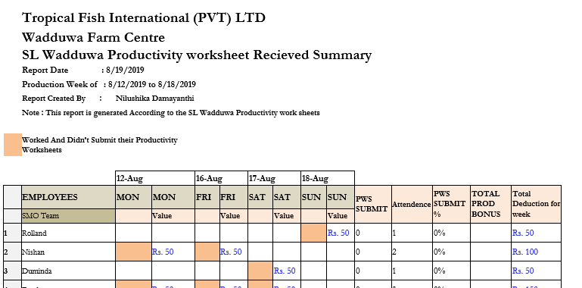

1. Daily OT report
2. Overtime must be controlled and monitored
3. Overtime projection for the week to be considered against the actual utilization in this report
4. Variance to be identified and questioned
5. High overtime consuming tasks/sections must be reviewed and make precaution to avoid overtime
6. Monthly overtime report to be prepared using weekly details for HR

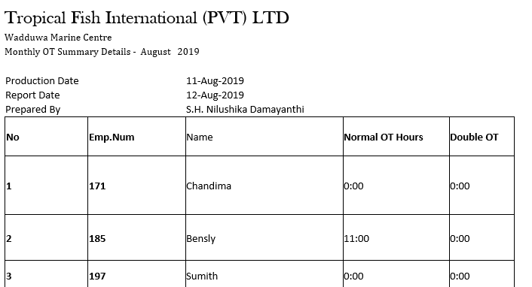

1. Weekly Shipment analysis report
2. Labor utilization of the weekly shipment task must be recorded and analyzed
3. Different shipment related task to be measured
4. Month to date record is required to maintain
5. Weekly attendance and Out of Schedule report

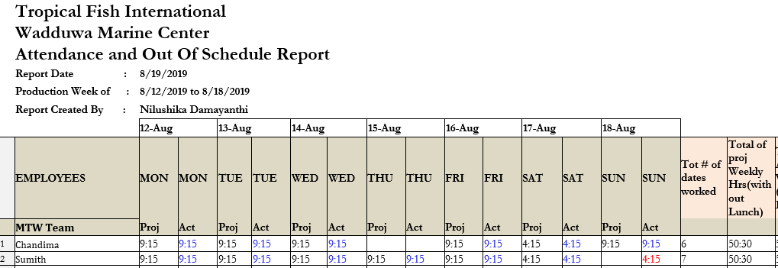

Meetings

1. Meeting to be conducted to maintain the labor goals as per the company expectation
2. Meeting must have a agenda which covers the meeting topic
3. Participant must be selected as per the objective
4. Meeting minutes must be sent
5. Currently assigned meetings
6. Monthly process review meeting
7. Weekly Labor projection meeting

Farm Visits

1. Regular farm visits must be done
2. Identified issues from the labor analysis must be reviewed at the site with concern parties
3. Process modifications to be finalized to avoid above issues
4. Farm visit will help to understand issues that employee face.
5. Benchmark finalization/upgrade can be done
6. New process improvement can be identified/implemented

Utilize labor outside the Facility

**Requirement**

Additional labor requirement may arise in different facilities at any time. Farm management must attend on the request as per the priority and fulfill the labor requirement as requested. Depend on the regular farm activities, need to make correct decision to select required labor with minimum impact to regular activities.

**Major Consideration**

1. **Labor**
   1. Actual requirement & category of labor based on the task which need to be done.
   2. Availability-Identify the possible labor from the facility per the requirement
   3. Covering – Make necessary arrangement to cover regular task once the labor have been used for another task.
   4. Inform labor management, HR and the Labor who will be assigned. Selected labor must be well notified regarding the task which need to be performed.
2. **Transport**
3. Based on the distance, working time and nature of the work, best available transport mode to be selected.
4. Cost & availability

If farm vehicles are used,

* + 1. Alternative plan must be prepared to cover regular activates
    2. Fuel, driver to be arranged

1. If the public or any other transport will used, necessary budget to be arranged.
2. **Tool requirement**

Based on the task to be done and type of labor are used. All necessary tools must be send along the crew. All tool issuance must be recorded and must be checked once return. If the required tools are not available, farm management must notify the requestor and inform in advance.

1. **Material**

If materials are required to perform the task, farm management must see the possibility to issue if the required materials are already available. material issues must be record as transfer and concern parties (HR, Finance) must be notified to do the necessary cost adjustments.

1. **Expenses**

Farm management must evaluate the nature of the work and all necessary expenses must be arranged.

* Transportation
* Foods
* Accommodation if necessary
* Medical support
* Any other relevant expenses

Farm management must coordinate with the requestor and must have better understand of the work which need to be done by the they own labor. Risk assessment must be done and necessary medical support to be arranged as required.

All expenses related to outside activities must be record by farm management and provide the information to Finance and HR.

Farm management must be in contact with the requestor and have a better understand about the crew provided until they returned.

**Process Flow Chart - Labor Utilization Outside the Facility**

Justify & feed back

Official request

Evaluate

If not Ava

Farm Management

If available

Expenses

Material

Tools

Transport

Update Project

HR

Provide the Labor

Labor Mgt

Finance

Record Expenses

Perform the Task

Update status

Update status

Complete the task