**Teknowledge Shared Services Pvt. Ltd**

OPR for How Check DHCP IP Pool in DHCP server – SLHO & USWH

|  |  |
| --- | --- |
| **SUBJECT** | **OPR for How Check DHCP IP Pool in**  **DHCP server – SLHO & USWH** |
| **DEPARTMENT** | IT Support |
| **RECORDER (Name & Designation)** | Fowzan Rahumathullah |
| **APPROVEDBY (Name & Designation)** | Tharindu Chinthaka |
| **CREATED DATE** | 25 – July – 2019 |
| **LAST UPDATED** | 25 – July – 2019 |
| **PATH ON NETWORK FOLDER** | [Click Here](https://cisintlcom.sharepoint.com/:w:/g/itsupport/EYv9gMFWbypPvPl5_ScjAmcBHtCBI0GKKCwokphiSzpzMA?e=GkVEWT) |
| **NO. OF PAGES INCLUDING THIS PAGE** | Pages |

1. Log in Firewall SLHO (Cyberoam)

* IP 192.168.3.1

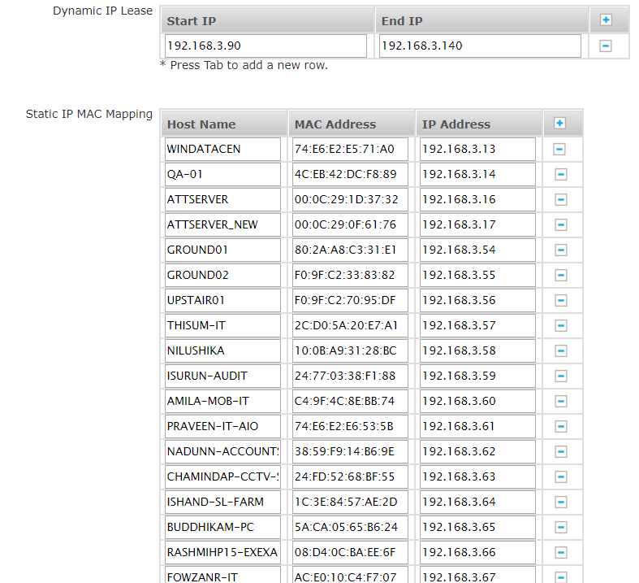

1. Then check the DHCP IP pool rang and list all available IPs in a Excel File

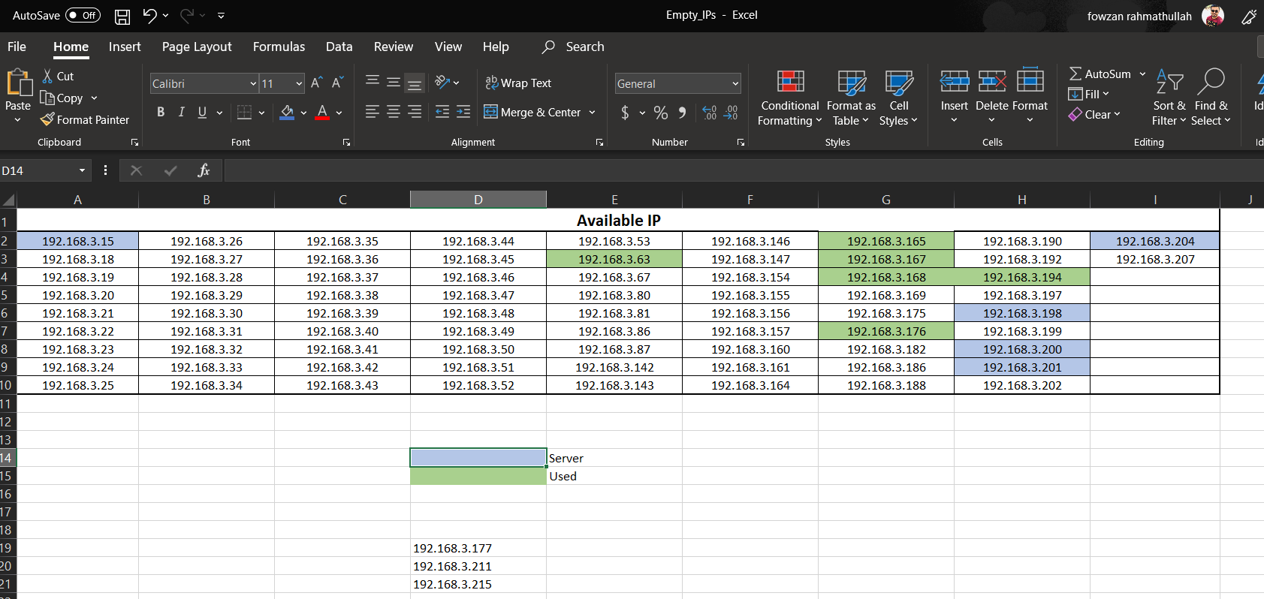

1. Log in Firewall USWH (Dell)

* IP : 192.168.1.254 - Local
* IP : 12.162.222.194 – Public

1. Same as SLHO Procedures to Follow