|  |  |
| --- | --- |
| **Subject** | **How to Access ASI Fileserver via RDP** |
| **Department** | **IT Support** |
| **Recorder** | **Tharindu Chinthaka – IT Support Engineer**  **Upali Wijekoon** |
| **Approved by** | **Amila Kaushalya** |
| **Create Date** | **22/05/2017** |
| **Last Update** | **22/05/2017** |
| **Path on Network Location** | **https://cisintlcom.sharepoint.com/OPR/default.aspx** |
| **No. of Pages Including this page** | **3** |

**How to access a server via Remote Desktop Service**

*Note : If you need to access the server from remote location (not USWH network) you need to connect to VPN first.*

1. On Start type **Remote Desktop Service** and select it.

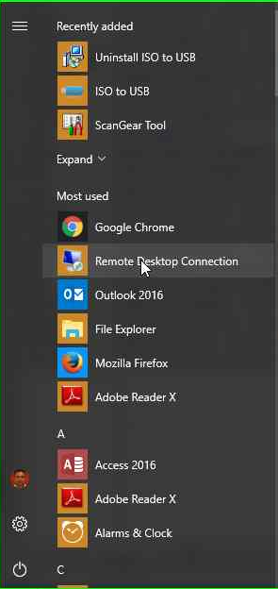

1. Enter server IP 192.168.1.103 and click connect.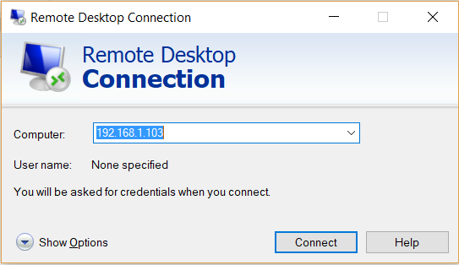
2. On next window select **More choices** and then **Use a different account** .

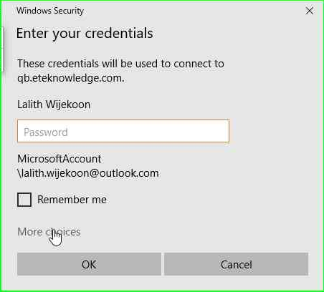

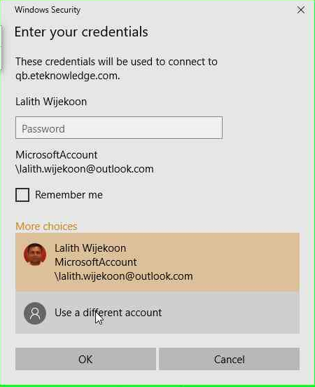

1. Enter given Username and Password on next window. Press OK.

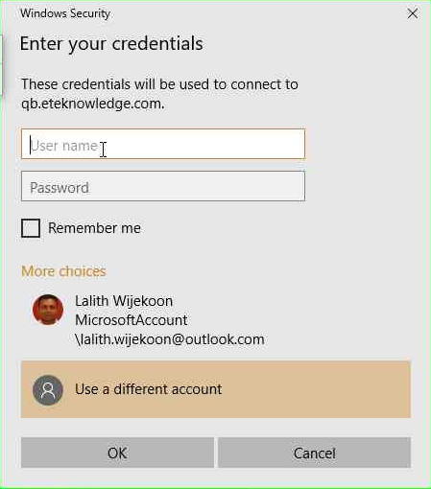

1. You will be direct to the server.