**Teknowledge Shared Services Pvt. Ltd**

OPR for How Check Ensure all department properly functioning SharePoint

|  |  |
| --- | --- |
| **SUBJECT** | **OPR for How Check Ensure all department**  **properly functioning SharePoint** |
| **DEPARTMENT** | IT Support |
| **RECORDER (Name & Designation)** | Fowzan Rahumathullah |
| **APPROVEDBY (Name & Designation)** | Tharindu Chinthaka |
| **CREATED DATE** | 25 – July – 2019 |
| **LAST UPDATED** | 25 – July – 2019 |
| **PATH ON NETWORK FOLDER** | [Click Here](https://cisintlcom.sharepoint.com/:w:/g/itsupport/Ec4QqBL1I1JLhj7nPcPy92YBkhixnIPBkN2u_uzp9bMY3A?e=dbMsJu) |
| **NO. OF PAGES INCLUDING THIS PAGE** | 2 Pages |

1. Log in to System Admin Penal of SharePoint

* Spadmin………

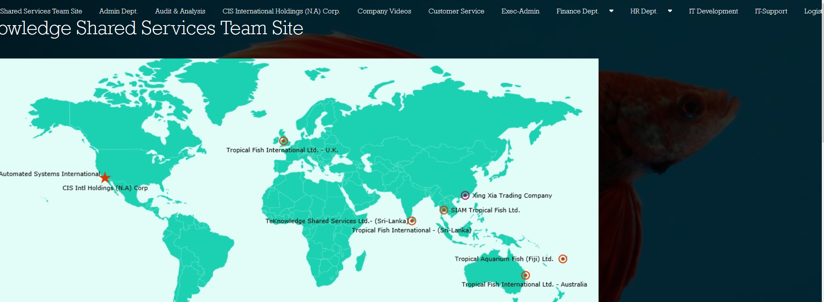

1. After log in their option called “Team Site” Select
2. Then go for Setting Icon, it’s located from Right side of the window and click that icon
3. Then go for each department Panel have separate “Site Setting” Option

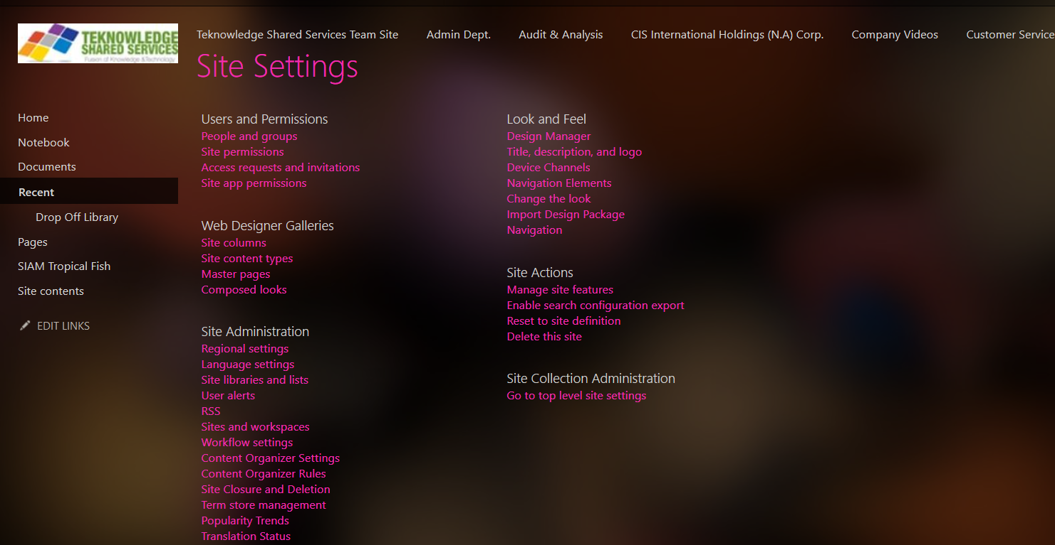

1. Then monitored all the departments are following as per Company policy.