**Teknowledge Shared Services Pvt. Ltd**

OPR for How to Get SL & USWH firewall Backup

|  |  |
| --- | --- |
| **SUBJECT** | **OPR for How to Get**  **SL & USWH firewall Backup** |
| **DEPARTMENT** | IT Support |
| **RECORDER (Name & Designation)** | Fowzan Rahumathullah |
| **APPROVEDBY (Name & Designation)** | Tharindu Chinthaka |
| **CREATED DATE** | 25 – July – 2019 |
| **LAST UPDATED** | 25 – July – 2019 |
| **PATH ON NETWORK FOLDER** | [Click Here](https://cisintlcom.sharepoint.com/:w:/g/itsupport/EaneLG5yvQJEs0kjo8MQRwQBjgBXrjnXbXGRb8CRLAWr9A?e=FssSdY) |
| **NO. OF PAGES INCLUDING THIS PAGE** | Pages |

1. Log in to SL Firewall System (Cyberoam)

* 192.168.3.1

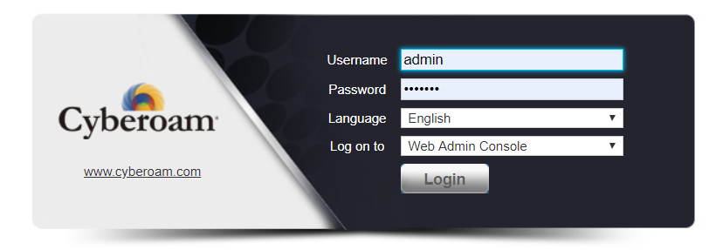

1. Go for Backup menu and save the backup into local location

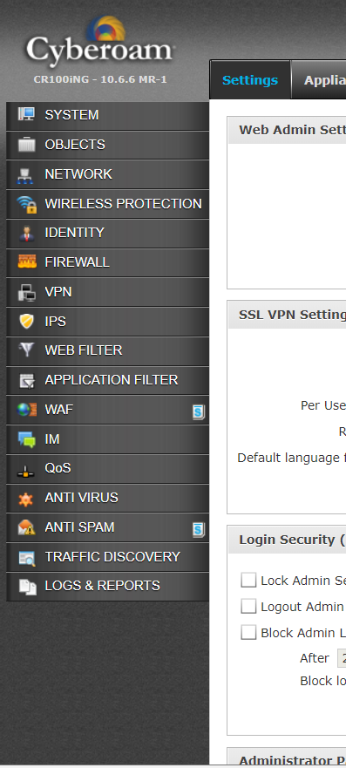

1. Log in USWH Firewall (Dell)

- Local IP : 192.168.1.254

- Public IP  :  12.162.222.194

1. Go for Backup option menu and get the backup as local location
2. Then log in our System Admin OneDrive and Upload those backups to the Virtual location

* [systemnotifications@eteknowledge.com](mailto:systemnotifications@eteknowledge.com)

