**CIS International Pvt Ltd**

**OPR for Preparation of Daily Question Log**

|  |  |
| --- | --- |
| **SUBJECT** | **OPR for Preparation of Daily Question Log** |
| **DEPARTMENT** | **Labour Management** |
| **RECORDER (Name and Designation)** | **Dilan Maduranga- Labour Planning Executive** |
| **APPROVED BY** |  |
| **CREATED DATE** | **15/05/2016** |
| **LAST UPDATED** | **15/05/2016** |
| **NO OF PAGES INCLUDING THIS PAGE** | **2** |

**Introduction to the OPR**

This OPR was created with the intention of providing a guideline to prepare the Daily Question Log pertaining to Labour Utilization of US WH.

**Objectives**

The objectives of preparing the Daily Question log,

1. To ensure optimum utilization of Labour everyday
2. To reduce unnecessary Labour cost
3. Improve the employee productivity

**Contents**

1. Preparing daily Question Log and follow up.

**Introduction of Daily Question Log**

Daily question Log is basically prepared to inquire the US WH with regard to the Daily Labour inefficiency and it needs to be based on the Daily Labour Efficiency analysis Report.

Usually, Daily question log consists of following question.

* Projected Vs actual high variance in term of individual wise and station wise
* When Productivity worksheets submission is considerably low,
* In the case of not adhere with Daily Labour schedule send by Labour Planning Dept.
* As per dash Board if an employee had not completed the breakdown
* Excessive Over time
* When relevant reports are not submitted such as Boxes and cups prepping tracker, Daily Betta inventory count report, Sign out sheet, Weekly Employee Availability Report etc..
* Other employee related issues

**How to prepare Daily Question Log**

**Figure 1. Daily Question Log**

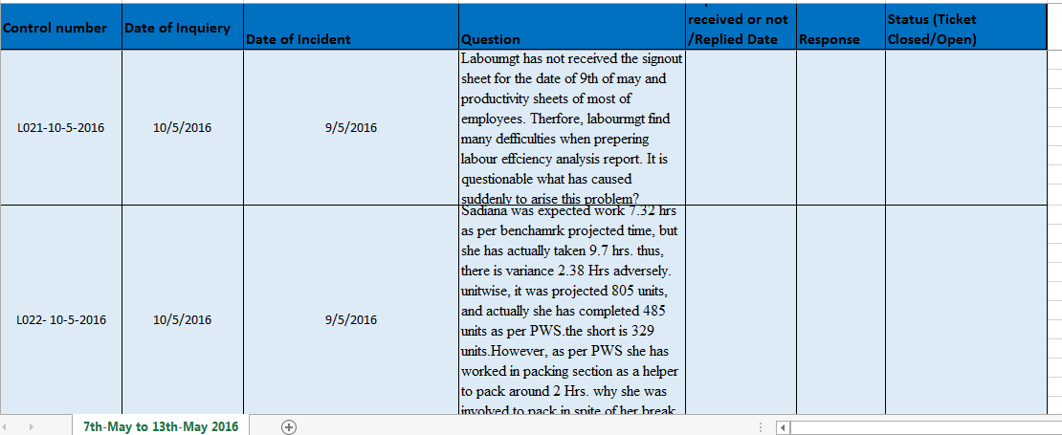

**Step 1**: You are required to obtain relevant details form Daily Labour Efficiency Analysis and incorporate those info to the Daily question Log. See the extract of Daily Question log in figure 1.

Remarks: Since Daily Question Log is based on Daily Labour Efficiency Analysis Report. Accuracy of the Daily Labor Efficiency Report is essential.

**Step 2**: Daily Question log should be sent over the system by the labourmgt Dept and US WH is responsible for answering them.

**Step 3**: If intended answer/ Justification is not provided, Mark the column “Status” and mention that ticket is still open. In that case, continuous follow up is required from Labourmgt Dept. Otherwise, mark this column as “yes”.

**Remarks:**

1. **Control Number** – Represent each question under unique question number
2. **Date of Inquiry** / **Date of incident** – Date of inquiry and Date of incident are most likely not be the same date and both of dates should be stated correctly since they will be useful for future reference as well.
3. **Question :** See the introduction of Daily Question Log
4. **Replied Date:** The date whenlabourmgt received the response.
5. **Response:** explanations/ Justification send by US WH.
6. **Status of Ticket**: see the step No. 3.

END….