**TEKNOWLEDGE SHARED SERVICES-SRI LANKA**

**OPR ASI ANALYZING PROCESS**

|  |  |
| --- | --- |
| SUBJECT | OPR ASI ANALYZING PROCESS |
| DEPARTMENT | PRODUCTION & LABOR PLANNING |
| RECORDER | BUDDIKA MADURANGANA |
| APPROVED BY |  |
| CREATED DATE | 09/10/2019 |
| LAST UPDATED |  |
| PATH ON NETWORK FOLDER |  |
| NO. OF PAGES INCLUDING THIS PAGE | 3 |

ASI Job Records

ASI team must fill daily job record sheet according to the actual work completion details and scanned to ASI Labor at the end of the day

If the person is at field work, he must email the job details, hours expended and mileage details to ASI Labor.

If the person has taken a PTO (Paid time off), he must send the job record sheet with utilized PTO hours

Mandatory fields must be in daily job records are,

1. Employee name
2. Date
3. Week
4. Job#
5. Task description
6. Station ID
7. Start and end time

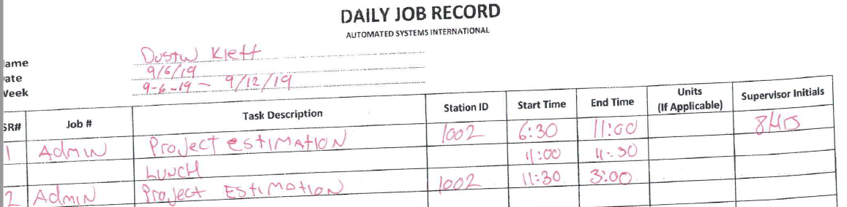

Regular Time (RT), Over Time (OT), Double Time (DT)

First 8 hours will be considered as Regular Time (RT)

If the worked hours are more than 8 and less than or equal to 12, that hours will be considered as Over Time (OT) and will be paid 1.5 times of regular pay rate

Hours more than 12 are considered as double time and will be paid 2 times of regular rate.

PTO- Payed Time Off

PTO are calculated only for the total working hours

PTO rate is 0.0919

Once employee used the PTO, record must be correctly updated on data entry sheet and make sure the calculations are done accurately to maintain the PTO balance.

ASI Daily Analysis

1. Data Entry
2. Make sure all available employees have sent their Job record sheets for the previous working day
3. If anyone have not sent the job record, update in question log and inquire via email
4. Check the dates Week# are correct and all relevant information are available on the job sheet
5. Job details must be clearly mentioned with the job number
6. Start and End time must be available for each task
7. Enter individual job records into daily record sheet
8. Following fields must be entered

Working Date

Employee Name

Job #

Task Description

Station ID

Start and End Time

1. As per the actual working hours, hours must be assigned as Regular time, Over Time and Double Time
2. For the Lunch, need to mention as record but do not categorize under Regular time, Over Time and Double Time- Job# and Description must be updated as Lunch
3. If they perform ADMIN or Other task, need to update Job# and Description as Admin or Other
4. Need to check the Week# is correct as per the given date



1. If the PTOs utilized, need to update Job#, description as PTO (Start/End time are not mandatory but total hours to be updated). Total PTO hours must be updated under PTO category.



1. If the mileage details are given, total number of miles must be updated under mileage as per relevant job#.



1. Weekly time sheet

Weekly time sheet will be updated automatically with daily records

This is summarized tables for each employee that provide weekly hours, PTO earned, utilize & carry forward.

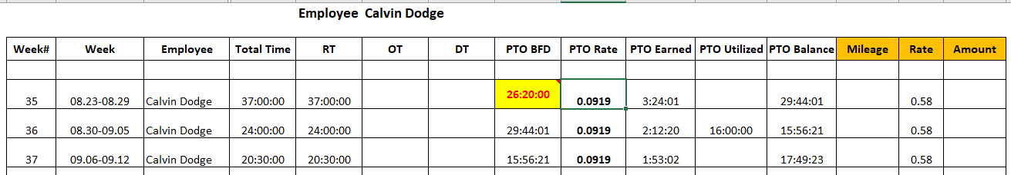

1. Summary Report

Relevant day must be updated, and Summary report consist with,

1. Daily Employee Summary- currently 3 employees are working, and Excel will update actual hours as per the day
2. Daily job summary- Copy the list of jobs performed during the day from “Daily record sheet”, remove duplicate and paste on the table. Excel provides work duration for each job for given day

Note: Total hours of daily employee summary must be equal to the total of daily job summary

1. Weekly Employee Summary

Week number will be updated as per the given day

Available employees’ hours will be updated for the week with PTO details and total payable hours

1. Weekly Job Summary

Get the list of jobs performed during week from daily records

Remove the duplicates

Paste the list on weekly job summary table

Note: Total hours of weekly employee summary (Worked hours) must be equal to total hours of weekly job summary

1. Weekly station summary

Get the list of station IDs during week from daily records

Remove the duplicates

Paste the list on weekly station summary table

Daily Analysis Report

1. Daily Analysis report must be sent to ASI thru report calendar