|  |  |
| --- | --- |
| Subject | To ensure all the Invoices are Update in timely Manner |
| Department | Finance |
| Recorder | Nadun Chamara (Accounts Executive) |
| Approved By | Deepika Thilakarathne (Accountant) |
| Created Date | 04th Aug 2019 |
| Last Updated |  |
| Path on Network Folder |  |
| No Of pages including this OPR | 03 |

**Objective : To ensure all the Invoices are Update in timely Manner**

Description,

1. Collect the Petco and PetSmart Invoice Details through the TFI system.

EDI Details Invoice Summery Repot

Select the Date Range

Choose the Customer from the List

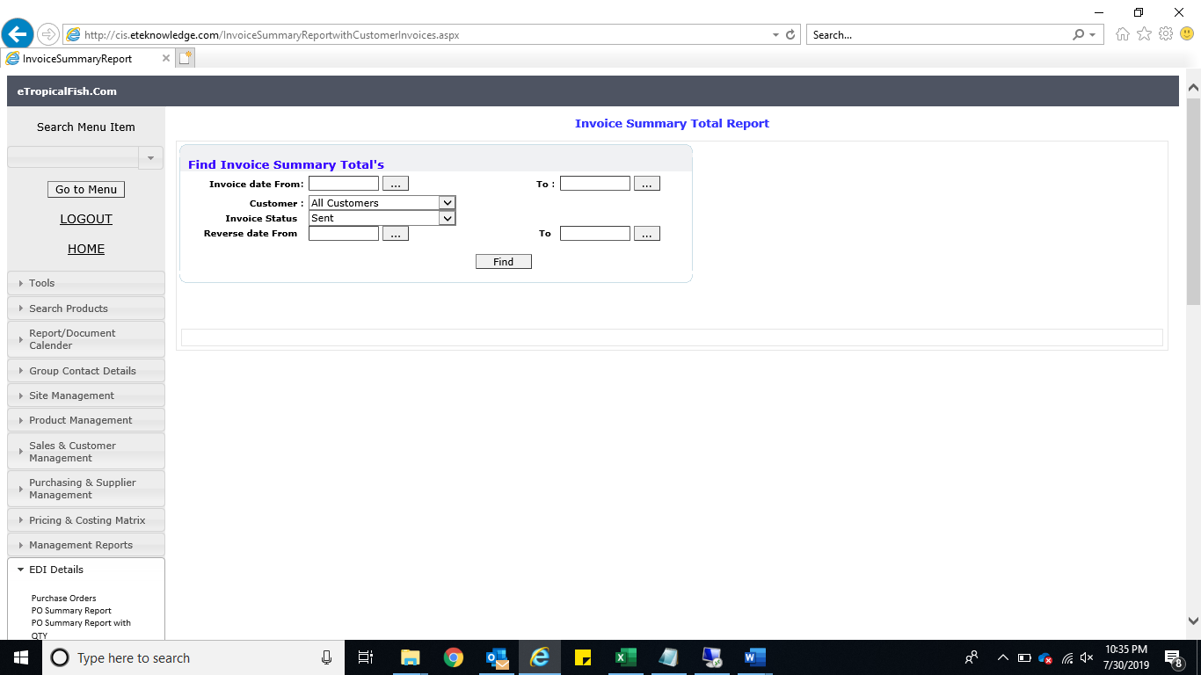

Click the “Find” Button

1. Prepare the Invoice summery using Excel workbook.
2. Gather the wholesale invoice from system generated emails.
3. Enter the invoices into Quick Book Accounting package.

* Create Invoice
  + Customer Create Invoice Or Use [CRT+I]

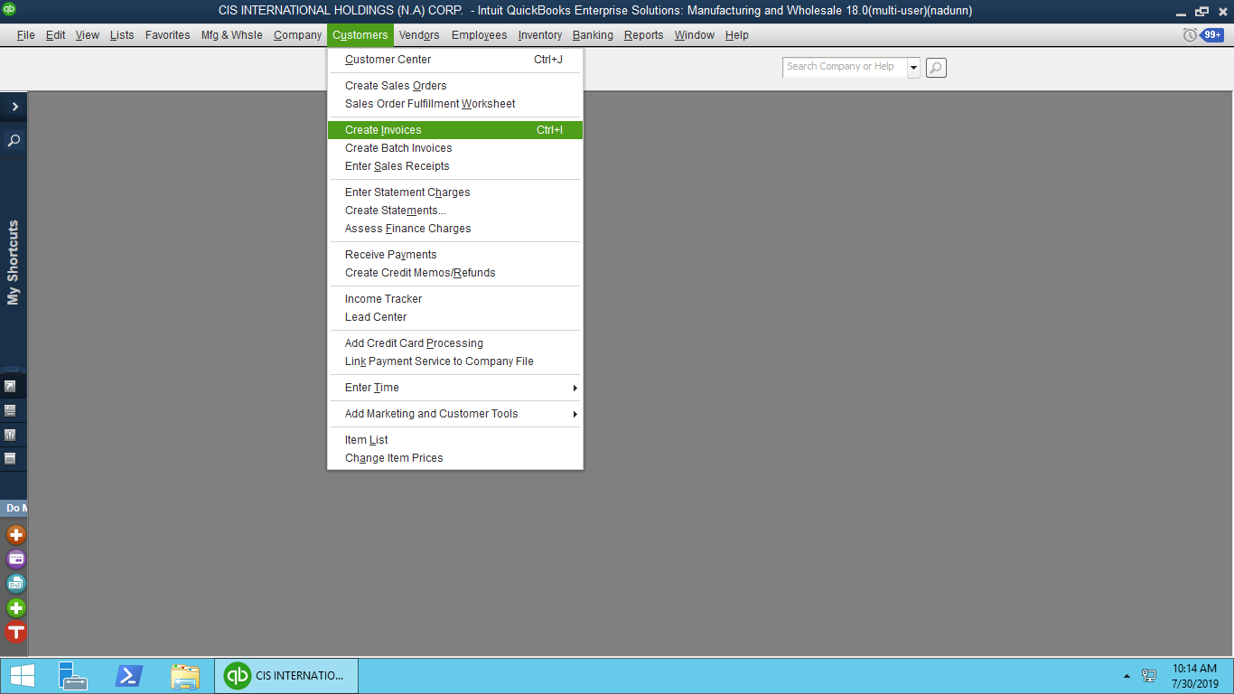

02. Set the Date

1. Choose the Customer

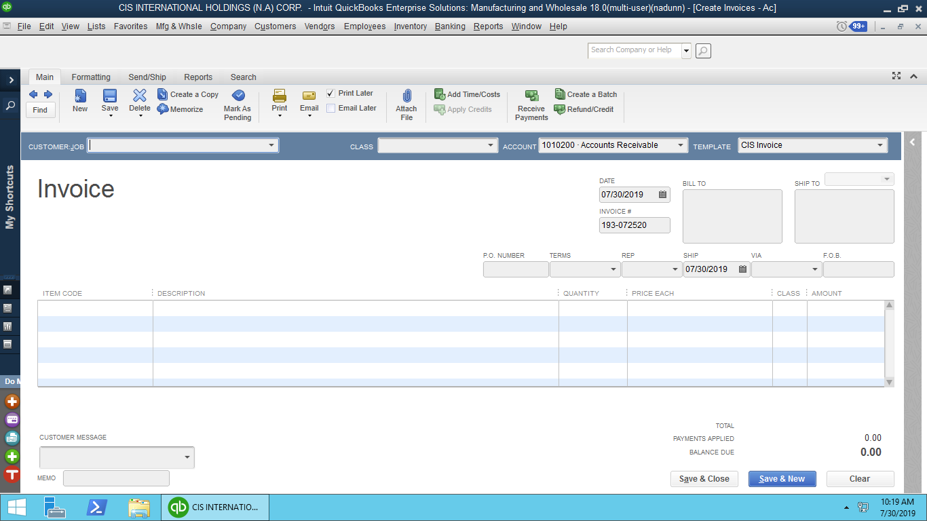

04. Set the Items and Relevant Class

03. Assigned the Relevant Invoice No

05. Select the “Save” Button to Post the transaction