|  |  |
| --- | --- |
| Subject | Ensure the accuracy of bank balances |
| Department | Finance |
| Recorder | Nadun Chamara (Accounts Executive) |
| Approved By | Deepika Thilakarathne (Accountant) |
| Created Date | 04th Aug 2019 |
| Last Updated |  |
| Path on Network Folder |  |
| No Of pages including this OPR | 03 |

**Objective : Ensure the accuracy of bank balances.**

Description,

1. Obtain the bank transactions details by Bank statements send by Deepika or Nisansala through the email (View hard copy of the bank statement of Peoples Bank current account).
2. Logon to the QB and click on reconcile under the bank section.

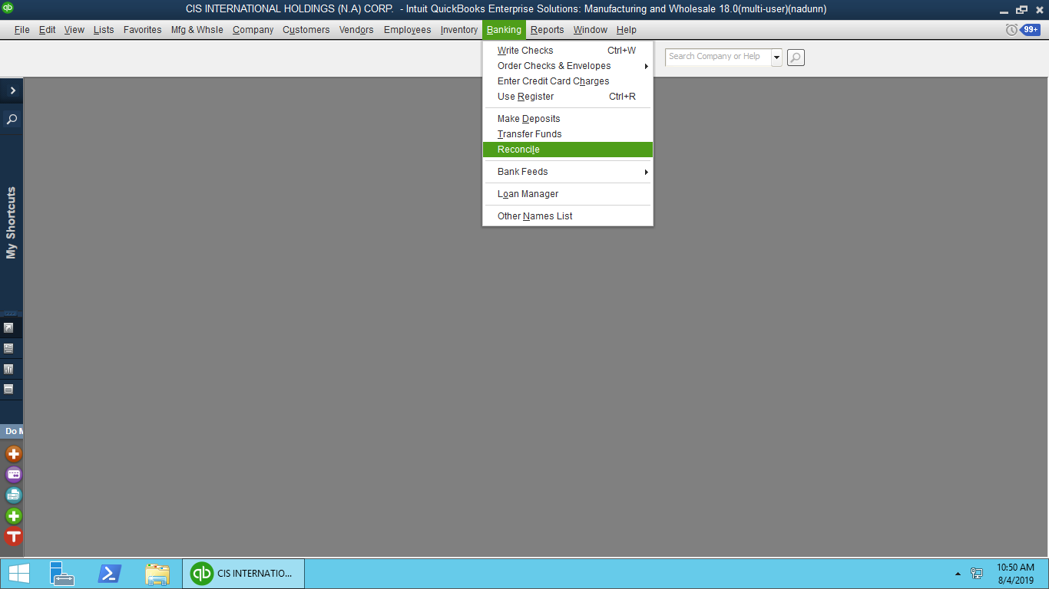

1. Then Select the relevant Bank AC and Change the ending balance According to bank statement balance.

03. Set the Closing Balance

1. Select the relevant bank account

02. Set the Date

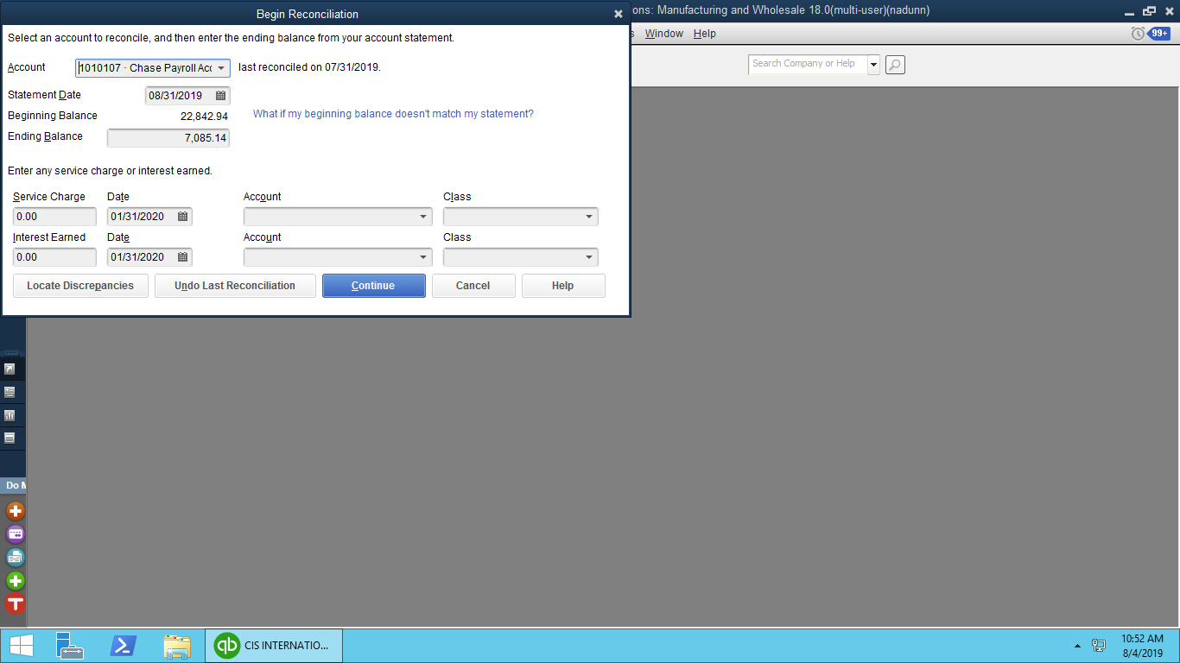

04. Click “Continue”

1. Cross reference with the bank statement and identifying unrecorded transactions, errors then correct it accordingly.

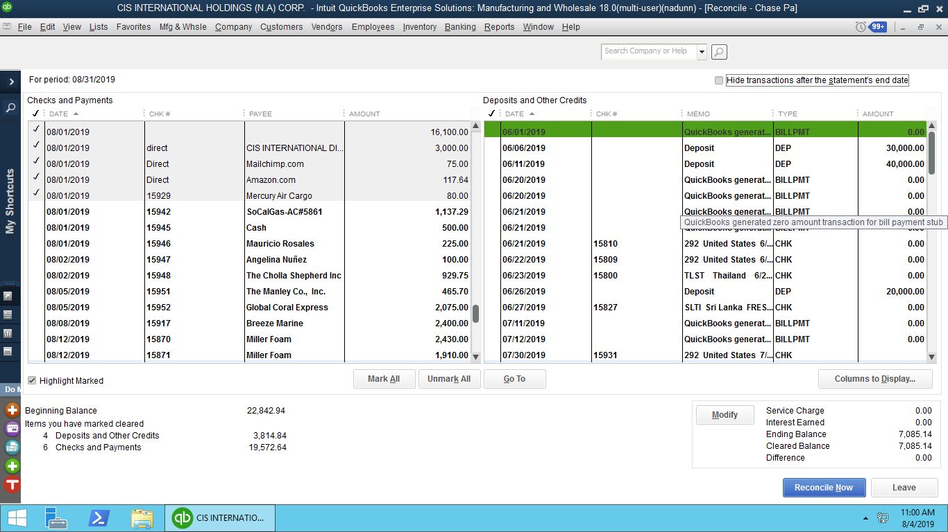

1. After recording all the transactions and then click on “Leave” or “Reconcile Now” end up with bank reconciliation