|  |  |
| --- | --- |
| Subject | Open the existing Company |
| Department | Finance |
| Recorder | Nadun Chamara (Accounts Executive) |
| Approved By | Deepika Thilakarathne (Accountant) |
| Created Date | 04th Aug 2019 |
| Last Updated |  |
| Path on Network Folder |  |
| No Of pages including this OPR | 08 |

**Objective : Open the existing Company**

Description,

1. Open a company file

Click Next Button

Select Open a Company File

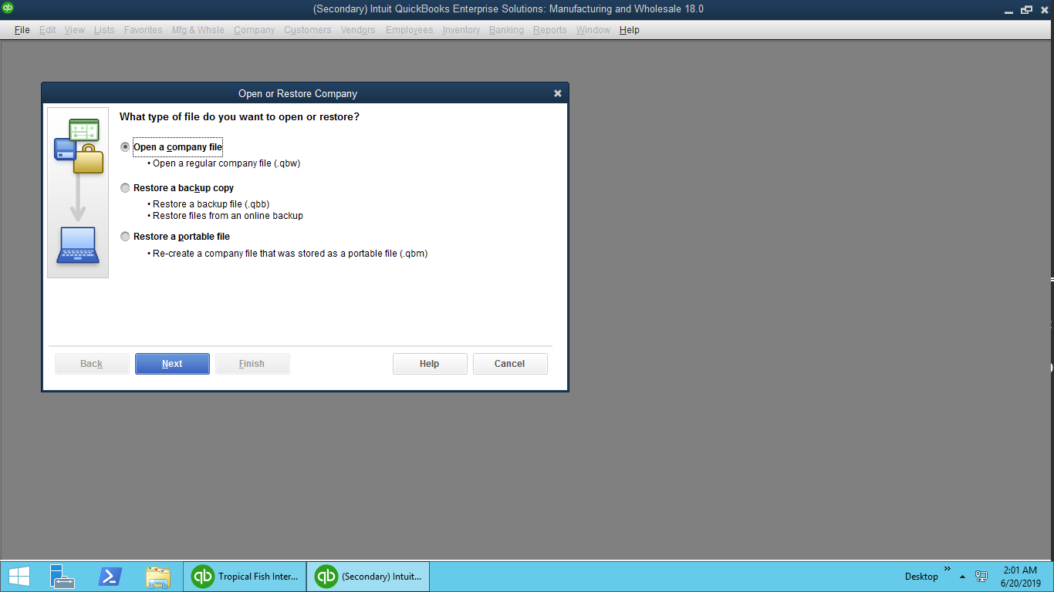

* Then, Select the company file Location.

Select Relevant company folder

Click “Open”

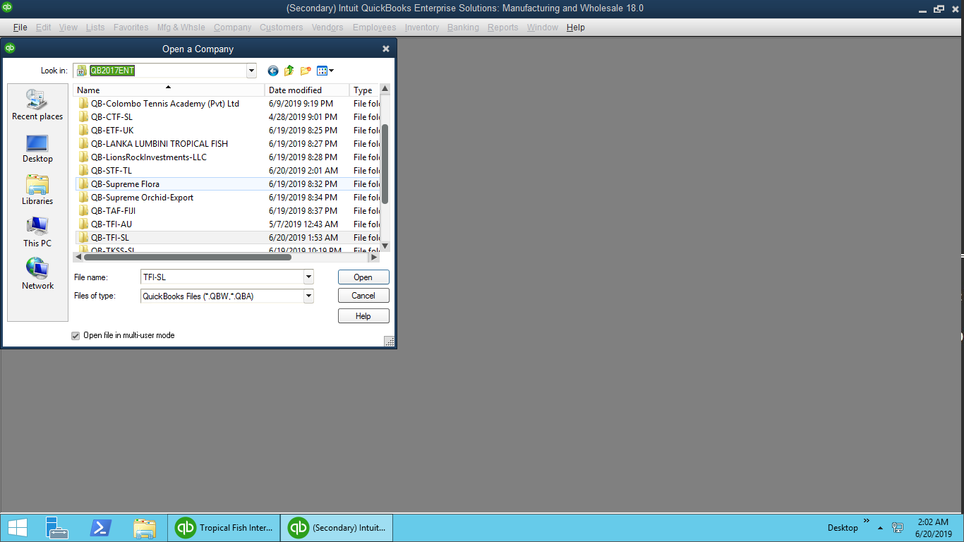

* Then,

Click “Open” To open the company files

Select the QB file

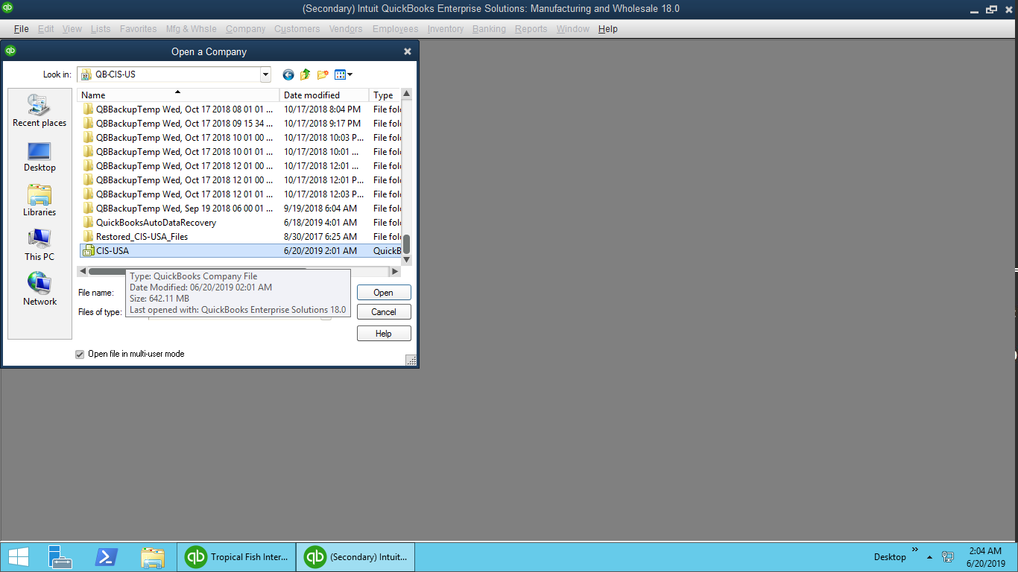

|  |  |
| --- | --- |
| Subject | Raisethe Purchasing Order |
| Department | Finance |
| Recorder | Nadun Chamara (Accounts Executive) |
| Approved By | Deepika Thilakarathne (Accountant) |
| Created Date | 04th Aug 2019 |
| Last Updated |  |
| Path on Network Folder |  |
| No Of pages including this OPR | 05 |

**Objective : Raise the Purchasing Order**

Description,

1. Collect the received PR through the email.
2. Open the company File.

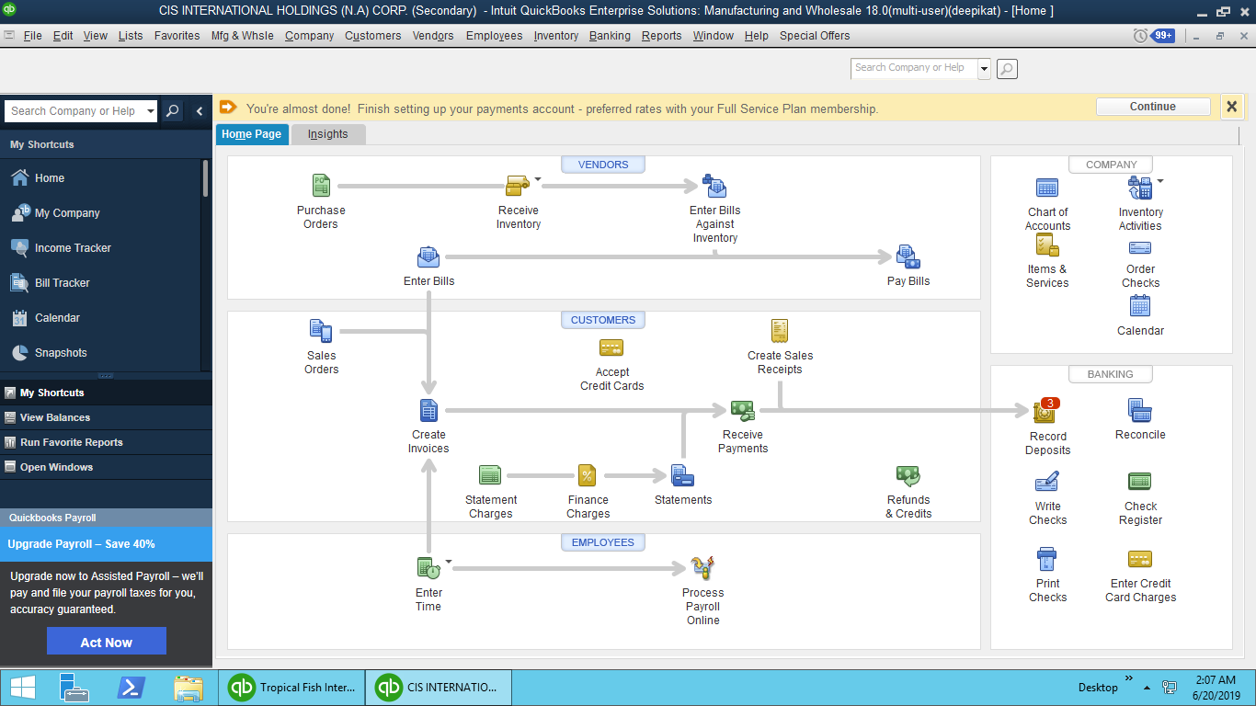

* Then,

Select “Create Purchase Order”

Go to “Vender” Tab

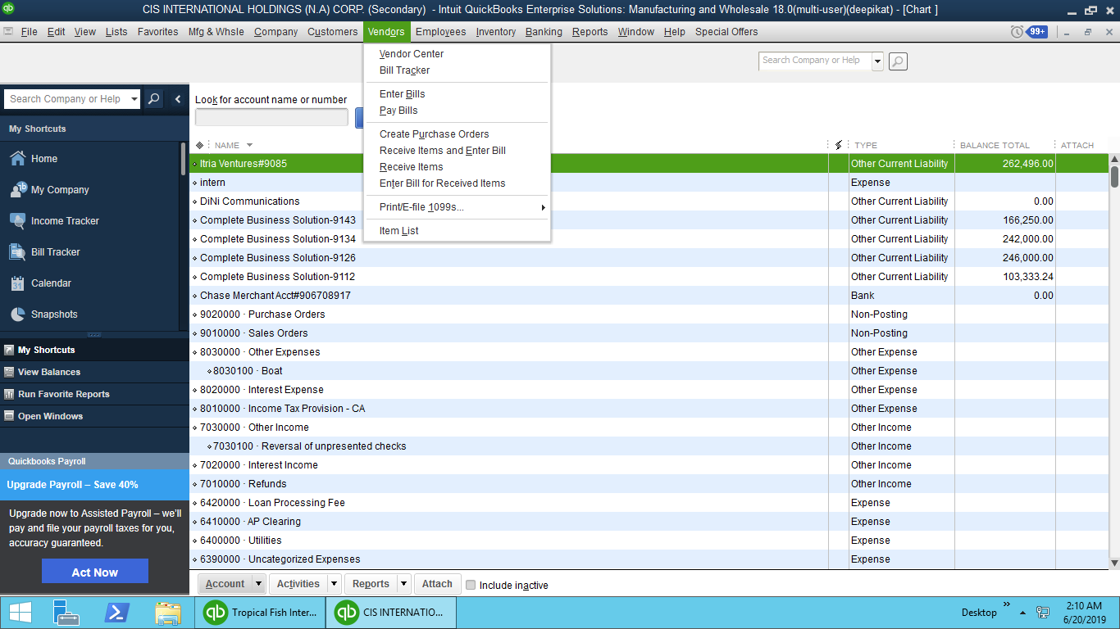

1. Select Vender Name

Select Vender

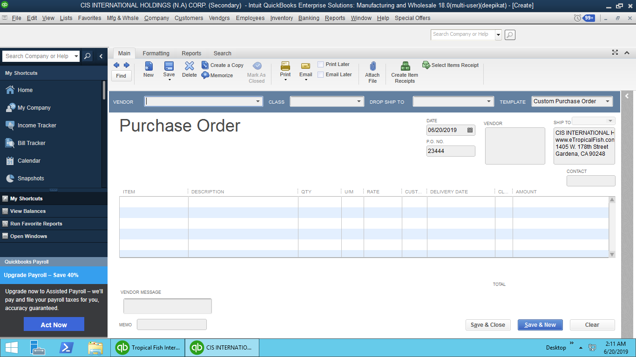

* If it is new vender, create new vender by using “Add New”
* Fill the relevant details then click “Ok”

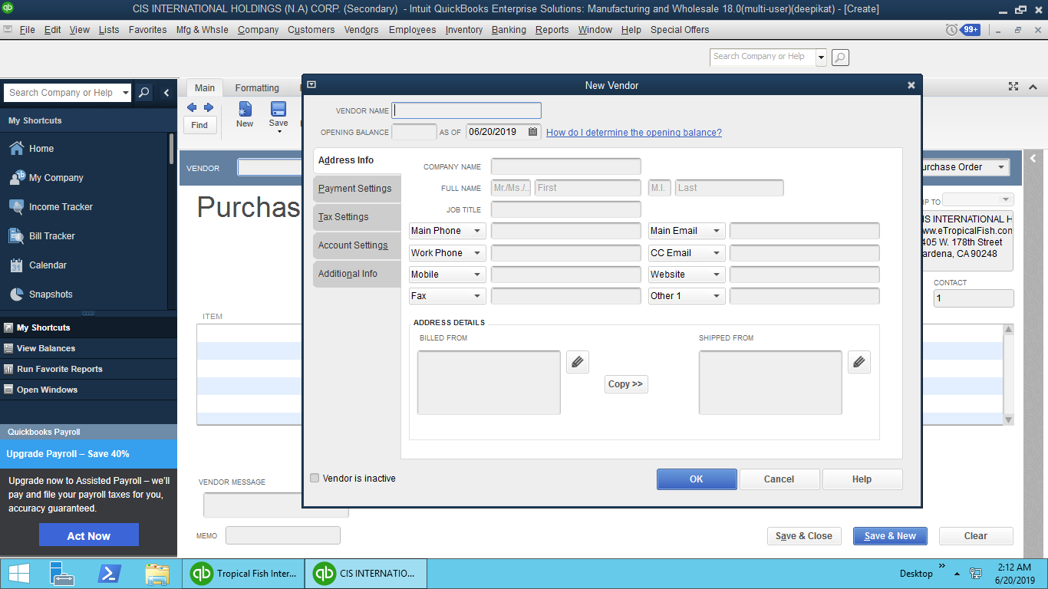

1. After filling relevant details and get the PDF copy of the PO

PO Save as a PDF to desktop

Fill Relevant data

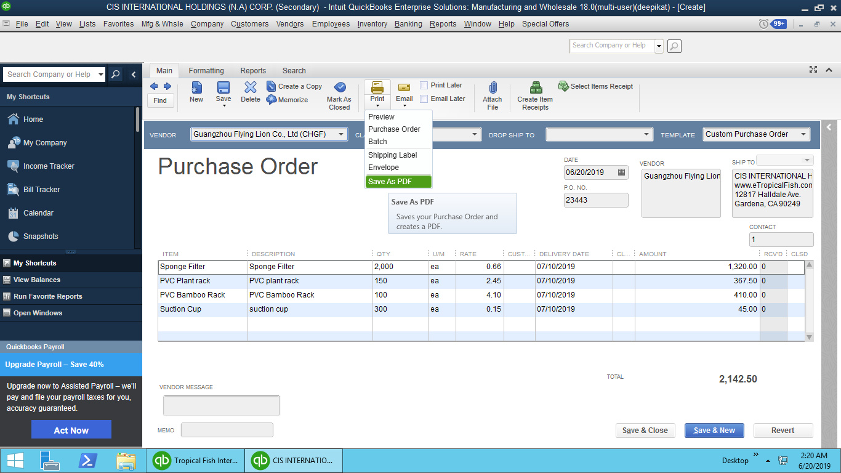

Click “Save & Close” or “Save & New” to new PO

1. After raise PO from Accounting system send that PO pdf copy to vender through the email.