|  |  |
| --- | --- |
| Subject | To ensure all the Supplier Bills are Update in timely Manner |
| Department | Finance |
| Recorder | Nadun Chamara (Accounts Executive) |
| Approved By | Deepika Thilakarathne (Accountant) |
| Created Date | 04th Aug 2019 |
| Last Updated |  |
| Path on Network Folder |  |
| No Of pages including this OPR | 02 |

**Objective : To ensure all the Supplier Bills are Update in timely Manner**

Description,

1. Collect the Supplier’s bills through the email send by the SLTI and TLST.
2. Summarized the bill data according to the class.
3. Record the bill in Quick Book Accounting Package.

* Go to Enter Bill

Then Choose “Enter Bill”

Use “Vender” Tab

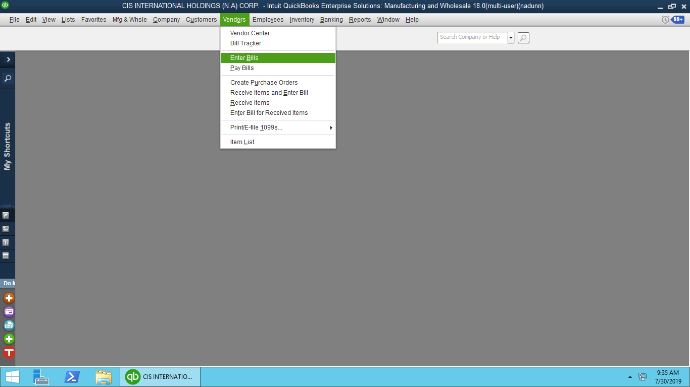

* Then, Enter the Bill

Assigned the Bill No

Select the Vender from List

Enter Bill Amount

Set the Bill Date

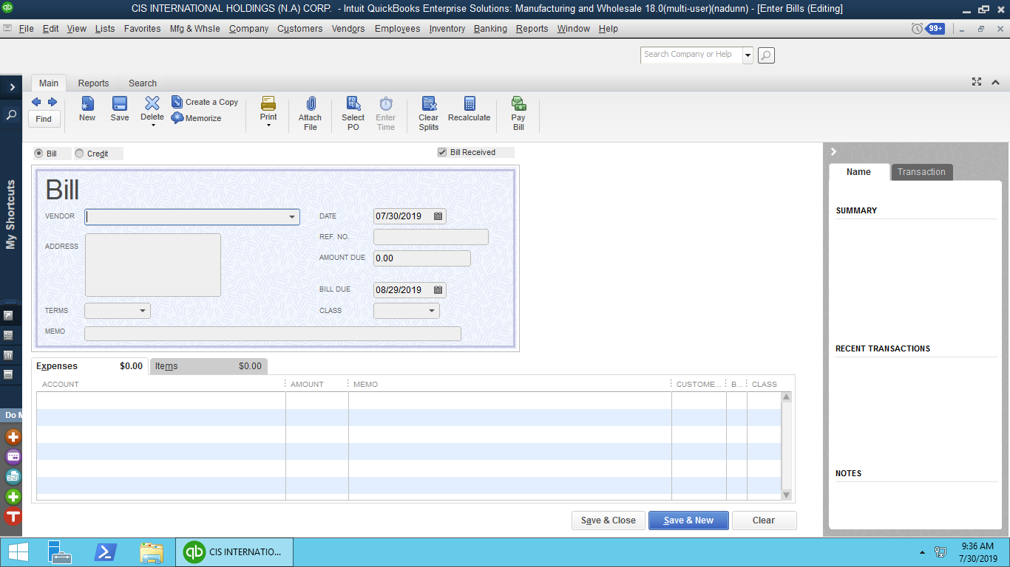

Select the Relevant Class

Select the Relevant Expense Account

Finally Use the “Save” button to Enter the transaction

1. Reconcile the QB balances with supplier statements.