|  |  |
| --- | --- |
| Subject | Prepare the report for reconcile the ETF sale with Quick Book |
| Department | Finance |
| Recorder | Nadun Chamara (Accounts Executive) |
| Approved By | Deepika Thilakarathne (Accountant) |
| Created Date | 04th Aug 2019 |
| Last Updated |  |
| Path on Network Folder |  |
| No Of pages including this OPR | 02 |

**Objective : Prepare the report for reconcile the ETF sale with Quick Book.**

Description,

1. Get the monthly class wise sale recorded in Quick Book accounting package by exporting monthly P&L export to the Excel workbook.

03. Click “Ok”

02. Select “Class” From List

1. Use “Customize Report” Tab

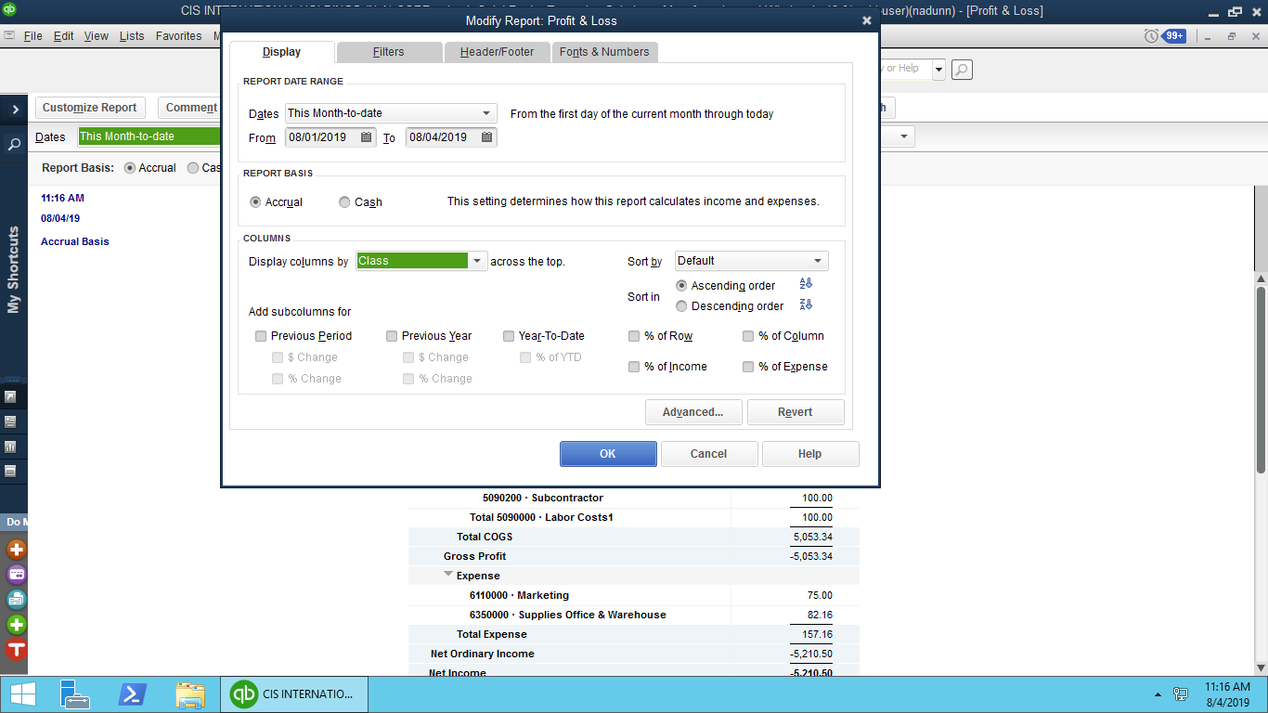

1. Export the customer wise monthly sale to the report from ETI system.
   * EDI Details Invoice Summery Report
2. Select the relevant date range

02. Select the Customer

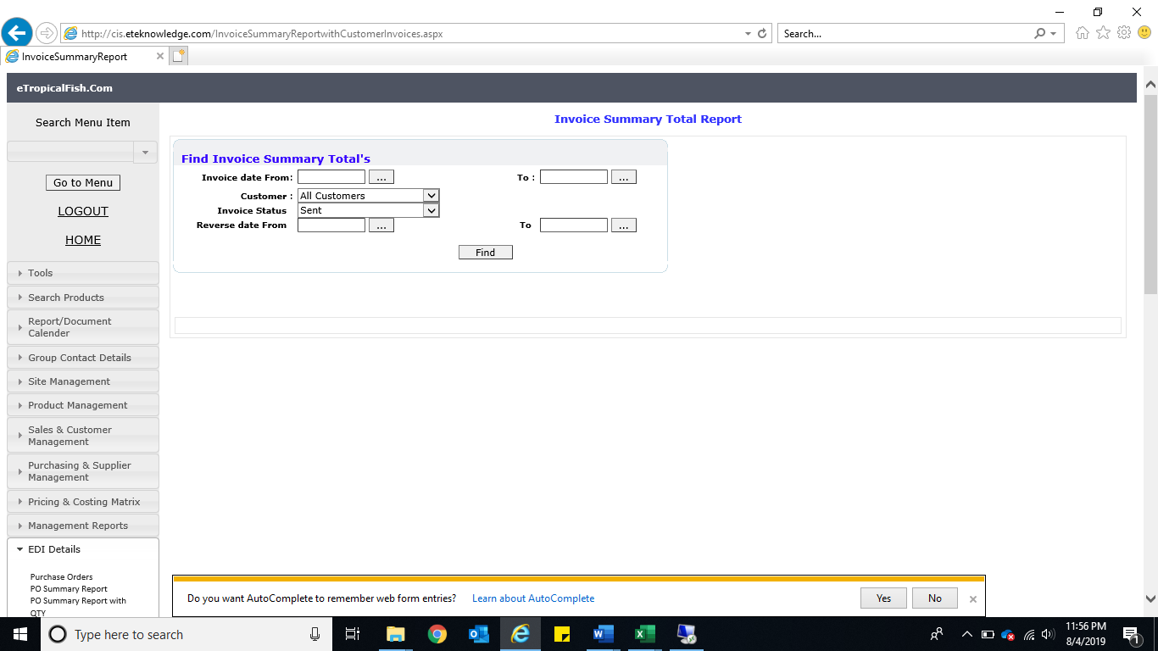

03. Click “Find”

1. Reconcile the monthly sale and identified the difference of the monthly sale on QB and ETI.