**CIS INTERNATIONAL HOLDINGS (N.A) CORP**

|  |  |
| --- | --- |
| Subject | Entering Utility Bills |
| Object | To ensure all the Mail Tracker Bills are Update in timely Manner |
| Department | Finance |
| Recorder | Nisansala Dilhani - (Accounts Executive) |
| Approved By | Deepika Thilakarathne (Accountant) |
| Created Date |  |
| Last Updated | 07.20.2019 |
| Path on Network Folder | Teknowledge Shared Services\Finance Dept. - Documents\OPR's\Nisansala Dilhani |
| No Of pages including this OPR | 02 |

1. **Mail tracker bills are saved by Maria in SharePoint and Check daily the SharePoint**

Share Point Finance Dept. - Documents Operational CIS INTERNATIONAL HOLDINGS (N.A) CORP Bills Mail Sorting

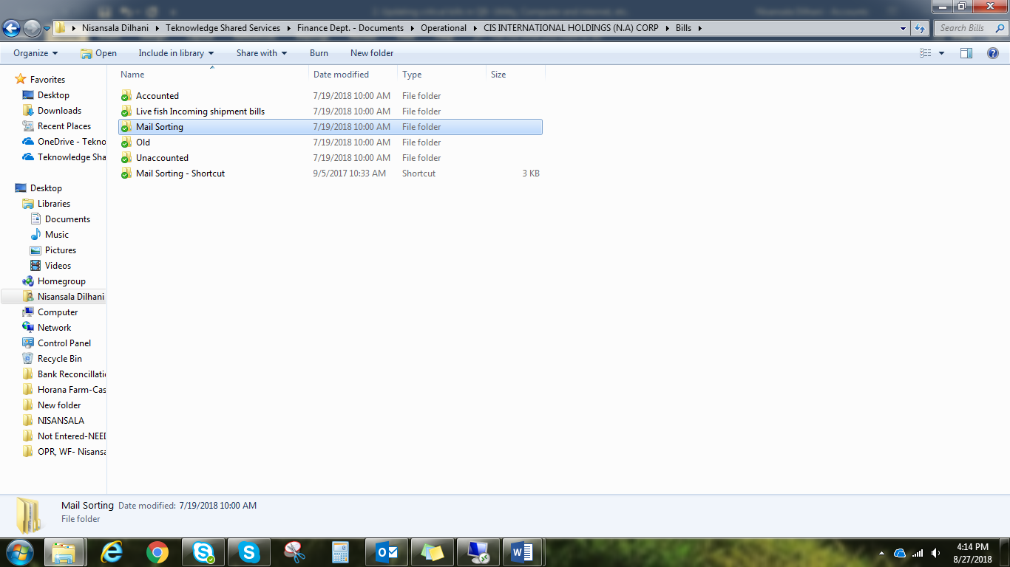

1. **Record bills in QB ( It is need to record "Due Date " more carefully.)**

Vendor Enter Bill Select Vendor Select Date Fill Relevant Details

Attached the bill Save

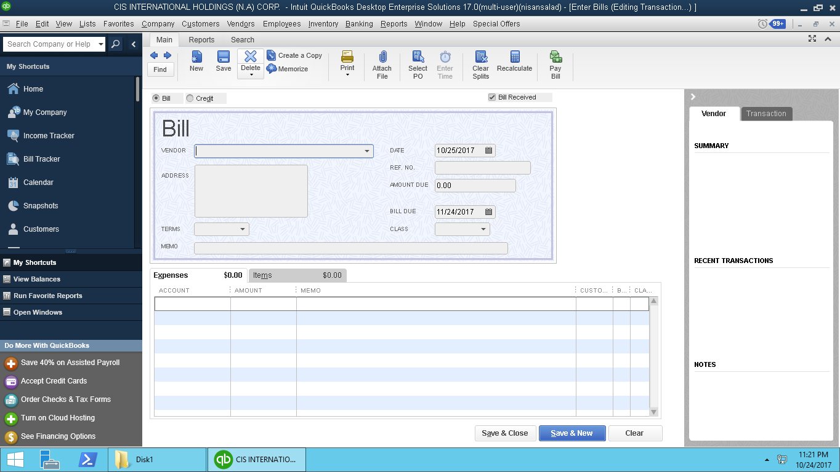

Vendor

Invoice Date Date

Due Date

Expenses $ Item

1. Make sure all the bills and payments are recorded properly in QB
2. Check whether the vendor Payable amounts are correct or not

**3.     If there is any argent Notices or payments immediately inform to Deepika.**